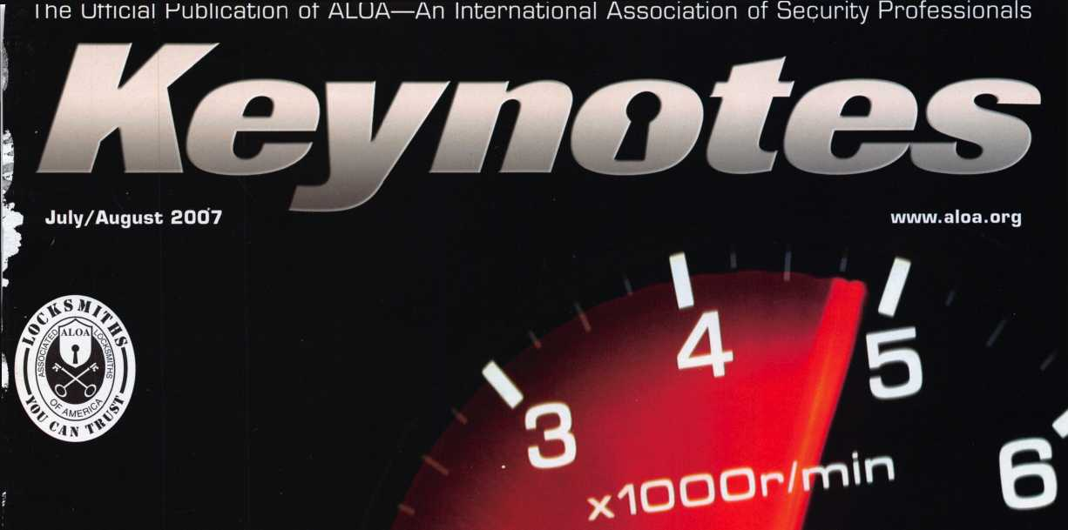

**Get the most out of the ALOA Convention & Security Expo with this month’s**

**DOUBLE**

**ISSUE!**

**\*2**

**+ 0 A1-Oa 2007**



/ PLUS!

**| m** a **h** f Scholarship Recipients

wWfafci Tfltn □ I flQ Dnn i»H Mnrr

ISSUE! ^

2007 RLOR Board Members Financial Report Conuention Guide

***************** *#2_]jlQjT 2Q3

Breck H. Camp CML PO Box *47070* Atlanta GA *30362-0070*

iiiililliiiiiiliiliimlillim||lil|,,,|||lll|m|||llll|||||

and MORE!

**LOCKSMITHS**

OUR STAND

**WE’RE IN BUSINESS TO HELP YOU**

**REDUCE DOWNTIME**

Commercial vehicle insurance designed to help you get back on the road.

When your vehicle is out of business, so are commercial vehicle insurance as well as other you. That's why Allstate provides fast and fair insurance products designed to help keep your

claim service. Your local Allstate agent offers business in the race. Are you in Good Hands®?

CALL NOW TO SPEAK TO AN ALLSTATE AGENT NEAR YOU

**Allstate**

**Subject to availability and qualifications. Allstate Insurance Company and Allstate Indemnity Company, Northbrook, IL. Allstate County Mutual Insurance Company, Irving, TX. Allstate New Jersey Insurance Company,**

**is a service mark of Allstate Insurance Company. NASCAR* is a registered trademark of the National Association for Stock Car**

**Bridgewater, NJ. The "Cupped Hands" logo is a registered service mark and "Our Stand' Auto Racing, Inc. © 2007 Allstate Insurance Company, Northbrook, IL.**

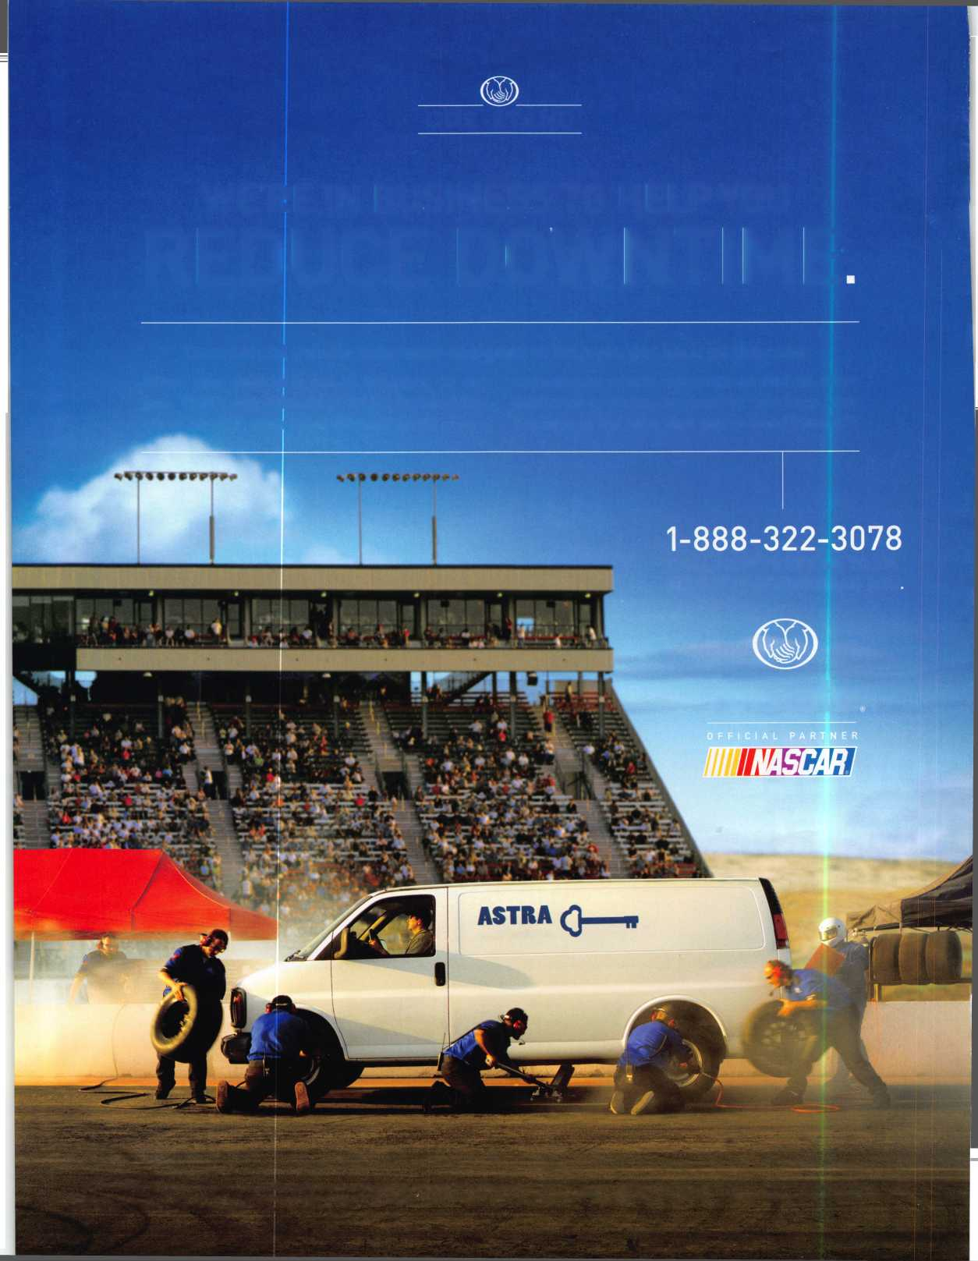

**Shattered**

**Fixed**

**Save Time, Make Money**

Repairing a broken doorjamb used to take hours. Now in less than an hour, you can fix broken jambs and help prevent repeat offenses. Stop giving good business away to your carpenter.

Hinge Shields fit around the existing ir hinges and help prevent hinges from ng kicked in

Hinge Shield

Protection  
Where It’s  
Needed Most

888-582-2294

Your Customers Need This

Door Shield

Door Shield reinforces the lock area of door and helps prevent the door from tting when kicked. Low profile model vailable in colors to match your locks

Jamb Shield

**A unique system that  
reinforces the key strike  
points on entry doors  
and repairs damage  
from previous kick-ins**

Current security products only alert homeowners that they have already been violated.

Your customers will actually be able to sleep secure the night after a break-in. Helps eliminate tenant initiated damage and secures vacant units for landlords.

This Will Change Your Business

; backbone of the system, the Jamb eld is a 48" long sleeve that wraps und the lock side of the doorjamb, king it extremely difficult to kick in. e Jamb Shield comes sizes to fit ndard (5.5") and Universal (5" to 12") k spacing. Jamb and hinge shields ure to stud with 3 V2" screws (included)

**Because You Can’t Afford Falee Security ®**

* You should make $1,000 on every call that you answer with this product
* Calling a carpenter to fix shattered jambs costs you money
* This will help you sell more high-end deadbolts

» Do you work with any landlords?

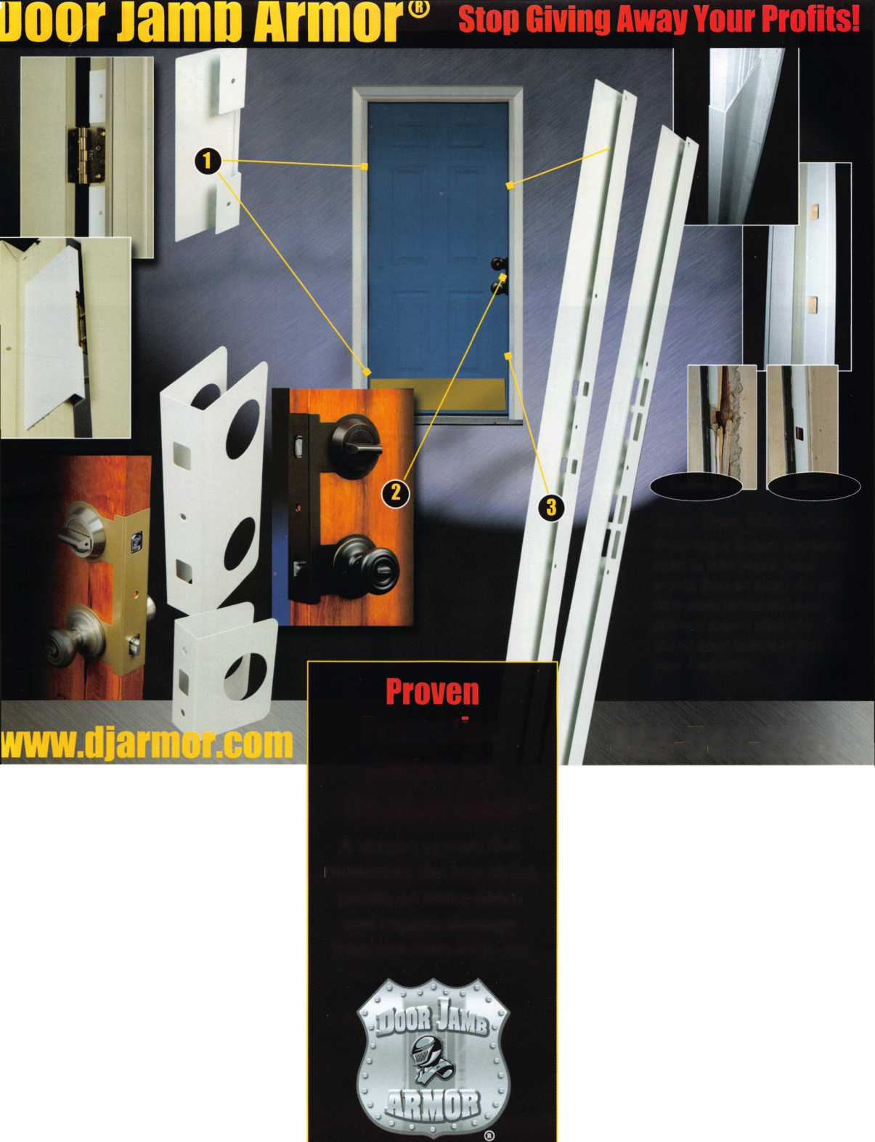

Flexibility **Merged** With Security...  
Now, In A Retrofit Cylinder.

**[www.medeco.com](http://www.medeco.com)**

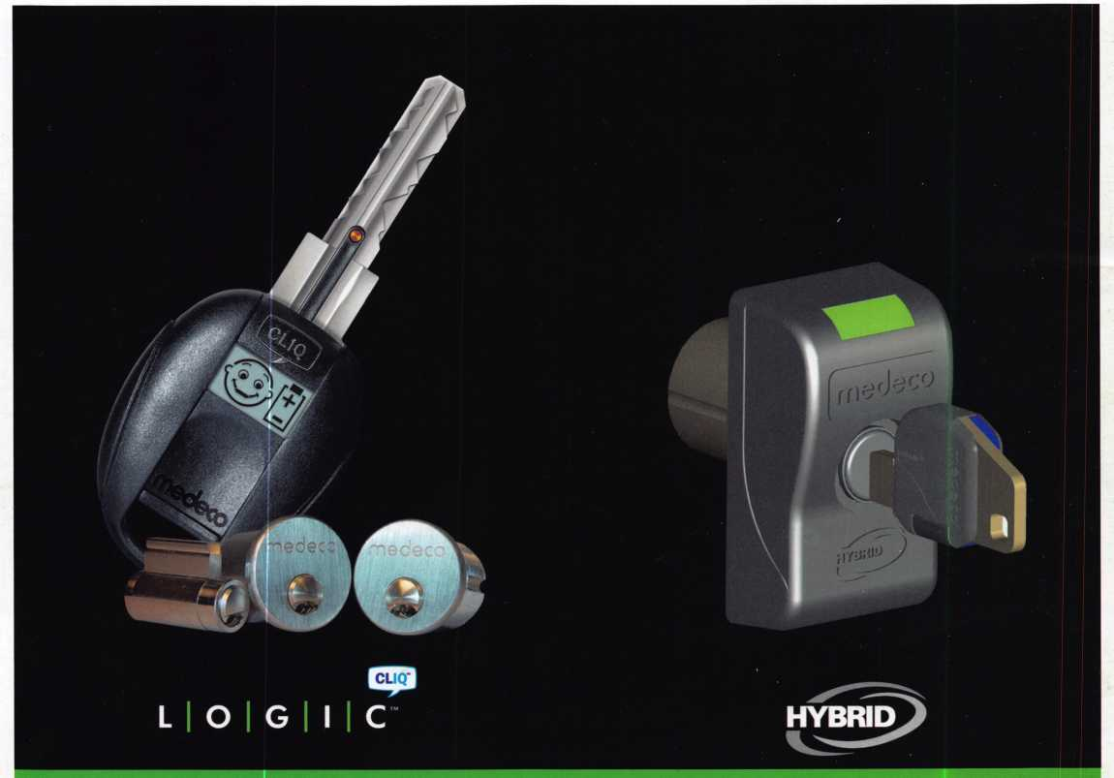

Medeco's new Electronic Cyl inder platforms merge the flexibility of electronics with proven mechanical technologies-all in a retrofit cylinder. Three exciting new product lines-Logic, Hybrid Key, and Hybrid Cylinder-offer end-users audit trails, custom access schedules, and the ability to

quickly add or remove a key from a system. And, unlike other stand-alone or access control products, Medeco E-Cylinders install in a matter of minutes without any wiring, door modifications, or related hardware. Learn more by calling 800-839-3157 or visit Medeco.com

medeco

HIGH SECURITY LOCKS

ASSA ABLOY

ASSA ABLOY, the global leader in door opening solutions

**WE ARE LISTENING TO YOUR NEEDS!**

J



**GET READY. CHANGE IS**

**[aloaIu**

**AROUND THE CORNER!**

Take a LOOK at some of the new things ALOA has planned for YOU in 2007.

ALOA is excited about the new changes in-store for everyone in 2007. For this membership cam­paign we have listened to the membership and are rapidly making changes to suit your needs.

• Don’t miss out as we roll out our new & improved Keynotes magazine introducing such interactive features as a Q&A section exclusively for members.

More user-friendly ALOA website.

More training & education opportunities. Better and broader networking possibilities.

• ALOA store with more books plus NEW products that help YOUR bottom line.

ALOA offers you the strength of over 8,000 leading firms & individuals. ALOA is YOUR voice in the industry. ALOA represents the collective interests of the association to the press, government, and the public. ALOA is able to open many doors needed for your success in our ever-changing industry.

CONTACT:

Associated Locksmiths of America  
3500 Easy Street  
Dallas, TX 75247

Phone 800-532-2562 • Fax 214-819-9736  
[www.aloa.org](http://www.aloa.org)

/

y

&

Wl

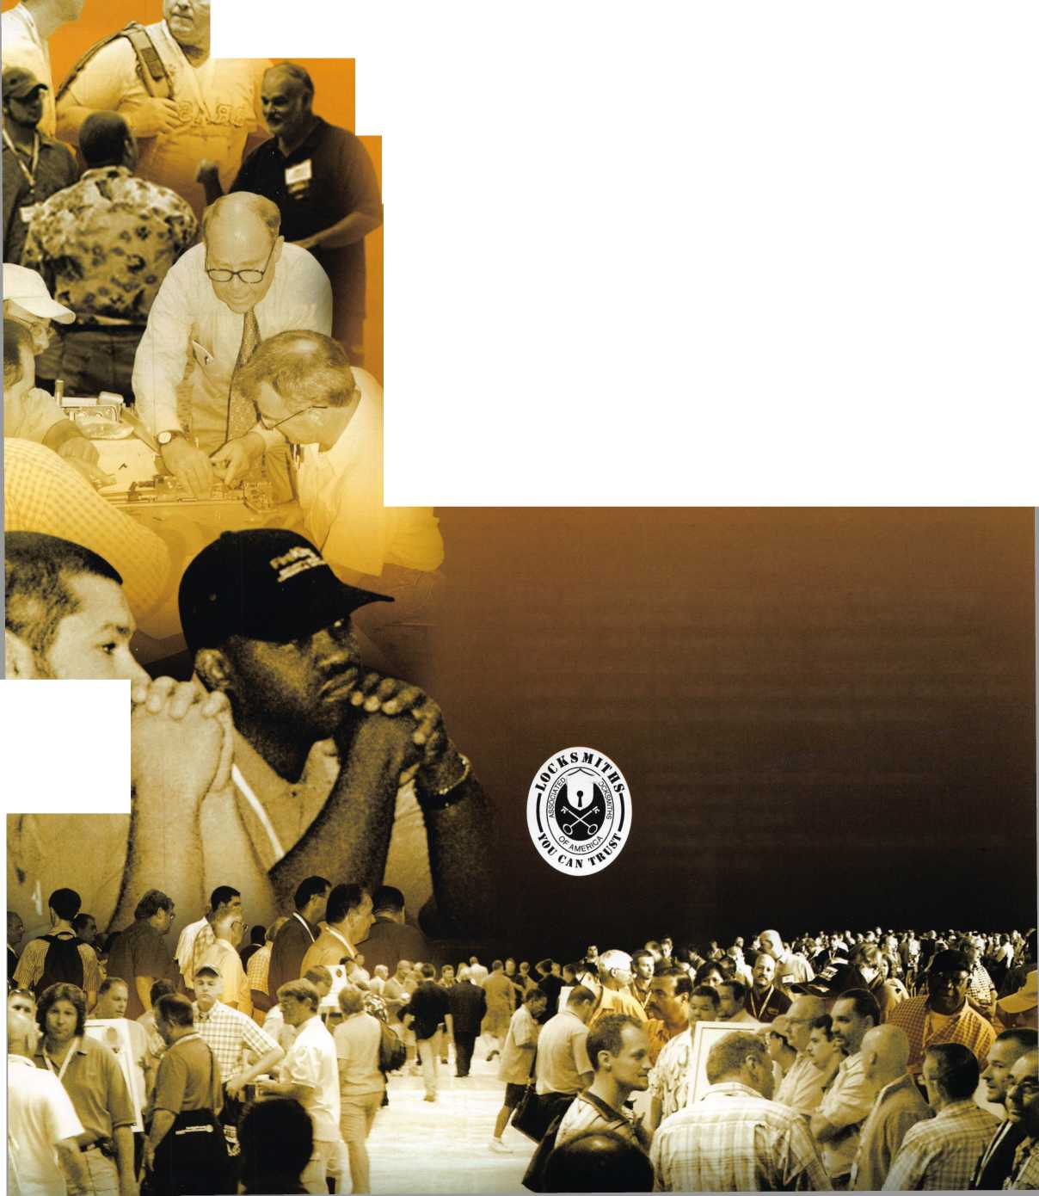

|  |  |  |
| --- | --- | --- |
| p r e s i d | e n 1 | t i a 1 |
| view | p o i | n t |

Volunteer

One who enters into or offers himself for service of his  
own free will. -Webster

Dear Members,

I thought long and hard about the topic of my last presidential  
viewpoint. I decided that since my first penning was about only  
one word, that my last message would follow suit. That last word is  
volunteer.

In our association, that volunteer works for our group for no  
charge. He or she may be an officer, director or that member who  
helps out at a booth at a convention. In fact, that person may not

even be a member at all, but desires to just help out. These people are the heart of our association.  
Without them, ALOA would not have lasted over a half a century.

The rewards of working forour association are not monetary. In some cases, an officer or director may incur extra costs that can never be reimbursed. Then one may question, "Why?" There are as many different answers as there are individual volunteers. Some say that they like to see the associ­ation grow and prosper. Others want to help their fellow locksmiths.Still others enjoy the teaching and learning process. It is the happiness of seeing a job well done (however one views this) is the payoff.

How do you spot a good volunteer? He/she is exceedingly a warm and friendly person who is positive thinking. He is not a complainer. If he offers criticism, he also offers some possible solu­tions. He doesn't throw out the baby with the bath water. His eye is on success, not failure. To these generous people, I dedicate my last presidential message. You know who you are!

As I had mentioned in my June message, the Audit Committee met in Dallas. Part of their duties is to do a physical audit of our building and its contents. I was present and toured the facilities with the committee. It, indeed, should be a source of pride to all our members, that an association our size, has such fantastic facilities. Never to downplay our hard-working staff, but I am sure, we are, where we are, due in large part to dedicated volunteers working diligently over our half century. When you are in Dallas for the convention next year, I suggest that you take a tour of our headquar­ters to see what positive thinking and good volunteers over the years can do.

I close this viewpoint with my best wishes and congratulations to our new president, Ken Kupfer- man, North Central Directors, Guy Spinello and Bill Smith, Southwest Directors, Greg Parks and Gordon Racine, and Sotheast Directors, Tom Gillingham and Steve Myslik, as well as all the present Directors who were not up for election and remain at their posts. Well done, volunteers!

Take 'er easy!

Sincerely,

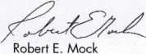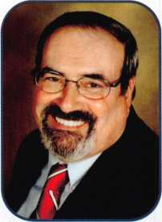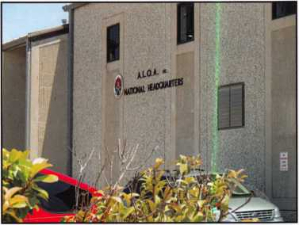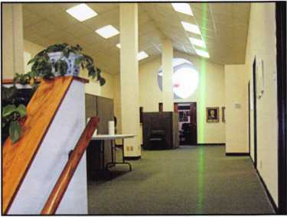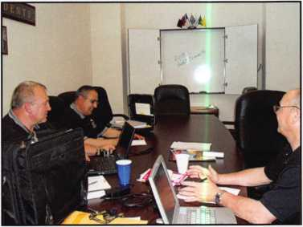

Keynotes • July/August 2007

**Single Door Access Control**

v.*£- :M

Controller Only Version

With Built-in Card Reader

**STAND ALONE**

* Up to 1000 card codes
* 3600 event transaction buffer

‘signing and Manufacturing a full line of product since 1948

120 Glasgow Avenue, Inglewood, CA 90301 U.S.A. T: 310-645-0023 1-800-826-7493 F: 310-641 -1586

E-mail: [info@doorking.com](mailto:info@doorking.com) [www.doorking.com](http://www.doorking.com)

**>arking Control Telephone Entry Gate Operators**

Member: AFA, DASMA, IDA, NOMMA, SIA, SSA

ACCESS CONTROL SOLUTIONS

for over fifty years

**SYSTEMS**

* Timed anti-pass back
* Four time zones

DoorKing's model 1520 is a full feature economical single door access controller. The 1520 can be ordered with a built-in proximity card reader or as a controller only allowing you to add your own 26-bit wiegand device. The 1520 is ideal for single door access control in a variety of applications and provides outstanding features.

* Print menu
* Real time print mode
* Built-in programming keypad

Call or visit our web site for more information!

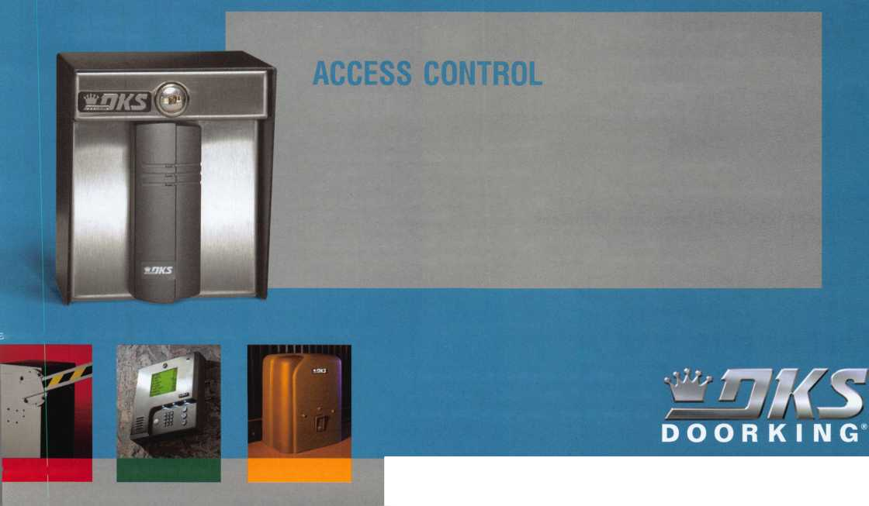

f

a

t

u

ALOA 2007 CONVENTION ISSUE!

ALOA 2007 Convention Guide

Member Spotlight: Eastway Lock & Key

Neil Pobuda tells us about his Charlotte, NC based business and about going to this year's convention.

Six Steps to Email Efficiency

Read how you can become a more efficient emailer.

by Lauren Rikleen

2003 Infiniti G35 Sedan

William gets his automotive prowess as well as his sanity tested in his story of trandsponder challenges.

by William Botek

ALOA 2007 Exhibitor List

The Elections Are In!

Lug Door Woes

Greg Perry tackles the ever common customer complaint, "It just stopped working".

by Greg Perry CML, CPS

ALOA 2007 Scholarship Winners

Meet this year's scholarship winners.

**AD INDEX**

**Allstate Inside Front Cover**

**SimonsVoss 1**

**DoorKing 3**

**Videx 7**

**Locksmithing UNL 11**

**Trade Show On Demand 11**

**INKAS 13**

**Top Notch 15**

**Intralock 17**

**Presidents Club 19**

**TownSteel 21**

**Pacific Lock 23**

**Straltec 25**

**Fax on Demand 27**

**Simon Voss 27**

**IR 29**

**Ultralift 31**

**A&B 33**

**CCL 35**

**H.L. Flake 37**

**Pacific Locksmith Association 39**

**WMW 41**

**Aable 43**

**Jet Hardware 45**

**ALOA 2008 49**

**STB Microtechniques 51**

**North Bennet Street School 53**

**Amsec 55**

**CSS 57**

**Bianchi 59**

**KABA Access Control 61**

**Novation 63**

**LetroTruck 64**

**A&B, Turn 10, Coast Safe & Lock 6$**

**Chase Paymentech Solutions 6^'**

**ClearStar, PBP 6V**

**KABA llco** 7! i

**Door Jam Armor Inside Back Cover**

**Medeco Back Cover**

**Departments**

|  |  |  |  |  |  |  |  |
| --- | --- | --- | --- | --- | --- | --- | --- |
| **Presidential** | **Executive** | **5** | **Calendar** | **8** | **Classified** | **72** | **Legislative ?** |
| **Viewpoint 2** | **Applicants ....** | **6** | **Core** | **9** | **Associate Members** | **74** |  |

**Visit our NEW website at [www.aloa.org](http://www.aloa.org)**

executive



Volume 53, Issue 7

Additional contact information for the ALOA Board is available on the ALOA website—  
[www.aloa.org](http://www.aloa.org) or by contacting the ALOA office at 3500 Easy Street; Dallas, TX 75247;  
(800)532-2562; FAX (214)819-9736; e-mail [aloa@aloa.org](mailto:aloa@aloa.org).

Editor & Director of Creative Services Comptroller

|  |  |  |  |
| --- | --- | --- | --- |
| Betty Southerland | [betty@aloa.org](mailto:betty@aloa.org) | Kathy Romo | [kathy@aloa.org](mailto:kathy@aloa.org) |
| Advertising Sales |  | Membership Development Manager | |
| Kim Hammond | voice: 817-645-6778 | Ellen R. McEwen | [ellen@aloa.org](mailto:ellen@aloa.org) |
|  | Fax: 817-645-7599 |  |  |
|  | e-mail: [adsales@aloa.org](mailto:adsales@aloa.org) | Convention & Meetings Assistant Karen Lyons | |
| Executive Director |  | Mail Room Coordinator | Kevin Wesley |
| Charles W. Gibson, Jr., CAE | [charlie@aloa.org](mailto:charlie@aloa.org) | Graphic Designer | Margarita Garza |
| Associate Executive Director | |  |  |
| David Lowell, CML, CMST | [david@aloa.org](mailto:david@aloa.org) | Accounting Coordinator | Joyce Nixon |
| Convention & Meetings Manager | | Executive Assistant | Sue Langford |
| Jo Anne Mims | [joanne@aloa.org](mailto:joanne@aloa.org) |  |  |
|  | Assistant Education Manager Bob Stafford, CML | |
| Operations/Membership Manager | | Legislative Manager | Tim McMullen |
| Mary May | [mary@aloa.org](mailto:mary@aloa.org) |
| Director of IT Operations |  |  |  |
| Greg K. Jackson | [greg@aloa.org](mailto:greg@aloa.org) |  |  |
| **Contributors** |  |  |  |
| Jerome Andrews, CML | Ray D’Adamo, CML | Randy Simpson, CML, CPP | Tom Seroogy |
| Paul Chandler, CRL | Billy Edwards, CML | Robert Stafford, CML | Charles Stephenson, CPS |
| Claire Cohen, CML | Dan Graffeo, CRL,CMST | Dave Thielen, CML | Dennis Watanabe, CML, CMST |
| Brian Costley, CML, CMST | Jim Hancock, CPL | Greg Perry, CML,CPS |  |
| Eric Costley, CRL | Jeff Nunberg, CML, CMST |  |  |

Mission Statement: The Associated Locksmiths of America, Inc. is dedicated to enhancing the professionalism, education and ethics among  
locksmiths and those in related sectors of the physical security industry. With approximately 10,000 members in the United States, Canada and the free-  
world, ALOA is poised to help members obtain the knowledge, the strength, and the confidence to perform their role in the physical security field with  
pride and dignity. But it is only through active involvement and participation that ALOA can fully achieve its potential—and can help members to achieve  
theirs.

Policies: Keynotes® is the official publication of the Associated Locksmiths of America, Inc. (ALOA). Keynotes® acts as a moderator without approving,  
disapproving, or guaranteeing the validity or accuracy of any data, claim, or opinion appearing under a byline or obtained or quoted from an ac-  
knowledged source. The opinions expressed by the authors do not necessarily reflect the official views of ALOA. Also, appearance of advertisements and  
new products or service information does not constitute an endorsement of products or services featured by the Association. The Association does not ac-  
cept responsibility for the inaccuracy of any data, claim, or opinion appearing in this publication, due to typographical errors on the part of the authors,  
Association staff or its agents.

Editor's Note: This publication is designed to provide accurate and authoritative information in regard to the subject matter covered. It is provided and  
disseminated with the understanding that the publisher is not engaged in rendering legal or other professional services. If legal advice and other expert  
assistance is required, the services of a competent professional should be sought.

Authors' Payment: Payment for eligible submissions to Keynotes will be based on the following criteria: topic, time spent and past contributions. Authors who  
regularly submit to Keynotes® are generally paid a higher rate. The latter is especially true of authors who write to fit specific editorial needs and submit said copy  
by Keynotes® deadlines. As a general guideline: Average payment for a 750 word, business or 'light' technical article would be $200. Payment for a 1500 word  
article involving significantly higher time and research efforts would be $400.

Payment will not be offered for articles submitted by ALOA employees or members of the ALOA Board of Directors (unless material is of a technical na-  
ture), nor for articles submitted by a company that promote that company's products or services. ALOA reserves the right not to pay for articles submitted  
by an individual(s) that promote a particular company's products or services.

Disclaimer: The Associated Locksmiths of America, Inc., (ALOA), reserves the right to refuse any article for any reason. Additionally, ALOA reserves  
the right to edit, amend or modify any article submitted for publication in order to preserve technical accuracy, clarity, fairness or grammatical correct-  
ness. ALOA will make the best efforts to notify the author of any changes. The extent of ALOA's liability for any article or information contained therein  
will be a notice of correction or retraction in the next possible issue.

Keynotes® (ISSN 0277 0792) is published monthly except for the combined June/July issue by The Associated Locksmiths of America, Inc.,  
3500 Easy St., Dallas, TX 75247-6416. Telephone: (214) 819-9733; FAX (214) 819-9736; e-mail [aloa@aloa.org](mailto:aloa@aloa.org). Subscription rates for  
members—$15.00 per year. Periodical class postage paid at Dallas, Texas. POSTMASTER: Send address changes to: Keynotes, 3500 Easy St., Dallas,  
TX 75247-6416. © Copyright 2003, All rights reserved. No part of the contents may be reproduced or reprinted in any form without prior  
written permission of the publisher.

President

Robert Mock

(856) 863-0710  
[president@aloa.org](mailto:president@aloa.org)

Secretary

John Soderland, CML, CMST  
(414) 327-5625  
[secretary@aloa.org](mailto:secretary@aloa.org)

Directors, Northeast

Tom Foxwell  
(410) 206-5772  
ned i rector@a loa.org

Robert D. DeWeese, CML, CPS  
(410) 285-0101  
ned i rector@a loa.org

Directors, Southeast

Tom Gillingham, Jr., CML, CPS  
(615) 300-3777  
sed i rector@a loa.org

Ken Kupferman, CML, CPS  
(813) 232-7600  
sed i rector@a loa.org

Director, North Central

William Smith, RL  
(920) 893-5282

Guy Spinello, RL  
(815) 394-1000  
[ncdirector@aloa.org](mailto:ncdirector@aloa.org)

Director, South Central

CD Lipscomb, CML, CPS  
(903) 874-3522  
sed i rector@a loa.org

Directors, Southwest

Greg Parks, CRL  
(858) 271-1155  
[swdirector@aloa.org](mailto:swdirector@aloa.org)

Julie McCluney, CRL  
(714) 636-5652  
swd i rector@aloa. org

Director, Northwest

Keith E. Whiting, CML, CFL  
(360) 601-5656  
nwdirecfor@aloa .org

Director, International

Hans Mejlshede, CML  
(453) 539-3939  
eurdirector@aloa .org

Director, Associate

Dan Floeck  
(800) 231-4105  
asd i rector@a loa. org

Trustees

[trustees@aloa.org](mailto:trustees@aloa.org)

Randy Simpson, CML, CPP  
(281) 240-5959

JohnJ. Greenan, CML, CPS  
(773) 486.2030

William Young, CML, CPS  
(610)647-5042

Past Presidents

2003-2005 William Young, CML, CPS  
2001-2003 Randy Simpson, CML  
1999-2001 John Greenan, CML, CPS  
1997-1999 Dallas C. Brooks  
1995-1997 David Lowell, CML, CMST  
1993-1995 Breck Camp, CML  
1991-1993 Henry Printz, CML  
1989-1991 Evelyn Wersonick, CML, CPS  
1987-1989 Leonard Passarello, CPL  
1985-1987 Joe Jackman, CML  
1983-1985 Stanley Haney, CPL  
1981-1983 Louis LaGreco, CPL  
1979-1981 John Kerr, RL  
1977-1979 Clifford Cox, CML  
1974-1977 Charles Hetherington  
1972-1974 Gene Laughridge  
1970-1972 William Dutcher, RL  
1968-1970 Constant Maffey, RL  
1966-1968 Harold Edelstein, RL  
1964-1966 William Meacham  
1962-1964 Robert Rackliffe, CPL  
1960-1962 Edwin Toepfer, RL  
1956-1960 Ernest Johannesen



Keynotes • July/August 2007

Anchorage

Brody Ward

Sponsor: Scott L. Henke CPL, CPS Wasilla

Wayne E. Romer

Sponsor: Scott L. Henke CPL, CPS

CO

Westminster

Peter Wiatr

CT

Gales Ferry

Deborah A. Ranquist

Sponsor: John K. Humphreys CRL

FL

Belle Glade

Freddie Garrett

Sponsor: Richard Moller Bradenton

Stephen C. Wilson

Sponsor: Kent M. McFarland CRL Fort Lauderdale

Robert Santos

Sponsor: Arthur L. Morris North Palm Beach

Avon Aiken

Sponsor: Van R. Schneider CRL Saint Petersburg

Robert Shields

GA

Atlanta

Kendall Gamble

Sponsor: James Latners Jr Kennesaw

Michael Dergosits

Sponsor: Dale R. Mattice Screven

Michael I. Whitted CRL

IL

Hoopeston

Joey D. Cartwright

Sponsor: Jim Williams CRL

LA

New Orleans

Maria Radosti

Sponsor: Diane M. Foto CRL

MA

Merrimac

Robert D. Auch CRL

Sponsor: John R. Whitmarsh CPL

MD

Columbia

Robert M. Booher

Sponsor: Roger W. Pfanstiel CML

Ml

East Lansing

Douglas Katt

Sponsor: Mark E. Blum CML, CPS

Dennis E. Lantzy

MS

Picayune

James E. Portie CRL

Sponsor: Donald E. Rule CML

NC

Kitty Hawk

Justin S. Petri

Raleigh

Matthew S. Houchins

Sponsor: Granger L. Marley CML

NJ

Millburn

David M. Hawes

NY

Brooklyn

Nestor Andrianos

Sponsor: Shane M. Varney CRL, CPS

Livonia

Richard Canarvis

Sponsor: Joseph P. Ferrero CML

OH

Cincinnati

Russell A. McGurrin

OK

Tulsa

Andrea G. Parsons

Sponsor: Bert R. Parsons CRL

OR

Corvallis

Christian R. Abbes

TN

Memphis

Ron T. Swanson

UT

Salt Lake City

Herbert A. Martin

Sponsor: Robert W. Martin CML

VA

Arlington

Jason P. Dehond

Sponsor: Jesse W. Strange III Clear Brook

Kyle K. Bouck

Sponsor: Doug Willhite Newington

David R. Graham

Sponsor: Robin G. Leckey

Angel A. Perez

Sponsor: Edward J. Miller Winchester

Jack Phipps

England

Tunbridge Wells, Ke

Michael Cripps

These applicants are scheduled for clearance as members of ALOA. The names are published for member review and comment within 30 days of this Keynotes issue date, respectively, to ensure applicants meet standards of  
ALOAs Code of Ethics. Protests, if any, should be addressed to the Membership Department and must be signed. Active Membership applicants (a) have worked in the industry two or more years. Allied Membership (AL)  
applicants are not locksmiths, but work in a security-related field. Apprentice Membership (AP) applicants have worked in the industry less than two years.

**6**

Keynotes • July/August 2007

Most Marketing Stinks!

It’s a long way from an apprentice printer growing up ouer his  
parents’ corner store in a tiny town in England, to the creator of  
the largest Marketing Agency in America. Howeuer, for Jack  
Sims it typifies his philosophy that you can achieue success in  
whateuer you are truly prepared to work for. In fact, he is so  
sure that understanding “Most Marketing Stinks” and the  
process of branding will change your business, he has commit-  
ted his retirement to teaching others the skills he has spent his  
lifetime acquiring. Don’t miss the keynote address “Most Mar-  
keting Stinks... But Vour Locksmith Business can Smell Like  
Money” presented by Jack Sims at the Membership Meeting  
Friday, July 27, 2007 at 9:30 a.m.

Rlso, sign up now for class #620 Growing your Locksmith Business into a  
Big Brand! This session is going to be a high-content and high-energy session  
on probably the hottest topic in business today, the area we call branding and  
this is one that you just don’t want to miss! If you don’t know what branding is,  
then it is difficult to grow one and this session by Jack Sims will seriously de-  
liuer. Vou will leaue with the information that you need to start turning your  
Locksmith business into a Brand. Jack says “you already haue a brand, but it’s  
how you leuerage it in the marketplace as your differentiator and haue it posi-  
tiuely affect your bottom line for the long haul that counts”. Lab Fee $200.00 in-  
cludes Jack Sims book "Growing Small Businesses into Big Brands"

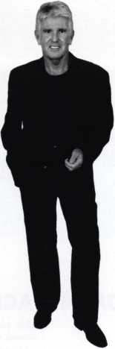

**CyberLock**

Complete Access Control in Every Lock Cylinder

* Keys work during days

and times you specify

* Keys cannot be duplicated
* Each opening is recorded
* Locks cannot be picked

Are Your Most Important Assets Secure?

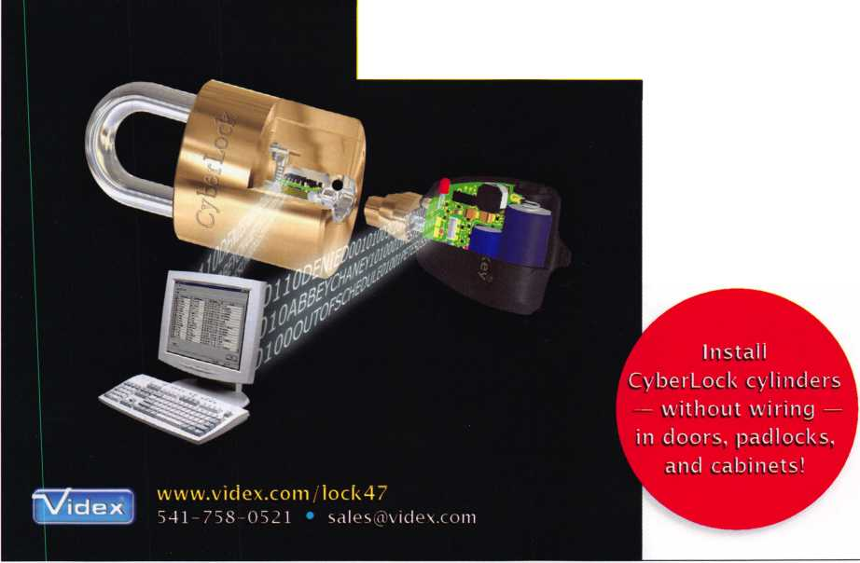

upcoming events

7/22-29 ALOA '07 Convention & Security Expo Charlotte, NC

Associated Locksmiths of America

[convention@aloa.org](mailto:convention@aloa.org)

[www.aloa.org/convention](http://www.aloa.org/convention)

7/11 Counter Days • [www.doylesecurity.com](http://www.doylesecurity.com)

8/4-5 CLA Education

Long Beach, California

For more info:http://<

index.Default.asp;

ralvalley.net/

154

* July, August, and September there will be no  
Doyle University -

Classes will resume after the September Trade  
Show.

9/14-15 Doyle Annual Trade Show & Education Prior Lake, MN Doyle Security Products Mystic Lake Casino [www.doylesecurity.com](http://www.doylesecurity.com)

10/20 VLA Meeting & Class • Charlottesville, VA

Contact: Elliot Paul Conner • [va_locksmith@verizon.net](mailto:va_locksmith@verizon.net)

**UPCOMING ACE CLASSES**

July 14, 2007 Norfolk, Nebraska • Nebraska Chapter of ALOA

Advanced Topics in Master Keying w/L-31 PRP Elmer Howard • [safeman@cox.net](mailto:safeman@cox.net) • 402-676-8973

July 22-29, 2007

August 20-25, 2007

September 11-15, 2007 September 14-15, 2007 September 15, 2007 September 19-21,2007 September 21-23, 2007

October 9-12, 2007

October 8-13, 2007

October 12 & 13, 2007

Charlotte, North Carolina

ALOA 51 st Annual Convention & Security Expo

70 Full Day Classes • 35 Half Day Classes

& Evening Seminars • ALOA Education • [education@aloa.org](mailto:education@aloa.org)

800-532-2562x101 •[www.aloa.org](http://www.aloa.org)

Dallas, Texas • ALOA Training Center

Six-Day Basic Locksmithing Course

ALOA Education • [education@aloa.org](mailto:education@aloa.org)

800-532-2562x104

Anaheim, California • Clark Security Products Safe Lock Manipulation, Safe Lock Servicing,

Transponder Servicing • Joan Emrick • 858-9746737 Minneapolis, MN • Doyle Security Show For a complete listing contact:

Kristina Larsen • 612-521-6226 • [www.doylesecurity.com](http://www.doylesecurity.com)

Roseville, Ml • Locksmiths Security Association

Intermediate Auto Lock Servicing w/L-03 PRP

Marc A. Dearing, CRL • 810-244-4038/[mkdearing@comcast.net](mailto:mkdearing@comcast.net)

Sturbridge, MA • Yankee Security Convention

For a complete listing contact: Stephen McKinney

800-209-8266 • [www.yankeesecurity.org](http://www.yankeesecurity.org)

Farmington, NM • Association Locksmiths of New Mexico

For a complete listing contact: Wayne Wilkins, CRL

505-632-6641 • [clasicrez@yahoo.com](mailto:clasicrez@yahoo.com)

Portland, OR • Pacific Security Conference

For a complete listing contact: Keith Whiting

360-601-5656 • [kwinwa@yahoo.com](mailto:kwinwa@yahoo.com)

Appleton, Wl • Fox Valley Technical College

6-Day Basic Locksmithing Course

Jerry Antoon • 800-735-3882x2482 • [antoon@fvtc.edu](mailto:antoon@fvtc.edu)

Kansas City, MO • Missouri-Kansas Locksmith Association

Advanced Automotive Lock Service

Transponders the Complete Story

Bob Turner • 816-525-5522

October 20, 2007 Omaha, NE • Nebraska Chapter of ALOA

Keyless Mechanical Lock Service w/L-20 PRP Elmer Howard • 402-676-8973 • [safeman@cox.net](mailto:safeman@cox.net)

**UPCOMING PRP Sittings**

7/27/07 Friday 6:00pm • Charlotte, NC • ALOA Certification

ALOA 2007 Convention • [education@aloa.org](mailto:education@aloa.org) 800-532-2562x104

8/25/07 Saturday 1:00pm • Dallas, TX • ALOA Certification

ALOA Training Center • [education@aloa.org](mailto:education@aloa.org) 800-532-2562x104

9/14/07 Friday 8:00am • Dallas, TX • ALOA Certification

ALOA Training Center • [education@aloa.org](mailto:education@aloa.org) 800-532-2562x104

9/16/07 Sunday 8:00am • Anaheim, CA • Joan Emrick

Clark Security Products • [joan.emrick@clarksecurity.com](mailto:joan.emrick@clarksecurity.com) 858-974-6737

9/22/07 Saturday 9:00am • Sturbridge, MA • Steve McKinney

Yankee Security Convention • [info@yankeesecurity.org](mailto:info@yankeesecurity.org) 800-209-8266

9/23/07 Sunday 10:00am • Farmington, NM • 505-632-6641

Association Locksmiths of New Mexico Wayne Wilkins, CRL • [classicrez@yahoo.com](mailto:classicrez@yahoo.com)

9/23/07 Sunday 1:00pm • Muskego, Wl • John Soderland, CML, CMST

[prolock@aol.com](mailto:prolock@aol.com) • 858-974-6737

10/5/07 Friday 8:00am • Dallas, TX • ALOA Certification

ALOA Training Center • [education@aloa.org](mailto:education@aloa.org) 800-532-2562x104

10/7/07 Sunday 8:00am • Syracuse, NY • Ron Smith, CPL, CJIL

Central New York Locksmiths Assn. • [advsl@imcnet.net](mailto:advsl@imcnet.net) 315-782-0912

10/12/07 Friday 6:00pm • Portland, OR • Jim French

Pacific Security Conference • [frencje@yahoo.com](mailto:frencje@yahoo.com) 503-235-4000

10/14/07 Sunday 8:00am • Orlando, FL • James Barnhardt, RL

SERLAC • [questions07@serlac.com](mailto:questions07@serlac.com) • 800-845-5294

10/28/07 Sunday 8:00am • Cherry Hill, NJ • Robert Shuetrumpf, CRL, CJIL

Greater Philadelphia Locksmiths Assc. • 856-486-9280

**Contact the ALOA Education De­partment for a list of classes and training offered in-house.**

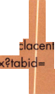

**core**

CORPORATE SAFE SPECIALISTS ANNOUNCES BIOMETRIC LOCK INITIATIVE

Corporate Safe Specialists (CSS) offers the retail and restaurant industries cash man­agement solutions. For many businesses, the contents of a business safe are subject to employee theft. Loss prevention process failure is often found to be the sharing of elec­tronic lock codes (or combinations). Biometric locks eliminate the possibility of code sharing by requiring a fingerprint scan for positive identification of the owner of the code.

With biometric locks customers no longer need to worry about losing, forgetting or sharing the combination or PIN to their safe. Customers can increase security with positive identification for safe access by combining a users fingerprint with a pin num­ber. Employees' fingers are their codes and only those whose fingerprint has been registered can open the lock. Using state-of-the-art biometric technology, CSS locks are secure, fast and easy to use. Each lock is programmable with up to eight user codes limiting access to those who need it. In addition, the ability to set a time delay can be a strong theft and armed robbery deterrent.

All these features, coupled with outstanding customer service and live technical sup­port when needed, provide our customers the capabilities and confidence required. Cash losses and internal theft are an unfortunate reality, and since 1988 CSS has been helping to make retail and restaurant establishments more secure. Whether cus­tomers require a new safe with a biometric lock or require a lock retrofit for an exist­ing safe, CSS offers solutions for businesses large and small.

INTERTEK LAUNCHES PERSONNEL CERTIFICATION PROGRAM FOR DOOR RACEWAY INSTALLERS

'Perfect Raceway' Program validates continued compliance after field modifications

Intertek (LSE: ITRK), a global leader in testing, inspection and certification, has launched the 'Perfect Raceway' program. Through the program, raceway installers will be trained and certified to modify fire rated doors for the installation of electrified hardware without altering the fire resistance ratings.

Today, installers are tasked with retrofitting existing doors with enhanced features such as access controls and electrified hardware. In many cases, field modifications to fac­tory-original doors or frames may void the fire rating. The 'Perfect Raceway' program provides the industry with the assurance that these raceway modifications allow the doors to remain compliant.

"By packaging the modification and certification process, this unique program pro­vides installers with a distinct value added service to offer clients," said Jeff Turcotte, vice president, Intertek. "We are confident that this program will allow modified fire doors to remain in compliance with NFPA 80 and continue to function as they were designed."

Beginning in June 2007 installers can register for certification classes provided by Product Certification Consultants, LLC, an independent training company hired by In­tertek. To demonstrate compliance after modifications, installers will be certified based on their use of the Dor-Cor drilling tool, a patented tool distributed by Marray. The tool allows the installer to drill a raceway through a wood door without voiding the fire rating. In addition to proper use of the drilling tool, installers will be trained on applicable code requirements, how to properly label the door in accordance with the program, and how to use Intertek's dedicated website under program require­ments.

August 2, 2007: Sacramento, CA (Fulcrum Industries)

August 14, 2007: Dallas, TX (ALOA Training Center)

August 16, 2007: Elmendorf, TX (Intertek)

September 24, 2007: Las Vegas, NV (ASIS Tradeshow)

October 18, 2007: Nashville, TN (DHI Tradeshow)

Visit [www.whmark.com/raceway](http://www.whmark.com/raceway) to register for a class, to host a class in your area, or to view more information on the program!

MARYLAND PRP

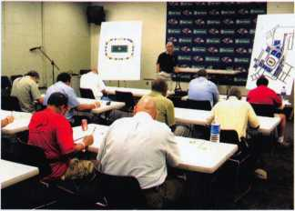

hind the scene tour of the stadium.

On June 5th, the MLA (Maryland Locksmith Association) was proud to sponsor the first local associa­tion sponsored PRP exam in Mary­land since 1992. There were 13 test takers with Bobby DeWeese CML, CPS as proctor. The exam was held at the Ravens Stadium in the News Room. The MLA held their annual Tail-Gate picnic in the parking lot after the exam and had about 60 locksmiths enjoy the food , companionship and a be-

IN PASSING

Stephen Ray Mead, RL, passed away on Thursday, June 14, 2007 after a lengthy illness. Steve was born in Ore­gon City on August 23, 1924. In the late 1960s, he pur­chased the locksmith business of George Christianson and became a locksmith. Steve remained active in his business until his illness in 2005 prevented him from continuing to work. Steve served on the ALOA board of directors representing the Northwest from 1 986 to 1990. He is survived by his three children, eight grand­children and five great-grandchildren. In lieu of flowers, the family asks that donations be made in his name to the Portland Shriner's Hospital.

FORMER ALOA PRESIDENT NAMED TO LICENSING BOARD

Former ALOA President Dallas Brooks was appointed the locksmith representative to the Alabama Electronic Security Board of Licensure (AESBL) on June 14, 2007 by Governor Bob Riley. "I am honored to be representing our industry on the Board," said Brooks, "I have helped Alabama get licensing for over eight years, and I am ex­cited to see it come to reality." Before being elected ALOA President, Dallas was the Chairman of the Legislative Committee and instrumental in having ALOA adopt a pro­licensing position for the locksmith industry.

The AESBL asked the Alabama Locksmith Association (ALA) to recommend three mem­bers to help promulgate rules and regulations. Those serving are Benny Hopper, James Turner and Jeffery Welch. The ALA will be conducting input and informational meetings throughout the state on the following dates and locations:

Tuesday, July 10th, 5:30pm to 6:30pm, Hoover Lock & Key, 3229 Lorna Rd. Birming­ham, AL 35216

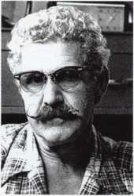

Classes will be held at the following locations: July 12, 2007: Middleton, Wl (Intertek)

July 22, 2007: Charlotte, NC (ALOA Tradeshow) July 31,2007: Los Angeles, CA (Embassy Suites)

Saturday, July 14th, 5:30pm to 6:30pm, Courtyard Marriott, 5555 Carmichael Rd., Montgomery, AL 361 17

Wednesday, July 25th, 5:30pm to 6:30pm, Ramada Inn, 255 Church St., Mobile, AL 36502

Your Visual Guide to ALOA 2007

Education

July 22-29

Over 100 quality ACE classes are offered this year! Plus, don't miss the free evening seminars designed to directly affect your bottom line

**CLASS TRACKS**

**General Locksmithing ir eluding: Key Codes'Code Equipment,**

Duplication, Impressioning; 'Standard and High Security Cylinder Serv-  
icing; Professional Lock Opening Techniques; Lockset Servicing, Funda-  
mental and Advanced Master Keying; Small Format Interchangeable  
Core; Large Format Intercha igeable/Removable Core; Tubular Key Cylinder Servic-  
ing; Investigative Locksmithing; Forensic Locksmithing.

Automotive Locksmithing including: Motorcycle Locks, Basic, Intermediate, Advanced, High Secu-  
rity, Transponders programming/equipment and Keyless Remotes; Auto Theft/Arson Investigations.

Dont miss our Tours on Wedm Old Salem, a living history ti shine" are your speed, then L

t

torsport Mu:

Thursday, July

takes place. Pi

Door Hardware including: Door Closers; Exit Hardware and Exit Alarms; Life Safety Codes; Lock /door  
hardware installation.

Access Control including: Basic Electricity; Keyless Mechanical Locks; Electromechanical Access Control  
Biometrics; CCTV; Systems I itegration and Alarms.

Safe and Vault including Safe Combination Locks; Safe Deposit Locks; Safe Installation; Safe Opening  
and Servicing; Troubleshooting and Dialing Diagnostics, Safe Lock Manipulation, Safe Lock Installation,  
Basic Safe and Lock Construction, Key-Operated Safe Locks and Safe-Related Electronics.

I

Business Owners including: Shop Management, Business Management, Financial Planning, Employee  
Benefits, Identity Theft, Asset Protection; Combating Unethical Business Practices; Marketing and

Branding; Doing Business with Big Business

Food, friends and networking abound at our free Kickoff Party on Thursday, July 26.

Saturday, July 28 make plans to attend the ALOA 51st Anniversary Dinner Ban-  
quet/Speedway Party The evening promises to be an exciting time with a fabulous  
buffet of North Carolina cuisine. Make busines contacts while you try your hand at  
racing in simulators and remote control racing. **J**

Friday's Membership Meeting will giv and offer input on future ALOA progi we have a keynote speaker, Jack Sin Stinks...But Your Locksmith Busines give us food for thought. Speaking < tal Breakfast for attendees!

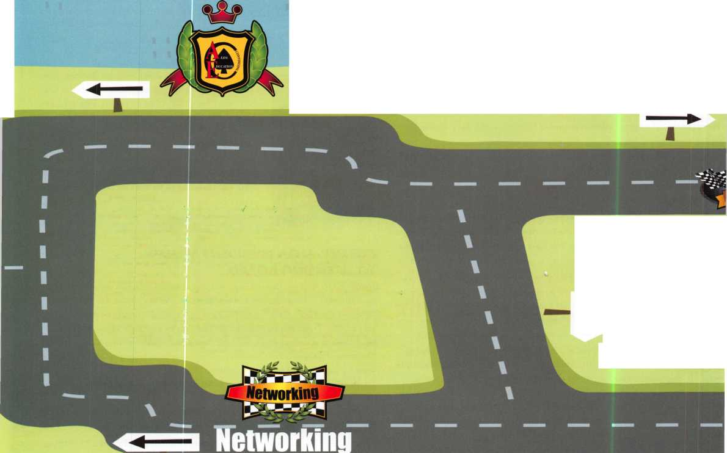

Exhibits

Cruise the aisles of the exhibit hal

faturing over 200 exhibitors offer-  
ing the latest product informatio,  
giveaways, contests and more!

Schedule:

Friday, July 27 12noon-5pm Saturday, July 28 12noon-5pm Sunday, July 29 12noon-4pm

Punch SARGENT blanks

to factory specifications.

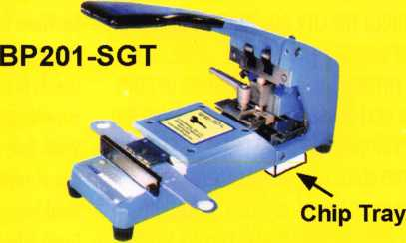

Try them at ALOA Booth 711  
Charlotte, NC • July 27-29

Available Exclusively from:

**Locksmithing, UNL. LLC  
302-575-0993  
[www.sargentpunch.com](http://www.sargentpunch.com)**

Video is Coming to This Years

**|** ALOA Convention & Security Expo

Attend ALOA 2007

[online from anywhere^

in the world!

COMING SOON AT:

aioa2007.tradeshowondemand.comr™

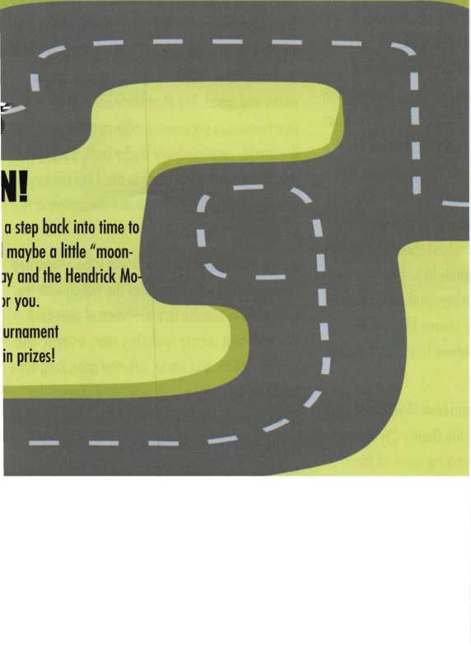

Dining and Culture in Charlotte

CHARLOTTE'S VIBRANT SPIRIT CAN BE SEEN THROUGHOUT THE CITY. BOASTING AN ECLECTIC ARRAY OF DINING AND NIGHTLIFE, CHARLOTTE S UNIQUE ENTERTAINMENT AND FEASTING OPTIONS CREATE A REAL SENSE OF CHARACTER. NAMED ONE OF THE "TOP 50 CITIES THAT SIZZLE" BY RESTAU­RANT NEWS MAGAZINE, CHARLOTTE OFFERS A WIDE ARRAY OF DINING OPTIONS, INCLUDING LOCAL FLAVOR, INTERNATIONAL CUISINE AND UP­SCALE DINING. STEP OUT ON THE TOWN TO ENJOY A RELAXING MEAL OR INTO MUSIC VENUES AND DANCE CLUBS, WINE AND MARTINI BARS, COFFEE­HOUSES AND MORE. CHARLOTTE'S DINING AND NIGHTLIFE SCENE IS EXPLODING WITH OPTIONS.

Charlotte boasts dining experiences paralleled by few other destinations. National hot spots and fa­vorites among many include The Palm, Morton's of Chicago, Capital Grille, Palomino, The Cheesecake Factory, PF Chang's China Bistro and Maggiano's Little Italy. The local scene sizzles with culinary finds nestled along the trolley tracks or a short walk from the Charlotte Convention Center includ­ing Aquavina, serving innovative contemporary seafood, Sonoma California Bistro & Wine Bar, Mert's Heart & Soul, preparing classic southern fa­vorites, Mimosa Grill with an atmosphere of bold timeless elegance featuring global cuisine with a southern twist, Harry & Jean's, specializing in American food, Blue Restaurant & Bar, offering a multi-cultural menu that takes your taste buds on a whirlwind tour of the Mediterranean, and Rock Bottom Brewery, where good friends celebrate great food and great beer.

Center City including Clayworks at McColl Center for Visual Art and Cuvee Wine + Art Gallery pro­viding a contemporary setting for Charlotte profes­sionals to savor different wines and explore incredible art, all while relaxing to jazz. Historic South End, a trolley stop away, couples an assorted mix of restaurants, like McIntosh's and Sullivan's Steakhouse, for fine steaks, seafood and live jazz, Greek Isles offering Greek classics from mousaka to spanakopita to Fuel Pizza and Southend Brew­ery & Smokehouse where locals turn for good food and brew in a relaxed atmosphere, with nightlife in Tutto Mondo, a Metropolitan upscale club featur­ing martinis and champagne, to galleries including ARTBAR and Elder Art. Fine local and regional artists are represented with live music and monthly gallery crawls. The NoDa district, Soho's little sister and Charlotte's historic arts district, located in North Charlotte's historic mill village 2 miles from Center City, is home to a funky collection of gal­leries, performance venues and amazing cuisine. NoDa features an eclectic mix of shops and gallery crawls, full-service restaurants including Boudreaux's Louisiana Kitchen, authentic Cajun cooking, Cabo Fish Taco, a unique blend of fresh cuisine and upbeat atmosphere from Southern Cal­ifornia and Coastal Baja

The Mint Museum of Art and Mint Museum of Craft + Design guide visitors to the Queen City through ever-changing exhibits featuring some of the world's finest collections. The Mint Museum of Art, North Carolina's first art museum, is a rich and di­verse resource featuring a noted collection of American fine and decorative arts. The museum

makes its home in the location that once served as the first branch of the United States Mint, coining $5 million in gold from 1836 to the outbreak of the Civil War. Enhancing the permanent collections is an active schedule of changing exhibitions and educational programs, major national and interna­tional exhibitions and public programs featuring daily tours, seminars, lectures, family day festivals and adult and children's art classes.

The Mint Museum of Craft + Design located in vi­brant Center City Charlotte celebrates artists who fabricate original objects, providing a glimpse into the ever-evolving field of international studio craft and design. Permanent collections include works in ceramics, fiber, furniture, glass, jewelry, metal­works and wood. The Mint Museum of Craft + De­sign features a permanent collection that documents contemporary studio craft, tracing the movement's historical roots in the 19th century and its relationship to traditional decorative arts and industrial design.

Levine Museum of the New South is an interactive history museum that provides the nation with the most comprehensive interpretation of post-Civil War southern society featuring men, women, and children, black and white, rich and poor, long-time residents and newcomers who have shaped the south. The centerpiece of the Levine Museum is the award-winning exhibition, Cotton Fields to Sky­scrapers: Charlotte and the Carolina Piedmont in the New South. Covering 8,000 square feet, the exhibit features Charlotte and its 13 surrounding counties as a case study to illustrate the profound changes in the south since the Civil War.

DEALERS & DISTRIBUTORS

REQUIRED

w \

INKAS

Call Today For Available Territories

**(877) 913-7233**

**[www.inkas](http://www.inkas). ca**

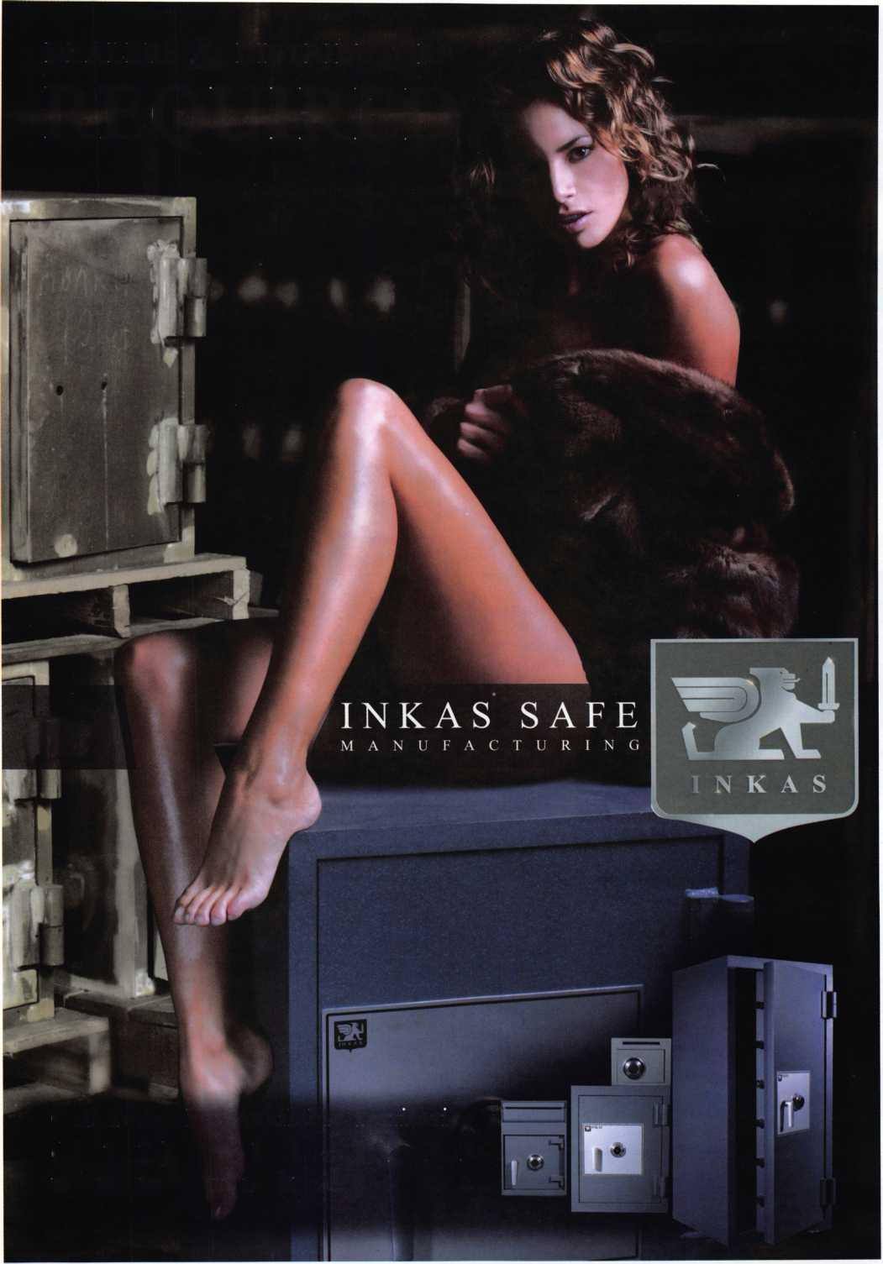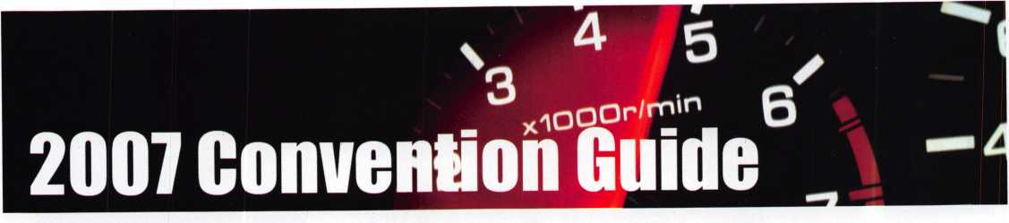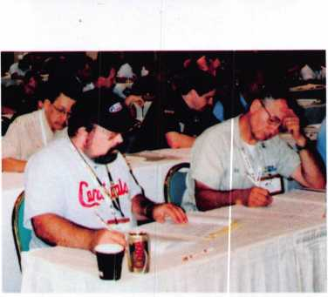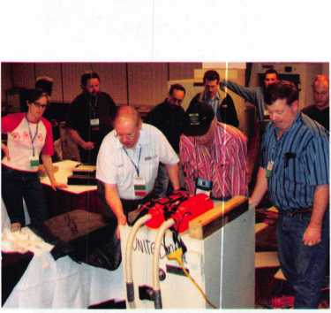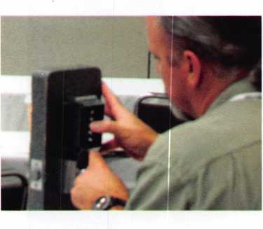

Certification

New Certifications since July 1,2006

New CML's

Kris A. Barney Provo, UT James W. Wiedman Nashville, TN

Rodney E. Thompson Pendleton, OR

Michael McElheney Toledo, OH

John S.Todd Littleton, CO

New CPL's

Gerald R.Hiebert Vero Beach FL

Mark A.McGrananhan Albuquerque NM

Brian C. Senden Winnipeg MB Canada

Eric A. Taylor Liverpool NY

Michael D. Dunkerley Plano TX

Gregory Henry Denver CO

Jesse J. Kippola Walled Lake Ml

Dale Rutherford Winnipeg MB Canada

Charles E. Batcke Midland Ml Jeremy J. Reeder Boise ID

W. Harrell Johnston Auburn WA

New CRL's

Raymond R.Ackerman Ft. Myers FL

Chad M. Anderson Vero Beach FL

Don Barber Marianna FL

Jonathon D. Bean Collinsville IL

Clyde W. Curley Mechamicsville VA

Anthony J. Davis Saint Paul MN

Charles Eastwood Phoenix AZ

Georgia G. McDonald Farmington NM

George E. Walters Rochelle IL

Leonard Solt Gainesville FL

Paul W.Bonkoski Villanova PA

Frank Danko Morgantown WV

Michael Dussia Redford Ml

Clarence Doughty Colorado Springs CO

Pete A. Herreid Fairfax VA

Harold Hively San Bernardino CA

Mark Kaehler Mercer Island WA

Casey J. Long Hollister CA

Gary J. Lorch Dillon CO

Walter I. Moreno Annandale VA

Tim G. McHenry Mesa AZ Paul M. Robert Intervale NH

Carey D. Roberson Artesia NM

Dan Wills Sedona AZ

Scott R.Wood Caro Ml

Steve M. Cobb Scottsville VA

Michael Dussia Redford Ml

Robert Bayron Tampa FL

Robert Butler Knoxville TN

Michael Foster Irving, TX

Joseph F. Hercik Chicago IL

Yakov Weiss Las Vegas NV

Laura Milliorn El Paso TX

James W. Wright Colorado Springs CO

Larry D. Bragg Shelbyville IL

Donald Quagliato Colorado Springs CO

Dana R. Hall Topeka KS

Reynaldo Gonzalez Deltona FL

Richard K. Melton Hiltonhead Island SC

Charles Monson Jacksonville Beach FL

Seth D. Rosner Ocala FL

Michael Lamanna Fontana CA

Bryan Guerin Imlay City Ml

Kenneth R. Ahlheim St Clair MO

Scott Azwell Mahomet IL

Joshua A.Higgins Germantown MD

Stephen Ferguson Tacoma WA

David D. Pettis Chippewa Falls Wl

Walter D. Blank Bremerton WA

Trevor Bridges Toronto ON

David Rider Cambridge ON

Michael J. Tierney Toronto ON

James Feuling Madison Wl

John P. Burgdorf Castle Rock CO

Mark D. Renshaw Canon City CO

James Lang West Chester OH

Amir Rubinshtein Chicago IL

Dan Dyess Dallas TX

Kevin Thompson New Baltimore Ml

Michael Sullivan Lino Lakes MN

Seth Morgan Redwing MN Scott Pantanella Pittsburg PA

Robert Akin Bolingbrook IL

Jennifer J. Dillin Corl Valley IL

Jose Hernandez Berwyn IL

Bryan Caleb Jensen Lincoln NE

James P. Fyn Jr. Fraser Ml David Kamber Waterford Ml

Edward A.Smith Bellesville Ml

Robert A. Bentz Fargo ND

Greg Barta Grand Forks ND

Christopher Chapman Fargo ND

Brent W. Dickman Golden CO

Rocky Steiner Thornton CO

John R.Stoody Ft Collins CO

Ben Parker Dallas TX

Curtis Zabel Kent WA

John Schatz Mount Airy MD

**Top Notch Distributors — Your Wholesale Source for KABA access control hardware**

Top Notch Distributors, Inc,

**East**

**Pennsylvania 1-800-233-4210 Fax: 1-800-854-4146**

**West**

**Nevada**

**1-800-722-4210 Fax: 1-800-248-3620**

**Midwest Missouri 1-800-211-4607 Fax: 1-800-211-4608**

**[www.topnotch.bz](http://www.topnotch.bz)**

**[sales@topnotch.bz](mailto:sales@topnotch.bz)**

Kaba Access ... your key to powerful security solutions

Access control is vital to providing a safe and secure environment.

The basic definition of access control is to restrict access at specific entry points only to authorized people. Kaba Access Control takes access control a step further — offering a wide range of powerful security solutions that work together to give you Complete Control.

Here are just a few reasons why Top Notch Distributors should be your first choice for KABA products:

* Extensive selection of architectural styles and finishes
* Products in stock and ready for immediate shipment
* 99%+ order accuracy rate
* Knowledgeable staff averaging 15+ years of experience

Together, our people, our products and our ability to get the job done exemplify ... We Know Service.

**Visit us in Booth #145 at the ALOA Trade Show.**

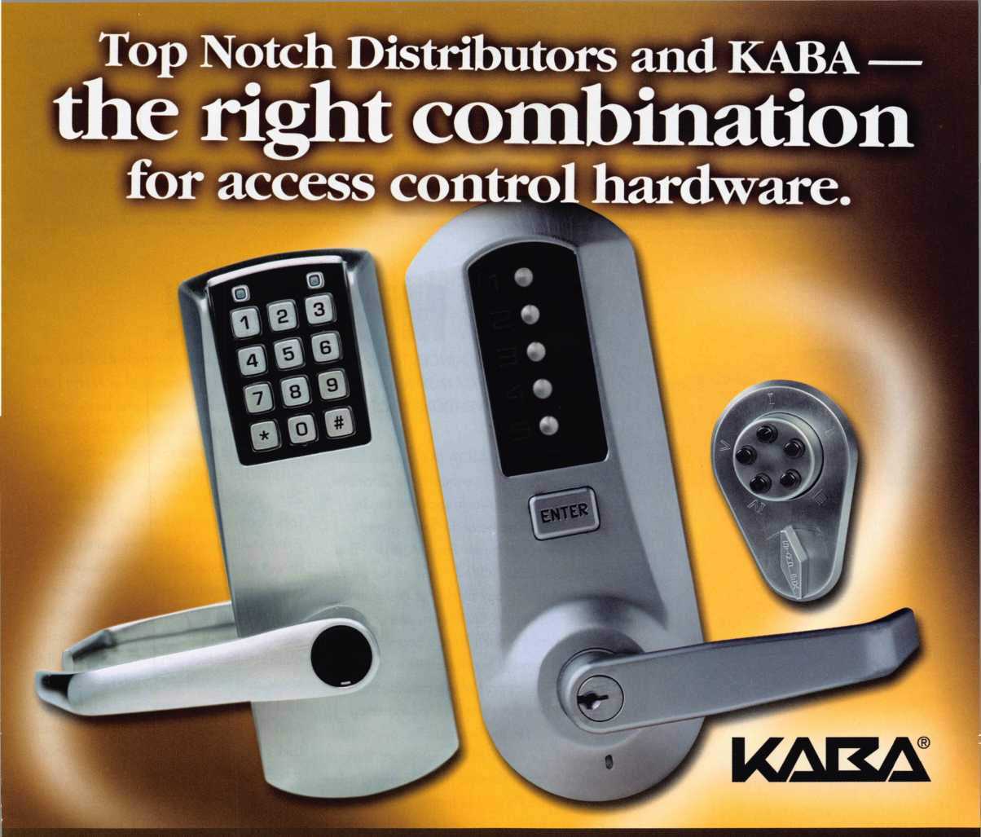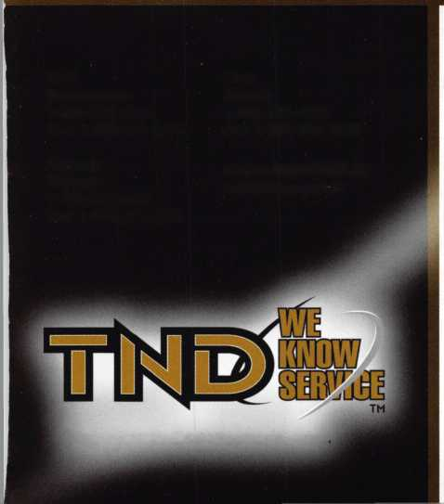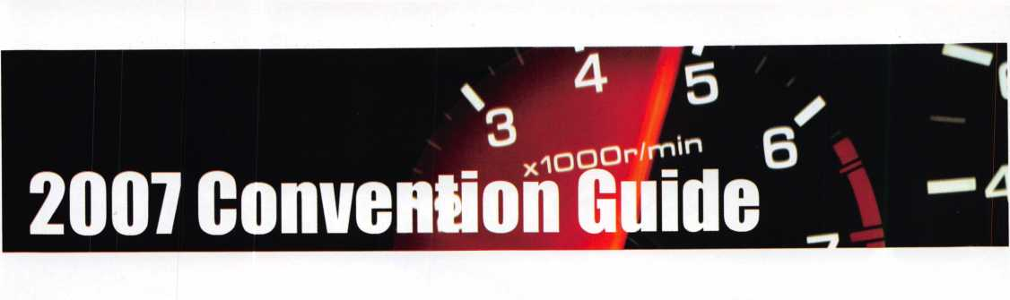

Don’t Miss This!

ALARM LOCK ANNOUNCES THE WIN­NER OF A NEW 2007 MUSTANG AT THE 2007 ALOA CONVENTION! BOOTH #234

During this year's ALOA (Associated Lock­smiths of America) conference in Charlotte, SC, July 27 -29, Alarm Lock will be an­nouncing the name of the lucky grand- prize winner of a new Ford Mustang. This past year, as an added incentive for using dependable Trilogy Electronic Pushbutton Locks, purchasers could earn one chance to win the car for each Trilogy bought and re­deemed through headquarters with proof of purchase as part of our promotional contest. Like the successful, customer-ap­preciation, Harley Davidson® promotions Alarm Lock has held in prior years, this year's "Vroom Contest" Ford Mustang prize is Alarm Lock's way of thanking loyal and growing family of locksmith customers for making the company one of the fastest growing manufacturers in the locking in­dustry and likewise making the increas- ingly-popular Trilogy® the leading electronic pushbutton, PIN/Prox Locks in the business.

This year's presenter will be Alarm Lock's own Bob Swoope, Vice President of Sales, a name synonymous with Alarm Lock, Tril­ogy and 30 years locking expertise with both manufacturers and media companies.

Also At ALOA: Locksmiths can 'Snap-up' daily Alarm Lock ALOA Prizes with the Band - Everybody wins at Alarm Lock -

Every booth visitor can trade their business card to get a FREE trendy blue Alarm Lock rubber wristband. And some lucky few 'show-floor-spotted' wearers can even get Best Buy and iTunes Gift Card prizes awarded at 4pm between July 27th - July 28th and 3pm on July 29th at the Alarm Lock Booth. A reward in and of itself, booth visitors will get one-on-one product demos on our electronic locks, now including cylindrical, mortise and narrow stile for glass door retrofits, and see Alarm Lock's access keypads, power supplies and exit alarms. Attendees can show they're in the know, and know the #1 PIN/Prox Locks in the biz are Trilogys sporting the band.

Also, retail locksmiths can ask about Alarm Lock's free Profit Center Program seminar schedule, where locksmiths can learn how to increase a sales call's profits six fold (6x) (vs. a typical deadbolt installation) and grow their bottom-line dramatically with standalone access control offerings.

Alarm Lock Systems, Inc. has built a strong reputation for over three decades as a re­spected leader in the design and manufac­ture of electronic and mechanical access and egress control products. The popular Trilogy® line of standalone access locks continue to produce favorable results where secured access or egress is a concern. Tril­ogy's keyless access dependably promises time-automated security and a wealth of management information.

Serving security professions s since 1985

**KEY CUTTERS IIIRAL®C<**

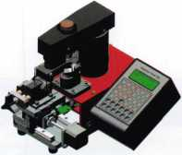

ITL Sidewinder

* Duplicates external cuts.
* Pre-loaded with available high-security codes e.g. -BMW 2-track & 4-track.

- Mercedes 2-track & 4-track.

* One code input.Two sides. Easy.

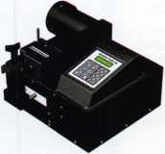

ITL 9000

* The original computerized code machine.
* Ideal for shop use.

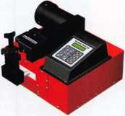

ITL 9700A

* The heavy-duty one.
* Cuts high volumes of keys in succession.
* Auto-rotating Medeco™ head.
* Supplied with carbide cutter.

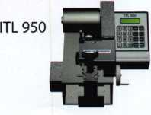

ITL 950 series

* The mobile ones. Perfect for shop and van use.
* Operates on 12VDC and 120 VAC power supply.

TOOLS LIMITED

**Yes, we have our standards!**

The following are common features for our ITL 9000,9700 and 950 series:

Customizable to cut Medeco™ keys. Some machines come with a Medeco™ head and cutter as standard.

99 sets of customizable depths and spaces.

One cutter emulates all flat widths.

RS232 communication port enables connection to laptop or computer.

Compatible with 90% of commercially available code software.

CF function enables corrections to +/- .009 of manufacturer settings

ITL 950C

- Pre-loaded with

major car codes.  
- Ask for a free

demonstration CD.

Contact Us

2639-B Progressive Way Abbotsford, BC Canada V2T 6H8 T: 1 -888-264-6627 F: 1-604-852-8938 e: [info@intralocktools.com](mailto:info@intralocktools.com)

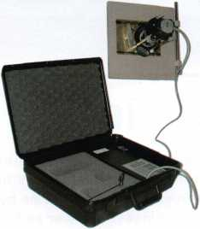

**SAFE TDDLS**

ITL 2000 Safe Dialer

* Easy to set up.
* Little supervision required.
* Dials until it finds the opening combination.
* Selectable dialing options:
* Through a range of numbers
* Through all possible safe combinations.
* No drilling. Safes remain intact.
* Optional extras available:
* Mount plate kit
* Jaw set for larger dials.

**[www.intralDcktaols.com](http://www.intralDcktaols.com)**

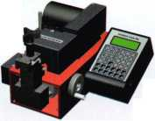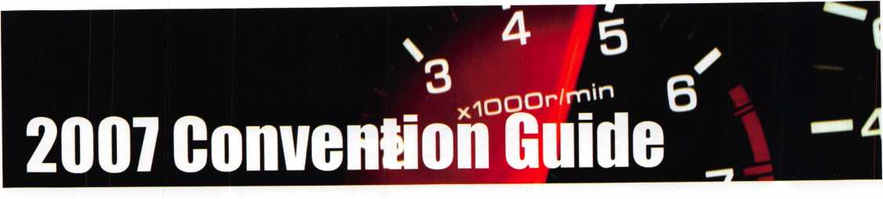

Floorplan

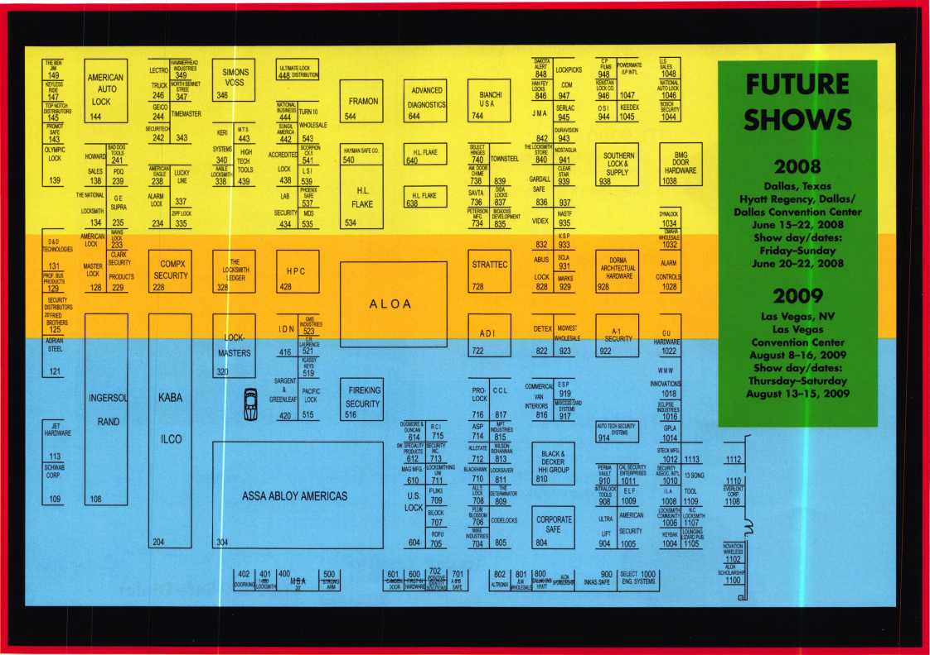

Made for Lockin’

Hs part of our promotion to welcome flLOfl members to Dallas, Texas for RLOR 2008, we are giuing  
away four pairs of Handcrafted Justin Cowbog Boots. Not only will these boots be tailored to  
your specific size, but will carry the RLOR logo on the front! Come by the RLOR Booth to register.

Then, stick around on Sunday to hear the drawings (1 per hour on Sunday during the trade show.)

This drawing is for member attendees only and it is not open to exhibitors.

Sponsored By:

SB SECURITY

MM LOCK DISTRIBUTORS

SUPPLYING INTEGRATED SOLUTIONS

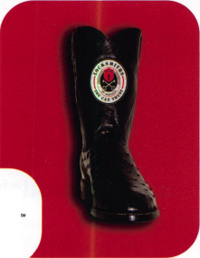

**RING of a KING**

|  |  |  |  |
| --- | --- | --- | --- |
| Member Name Spon | sorships | Ronald E. Heidzig | ,...18 |
|  |  | Joe J. Lee CRL | ...18 |
| Kwok-kei Leung | .223 | Peter R. Hall | ...17 |
| Toshihiro Asano | .119 | Eugene R. Altobella Jr | ...17 |
| Henry W. Raymond | .92 | Joseph P. Ferrero CML | ...16 |
| Yuriko Yanai | .82 | Kenneth E. Kim CRL, CPS | ...16 |
| David M. Troiano | ..69 | John A. Ilk CRL, CPS | ...16 |
| Mary S. Ohmit CPL | .66 | Evelyn V. Wersonick CML, CPS ... | ...15 |
| William Lee CRL | ..66 | John W Soderland CML CMST | 15 |
| Clifford D. Lipscomb CML, CPS .... | ..64 | Michael E. Jordan Jr, CML | ...15 |
| Michael B. Groves | ..58 | John J. Greenan CML, CPS | ...15 |
| Jack Hobin CPL | ..51 | Brian J. Reetz | ...15 |
| William B. Neff CML CPP PSP | ..48 | Richard C. Sievers | ...15 |
| Jim Williams CRL | ..45 | Charles E. Batcke CPL CPS | 15 |
| C Allan Halverson | ..40 | Steve L. Cothron | ...15 |
| Myeong-Rae Cho | ..38 | Leonard J. Passarello CPL | ...14 |
| David M. Lowell CML, CMST | ..37 | Robert E. Mock | ...14 |
| Dana L. Barnum CML | ..35 | Gary F. Teams CPL | ...14 |
| Barry K. Leas CRL | ..35 | Todd K. Ladwig CML, CPS | ...14 |
| Hans Mejlshede CML | ..34 | John D. Cannon CML | ...14 |
| Scott L. Henke CPL, CPS | ..34 | Timothy J. Moore CRL | ...14 |
| Robert D. DeWeese CML, CPS | ..34 | Gregory L. Perry CML, CPS | ...14 |
| Danny W. Rudd CPL | ..33 | Paul M. Souber | ...14 |
| Peter Sarailian CRL | ..33 | James T. Brickler CML | ...14 |
| William L. Young CML, CPS | ..33 | Joseph C. Fuller CML, CMST | ...13 |
| William T. Beranek | ..32 | Robert C. Rodocker CPL | ...13 |
| James L. Hancock CPL | ..32 | Calvin G. Harris CML | ...13 |
| Larry A. Warnick CML | ..31 | Barry L. McMenimon CPL | ...13 |
| Robert W. Duman Sr, CML | ..31 | Basil W. Shannon CPL | ...12 |
| Eugene R. Altobella Sr | ..31 | William J. Wickward CML | ...12 |
| John C. Elliott Jr, CML, CPS | ..30 | Bruce J. Tarbet CML, CPS | ...12 |
| Dallas C. Brooks | ..28 | Gordon R. Racine CML . | 12 |
| Philip A. RovenoltCPL | ..28 | Robert M. Massard CRL,AHC | ...12 |
| Breck H. Camp CML | ..27 | Thomas Demont CML, AHC | ...11 |
| Lawrence F. Smith Jr, CML | ..27 | J Casey Camper CML, CPS | ...11 |
| Marian M. Swann CRL | ..27 | Bruce P. Eagan CML | ...11 |
| James M. Watt CML, CPS | ..27 | Kevin R. Wilson CML, CPS | ...11 |
| John L. Shandy CML | ..26 | Dana L. Lee CML | ...11 |
| Jeffrey S. Nunberg CML, CMST .... | ..26 | Andrew A. Edmunds CML, CPS ... | ...11 |
| J Thomas Hood CML | ..26 | Maurice R. Horne CML | ...11 |
| Elvis D. Hammerschmidt CPL | ..25 | Daniel S. Enriquez CRL | ...11 |
| Anthony J. Ramunno CML, CPS .... | ..24 | Charles E. Haas CML | ...10 |
| Takashi Kuwana CRL | ..24 | Lester S. Brodsky | ...10 |
| Man-Soo Seo RL | ..23 | Ralph O. Warren CML | ...10 |
| Jerome L. Cohen CML | ..22 | Thomas R. Smith CPL | ...10 |
| Peter K. Gauthier CPL, CPS | ..22 | Timothy K. Chow | ...10 |
| John S. Dorsey CML, CPS | ..20 | Richard T. Johnson CPL | ...10 |
| James J. Cawby CML, CPS | ..20 | Raymond C. Lusk CML | ...10 |
| William P. Grant CRL | ..20 | Vincent L. Formon CML, CPS | ...10 |
| Walter W. Lascar Sr., RL | ..19 | Carroll T. Croson Jr | ...10 |
| Thomas G. Vandersteen CML, CPS | ..19 | David M. Howdle | ...10 |
| Ernest W. Wright | ..18 | Jim L. Jeffries CPS | ...10 |
| James E. Gruber CPL | ..18 | Kenny R. Carroll | ...10 |
| William J. McElheney CML | ..18 |  |  |

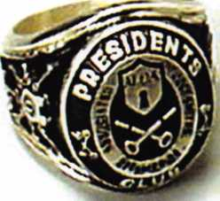

How can I join the President's Club?

You can earn a membership in this prestigious club by recruiting  
just 10 new members for ALOA.

*Any ALOA member may participate.

What do I get?

When you recruit 10 members, you receive a  
handsome blue blazer with a President's Club crest.

For each additional five members you recruit, you receive  
a lapel pin with gold-filled numbers, indicating, your re-  
cruiting successes.

You also get the satisifaction of knowing that you are help-  
ing your association, helping your industry grow, and you  
are helping fellow locksmiths achieve success.

How do I get started?

Mail the form below to the ALOA office for a supply of  
applications (800) 532-ALOA or FAX (214) 819-9736.  
One President's Club credit is awarded for each new ap-  
plicant. Credit is awarded only after the membership ap-  
plication is pproved. However, the credit will apply for  
the period in which the application is received. Failure to  
identify yourself as the sponsor on the application form at  
the time it is submitted to ALOA for processing will forfeit  
any credit.

Yes! I want to join the ALOA President's Club.

; Please rush me applications so I can start earning credit toward membership in the club!

Name

Company

Address

City State Zip

Mail this form to ALOA • 3500 Easy St. • Dallas, Texas 75247-6416

ytfltROW

**ASSA ABLOY**

ARROW

|  |  |
| --- | --- |
| nn n  **meoecc**  HIGH SECURITY LOCH  1 | **1** |
|  | 1 |

Medeco

**ASSA**

**High Security Locks**

ASSA



Lucky Line



STRATTEC

TRUSTED SOURCE. MANY SOLUTIONS.

Strattec, Inc.

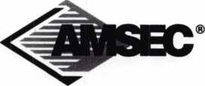

AMSEC

KARA

Kaba llco

ClearStar

**^TOorkV**

Clearstar

#

***Ingersoll Rand***

*Security Technologies*

Ingersoll Rand

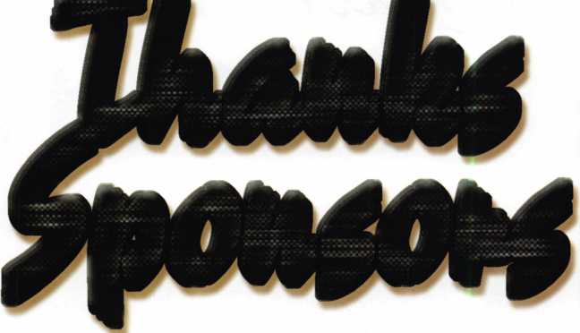

High Security

**ASSAABLOV**

For more information regarding sponsorship  
opportunities for ALOA 2008, contact Kim Hammond at the  
show (via Registration) or call 817-645-6778.

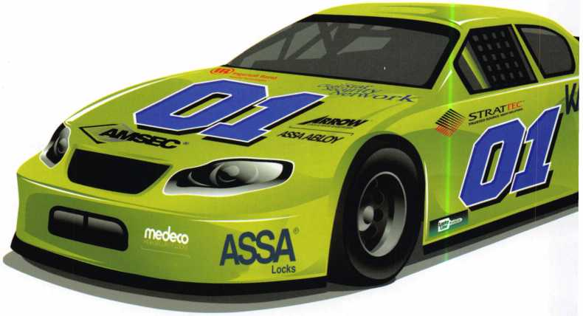

**Sectional Trim**

**Escutcheon Trim**

**ESCUTCHEON TRIM SECTIONAL TRIM**

TM

**Compatible with all brands* including:**

**+ Arrow + PDQ + Schlage**

**+ Best + Marks + Falcon**

**+ Corbin + Sargent + Yale**

**NOTE: Through bolt mortise case applications only**

**Never Make 2 trips to fix one lock...  
Get the job done the first time**

**The REJUVENATOR ' works as an all-in-one fix for your sagging and broken levers. Make your knob locks ADA compliant.**

**Introducing the new  
REJUVENATOR™mortise lock retrofit**

* **Save** BIG On Maintenance
* Maintain Existing Keyway & Cylinders
* Uniform Look Throughout Your Facility

**707 N. Barranca Ave., Bldg.#6 Covina, CA 91723  
[www.townsteel.com](http://www.townsteel.com) T: 877-858-0888 I F: 626-858-3393**

*\*AII brand names and trademarks are the property of their respective owners.*

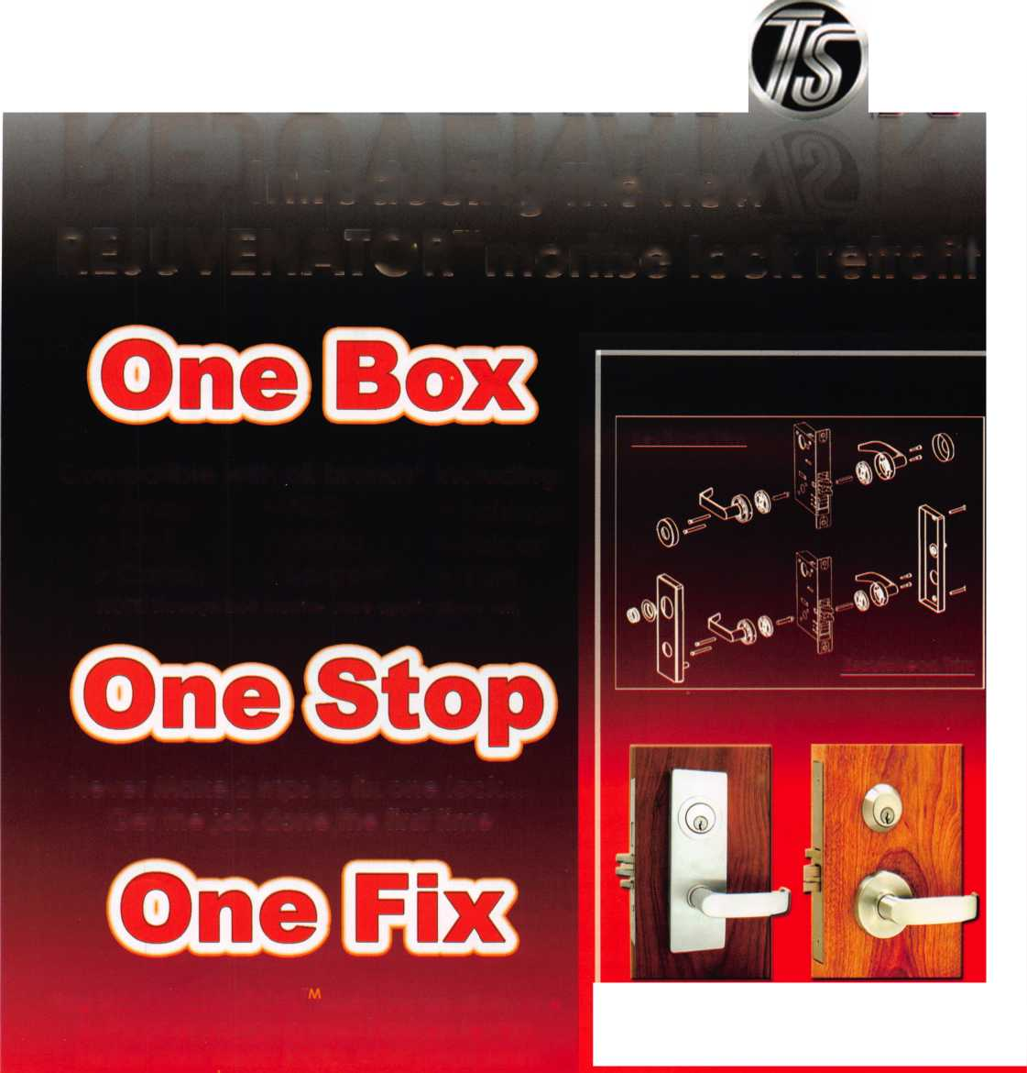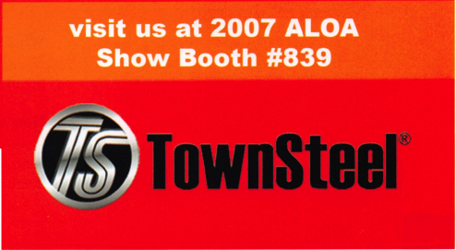

**MEMBER\***

potlight

Welcome to our new monthly feature! Each month we will highlight a current ALOA  
member & their lockshop with a short bio and in-depth questions. To be considered or to  
recommend a fellow ALOA member please send an email to [margarita@aloa.org](mailto:margarita@aloa.org).

4715 Woodlark Ln.  
Charlotte, NC 28211  
704-347-1088

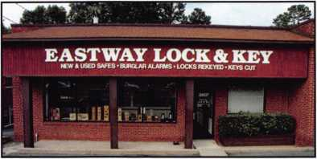

1. Tell us about your background in security and your experience in locksmithing.

Neil: In 1985 I started working with the largest AV and Video Company in the Midwest,

Pratt Audio-Visual and Video. I spent a great deal of time setting up professional audio video rentals and installing Apple computer systems. This gave me some background for access con trol and computer work. In 1995 I moved to a very small town in Texas, called Uvalde, because I was involved in a volunteer bible education work. There I met Don Probasco, a CML who was looking for someone honest to train. He hired me and provided training. I was a member of the Texas Locksmiths Association and attended the conventions and classes every year. Three years later, Eastway Lock and Key, flew me to Charlotte to offer me a position with their company, where I have been since.

1. How long have you been a member of ALOA?

Neil: 2 years

1. How long have you had your business?

Neil: Eastway Lock and Key has been in business since 1976, I’ve been with them since 1998

1. What was your starting point in security?

Neil: I’ve been fascinated with computers and access control since the late 1970’s but the train­ing in Uvalde, Texas with A-1 Lock and Key was what I consider my start.

1. How many employees does your business have?

Neil: Our website at [www.eastwaylock.com](http://www.eastwaylock.com) lists us as having 35 employees which includes our contract sales company, Coastal Contract Hardware in Mytrle Beach, SC, but that number fluctuates depending on turnover and the need.

**PACIFIC LOCK**

**PACIHC LOCK**

***UNLOCK THE POSSIBILITIES***

*What makes PACLOCK different?*

**PAC-SH1ELD**

Hockey-Puck padlock that accepts SFIC’s or KiK cylinders

\ * PACLOCK’s high security

laminated padlocks

jgg * Dual locking ball bearing ■ design

P * Based on a padlock pc-* designed for the US military

Turn any padlock into a shielded padlock

The right way to do high-security, high weather resistance

Patent Pending design

**Stainless Steal ^ Shackles**

**The Trucker Lock”**

No-nonsense padlock built for the trucking industry

Key retained, 2” shackle

Ordered as KD or KA

The world’s first alumi­num solid body padlock to accept standard KiK cylinders

Medical Grade 316 Stainless Steel is STANDARD on all Brass Rekeyable PACLOCK’s

Cost effective solution for a KiK padlock requirement

Why accept anything less or pay any extra?

MILSPEC design

**Your Logo, Your Locks” Customization**

Industry leading laser engraving capability

Fast shipping on small orders

We are the only company to engrave on Hardened Steel bodies

**Metro**

*We listen. We innovate.  
We are the future of padlocks*

***A Family Owned & Operated Small Business***

**Call Your Local Distributor or PACLOCK  
directly at 888-562-5565 or 818-678-6500**

**[www.paclock.com](http://www.paclock.com)**

21618 Manila Street Chats worth, CA 91311

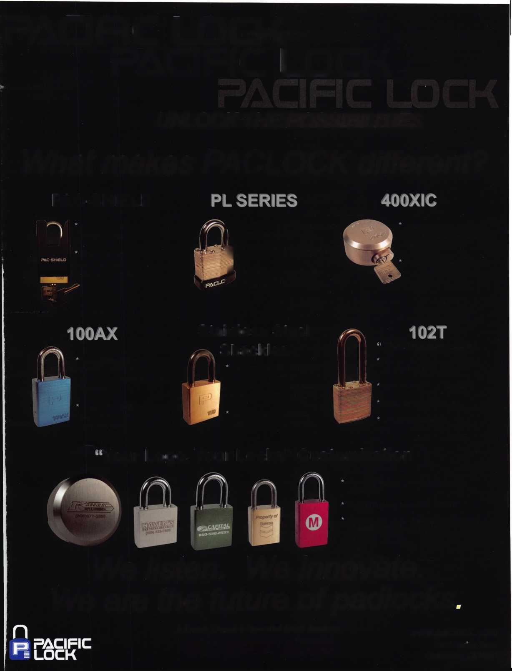

1. What are the changes that you’ve noticed in the security technol­ogy recently?

Neil: One disturbing trend IVe seen is the drop in the quality of some of the products being produced. Quality appears to sometimes be sacrificed for cost. I saw a newer product from one major manu­facturer that even dropping a cylinder will sometimes result in it being unusable.

1. What do you see as the future of security and where do you think are we headed in today’s age of technology?

Neil: For locksmiths and security professionals, I think smaller de­vices and more readily available information will be a boon to provid­ing what the public needs. For the consumer and commercial customers, with more security threats being realized, I think electron­ics and biometrics will take over many traditional mechanical appli­cations.

1. Will you be attending the ALOA 2007 Convention & Expo this year? If so, is this your first time?

Neil: Yes I will attend and this is my first time.

1. How many of your employees will be attending?

Neil: At least 6 of us from the company, but possibly more

1. What are you looking forward to the most at this year’s convention?

Neil: The PRP certification testing. I’ve wanted to have the certifica­tion for a number of years, but other things have gotten in the way.

1. How do you stay informed about new products and security tech­niques? i.e. magazines, classes, etc.

Neil: I am a member of the North Carolina Locksmith Association, along with ALOA which both are excellent sources of information along with a couple trade magazines. I’ve also found that the Internet and consumer security sources often help with perspective.

1. How has life changed for you as a security professional in the past year?

Neil: I ’ve been spending more of my time in managerial responsibili­ties and answering questions on the phone and less time on the road, installing products and dealing with the customers

1. How do you sell security to the public?

Neil: I always preferred the direct approach. For example, If they are interested in putting high security locks on their home, I start by telling them it’s going to be expensive. Then, I explain what they are getting for the money, why they are better and the value in the prod­uct, so they can make an informed decision. Be honest and give them what they want.

1. Explain what your position is at your business.

Neil: I started as the niche automotive expert for the company, which amounted to maybe 10% of our business. I also assisted on some of the access control. In the past 10 years the direction of the company has changed and we are no longer doing automotive. The company has divided the security aspects into an access control division and locksmithing division. Most of our work is commercial so I am pri­marily a mobile technician on the locksmith side, although they sometimes let me dabble with an access control system or an alarm. I also regularly manage the shop and dispatch when needed.

1. What do you like most about your job?

Neil: There are a number of things. One is the opportunity to see buildings and homes or working on vehicles that few other people are

able to see or enjoy. This has included going into secret government offices, helping with opening a safe. Sometimes, seeing the interior of a beautiful home in a gated secluded neighborhood and making keys for a classic 1937 coupe. Technology and techniques are constantly changing. Being a part of that and being able to learn new skills and honing old ones is a joy.

1. What advice can you give to an aspiring security professional?

Nei 1: We need to see more responsible young people looking to the security field. A good way to do this is to find a small town locksmith and work for him. It will give you a great deal of time to focus on some bench work and experience that you won’t get in a city. The pay may not be as good, but the background will help you in any se­curity field you later work with.

1. Can you remember your first big security job? What can you tell us about it?

Neil: I don’t know if it was my first, but it was about 12 years ago. I was working on a 4 level master key for the school system in Uvalde, Texas. It scared me to death. I thought for sure that I would have problems and destroy everything. This helped me to realize the value of not only doing the work, but also, understanding what you are doing and why things work in a system. Before I was finished, I un­derstood how it was all put together. As a result, I now can create the same type of system in my head if I need to.

1. Have you personally run into issues with bump keys which have recently been featured in the news? How do you feel about this issue?

Ned: I ’ve been asked about it and I usually tell the person that we have options for high-security locks that prevent this. I feel it’s like many other issues that have come up; another was picking tubular locks with a plastic Bic pen. It’s media hype made to scare people! How many of us have ever gone to a break-in where it was bumped open. Perhaps, a few, but its unusual. Many of these concepts require practice or a knack, just like picking and impressioning. Or they have easy solutions, like putting a hardened collar on a mortise cylinder to prevent it being wrenched out.

1. Name a few things that you think locksmith business owners should do to help their businesses prosper and grow.

Neil: Be honest and upfront with the customer. If they make an ap­pointment or order a part and you have a problem, tell them the truth about what happened. It’s easier to remember.

1. Do you find that other locksmiths in the Charlotte area work to­gether on referrals and work flow?

Neil: Charlotte’s a very competitive city. A couple of the primary sources of income, banking and racecar driving are competitive en­deavors. So this tends to carry over into other business. I see much less cooperation in the industry here than I did in Texas. However, over the years, I have seen some.

20. What is your favorite place in Charlotte?

Neil: That’s a tough question; there is so much diversity in Charlotte with the influx of people. I love the high-end technology that exists here, like having an Apple Store within a mile of my home. On the other hand, there are many mom and pop stores and restaurants that are unusual and excellent. One of my wife and my favorite stops is a small shack in a gravel parking lot on North Brevard called Brooks Sandwich Shop. Best hotdogs and hamburgers I’ve ever had. There is always a line and everyone from businessmen in Mercedes to truckers are there.

**24**

Keynotes • July/August 2007

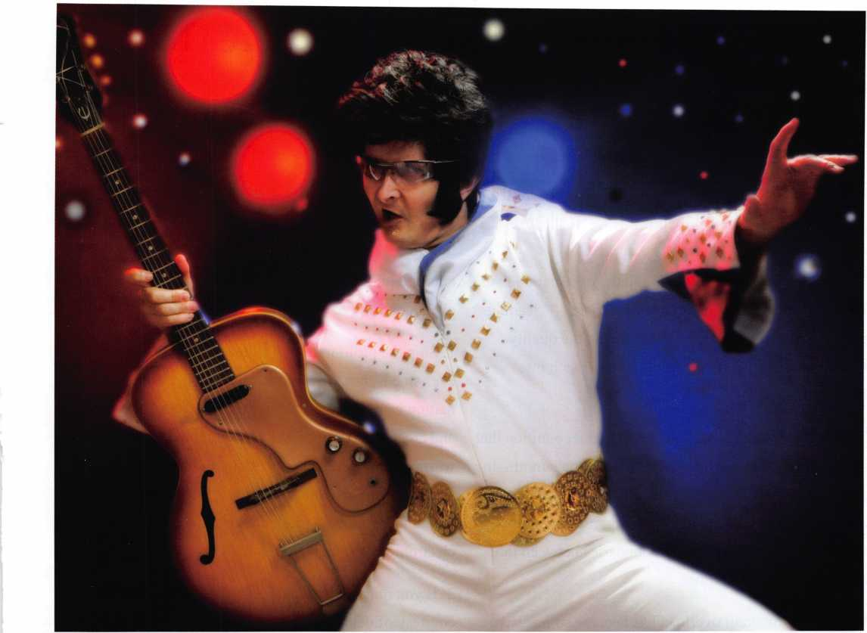

Lots of wannabes. One original.

There’s nothing quite like an original. When you buy Strattec products,  
you’re getting genuine service parts. As an authorized aftermarket supplier  
for Ford, General Motors, and Daimler Chrysler, we adhere to the high quality  
standards demanded by OE manufacturers. Those standards extend to  
the services we provide: extensive technical support, product information

materials, and training. Together, our precision engineered products  
and our support services are your assurance of unsurpassed  
reliability. Looking for the real deal? Count on the pro’s at Strattec.

Keys, locks and pinning kits - perfect fit, stellar performance.

0 **STRATTEC**

TRUSTED SOURCE. MANY SOLUTIONS.

<http://aftermarket.strattec.com>

**ALLIANCE** ^9

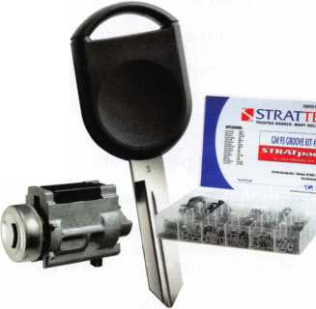

Six Steps to E-mail Efficiency

By Lauren Rikleen

The fantasy persists. We arrive at work, reflexively start our computers, and find an automatic “Out-of-Office Assistant” universally displaying the following message across the country:

“The endless stream of emails - and the expectation that people are constantly available to read them - is leading to incalculable inefficiency and impairing the quality of life. Accordingly, if you would like to reach me, please call.”

The fantasy invariably leads to the urgent recognition that we must gain control over this burgeoning behemoth. In just a few years, email has evolved from a convenient way to communicate into a demanding, incessant tool that has blurred any remaining boundaries between the workday and personal time.

The problem of email overload has become so intrusive that the Washington Post recently wrote about the grow­ing trend of declaring “email bankruptcy” in order to as­sert freedom from responding to old emails. But for the majority of us who cannot truly opt-out of the email world, there is a need to develop some reasoned expecta­tions about the effective and controlled use of email and to create a semblance of order in the unregulated universe where email resides.

It is time to become aggressive about decreasing the tril­lions (yes, trillions) of emails sent annually. With no regulating body, and nothing but our own self-restraint to guide us, perhaps it is time to develop consensus around how we should control - rather than be controlled by -

email. The following are six suggested rules to try to re­claim control over our computer-driven lives:

1. Stop the proliferation of illiteracy. We know how busy everyone is, but there is a reason why grammar and punc­tuation were invented; they make words easier to read, and create order out of written communications. Stop wasting other people’s time trying to discern where one sentence ends and another begins. What worked for e. e. Cummings’s form of prose does not translate into today’s electronic communications.
2. If you must forward nonessential emails, have the courtesy of deleting the endless stream of “Re: Fw:

Fw:” that precede the text. It is a waste of the recipient’s time to endlessly scroll down in search of an actual mes­sage. And the message is generally lost on blackberry users who give up rather than wait for the screen to con­tinually be prompted to search “More.”

1. Do not “Reply All” unless you absolutely, positively must - and even then, check to be sure it is necessary. Very rarely do others need to see your reply to a sender’s inquiry, especially when so many group emails are sim­ply announcements, scheduling inquiries, or a notice of some sort. Other people do not care that you have said “thank you” in response to the sender. Really.

**26**

Keynotes • July/August 2007

**Get What's  
Coming To You**

ALOA continues to provide you with this and other great benefits and services!

'TT- ■

QJL|JL2J

lUlLJuL)

LL)(JL)CiL)

(jDQDGD Q*Pa* -aw

Need information in a hurry?

Use AIMS Fax On Demand service.

Just call 310-575-5074 and receive:

ALOA Index of Documents Becoming a Locksmith (Ipg)

Locksmith Career Summary (3pg)

Locksmith School List (2pg)

ACE Class Schedule (8pg)

Certification lnformation(3pg)

PRP Category List (Ipg)

ALOA Membership Application(2pg)

ALOA List of Benefits (Ipg)

Scholarship Application Form (Ipg)

ALOA Video Library Order Form (1 pg)

ALOA Membership Items Order Form (Ipg) Safe & Vault Technicians Association Member plication/Subscription Form (2pg)

ALOA Chapter Roster (3pg)

Legislative Action Network (2pg)

Legislative Action Network Newsletters (Ipg) Various State Laws (lOpg)

Industry Position Pager (Ipg)

Current Legislative Action Network Newsletters (Ipg)

Board of Directors Nomination Form (2pg) ALOA Convention Registration ALOA Board Expense Reimbursement & Request Form

10.

11.

12.

13.

16.

17.

19.

20.

21.

22.

310-575-5074

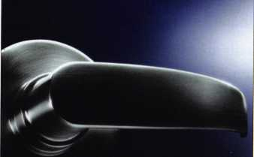

**BEAUTIFUL ON THE OUTSIDE. INTELLIGENT ON THE INSIDE.**

Finally, electronic access control that looks as good as it works. Introducing the 5V-1 Door Lock System from SimonsVoss - the world’s first electronic access control system contained entirely inside the handle.

Backed by more than a decade of German engineering, this completely wireless, network-ready system can be used over 150,000 times without changing batteries. It’s time to experience the beauty of a keyless world.

**Visit us at ALOA  
Booth #346**

[www.simons-voss.us](http://www.simons-voss.us)

414.421.2481

**Simons Voss**

**technologies**

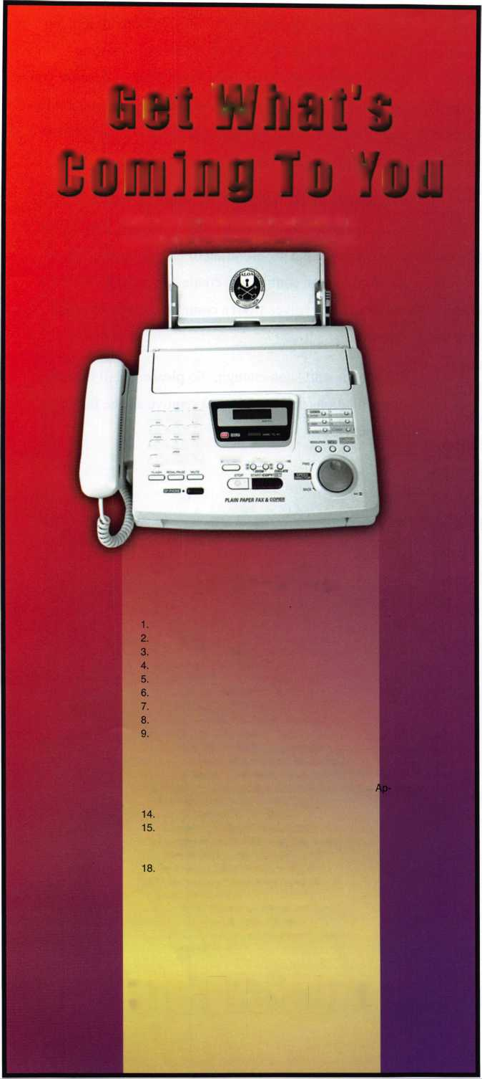

1. Do not use email to lessen your own burden by placing an unnecessary burden on someone else. Too frequently, emails are now used to escape tasks by leaving the fol­low-up burden to others. A prime example are the emails asking someone else to call you. In the old days - that is, two or three years ago - if you wanted to talk to someone on the phone, you would call them. Replacing telephone tag with email tag is inefficient and annoying.
2. Speaking of unnecessary burdens, simplify efforts to schedule calls and meetings among multiple parties. The only thing more inefficient than the old way of schedul­ing meetings and conference calls via telephone, is to use email alone. A sender’s email listing preferred dates is generally followed by a steady stream of “Reply All” re­sponses which invariably are not responsive to each other. Moreover, the burden is then placed on the recipi­ent to continually click back and forth between dates pro­posed in the email and one’s calendar to check for availability. Recipients then often suggest new dates, with no offer to coordinate the numerous options. Even worse, however, is the request for a meeting that begins: “Please send me some available dates.”
3. Stop incorporating email into your family life. You are

not doing your children any favor if you cannot look up from your hand-held device to watch their sporting events. They know your head is not lowered because you are praying, and they also see how unengaged you are in their activities while sitting in the stands. Being present requires your physical and mental presence.

The bottom line is that email should be a tool that serves us, rather than the form of slavery it has become. As we all experience the proliferation of emails overtaking us, we need to gain control and create a more ordered cyber­universe that evolves from a common ground of email etiquette.

We cannot start soon enough. So please, email these rec­ommendations to a friend. Just remove all the forward­ing details.

**28**

Keynotes • July/August 2007

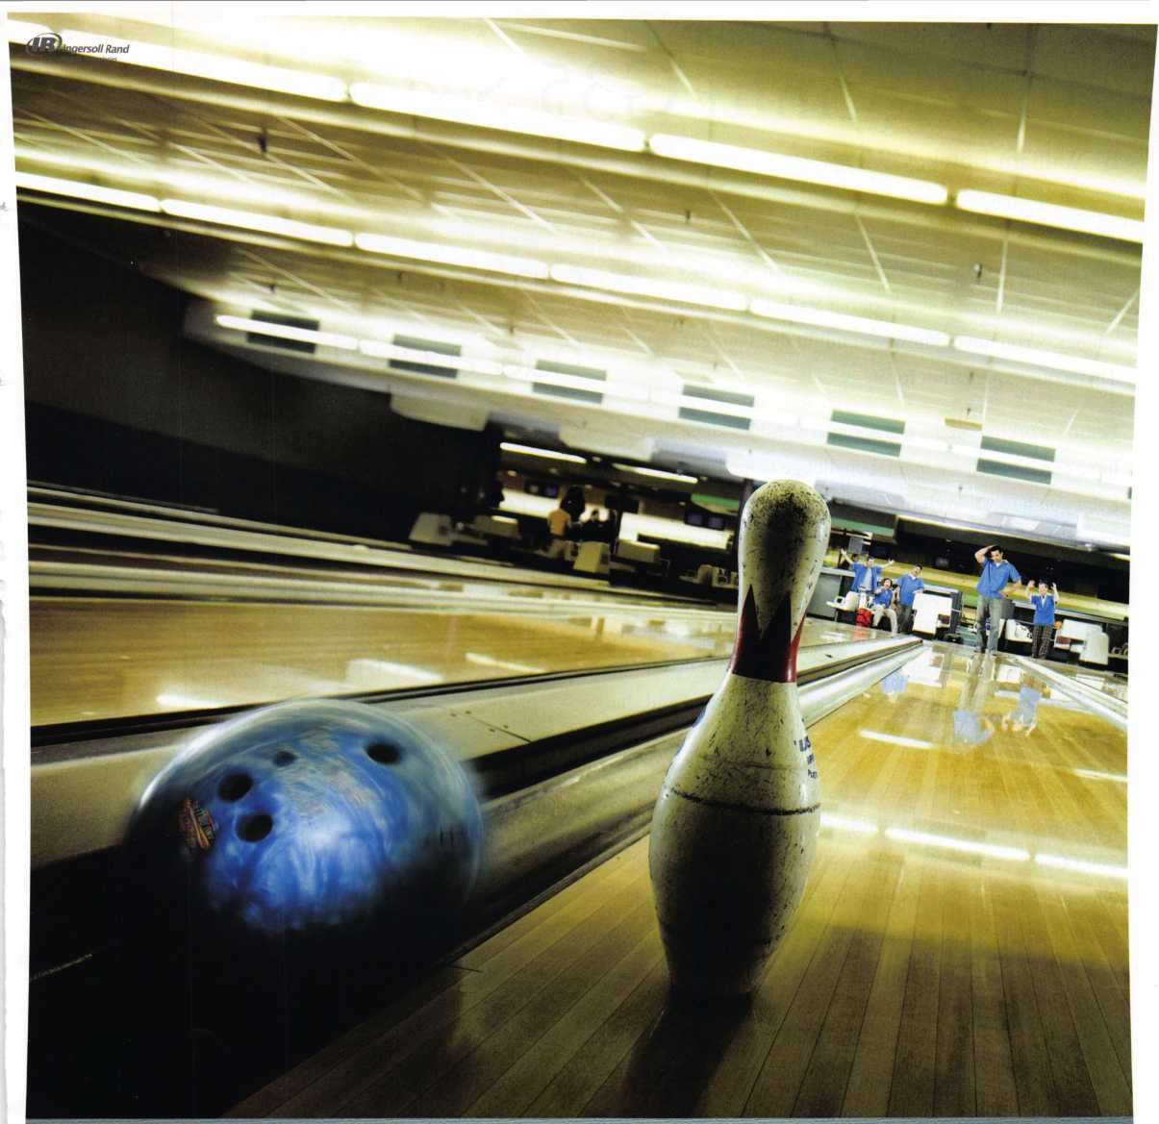

Real Security Is When Do-Overs  
Take Place Only On Your Personal Time.

When you install Schlage® locks, you know you've done the job right. After all, our products are among the most durable and dependable on the market today. They're also easy to install, repair and maintain, so they generate fewer callbacks. Which means you're free to concentrate on other things. Like learning how to pick up the 7-10 split.

Real Security Sets You Free?

[www.schlage.com](http://www.schlage.com)

**2006 Ingersoll-Rand Company Limited**



2003 Infiniti G33 Sedan

By William Botek, CRL

I feel in our trade you can’t have enough reference mate­rial. It has become a staple of our trade to hang onto “things.” You never know you might need it some day! That’s our explanation for it.

I enjoy working on the transponder vehicles since they have come out. It’s a mental challenge sometimes, it will keep you honest! Well on one day in June I had a cus­tomer come in that certainly tested my automotive prowess as well as my sanity.

She had a 2003 Infiniti G35 Sedan. She had a key that the chip came out of and of course lost the chip but had the mechanical. She did have a valet key that worked and she wanted a new master key.

I grabbed my 2006 Autosmart book to determine what key to use. There was no listing for a 2003 sedan. The 2003 Coupe said to use a Hata N104T. I was concerned because it was for the coupe. I checked my OLD T-code book and referenced a Dealer key # H0564-AM600. Of course there is a disclaimer at the bottom of the page that if a dealer key is listed there are no aftermarket keys to use.

Of course as you could imagine now I am beginning to get rather confused. Well I had got in later that day the NEW T-Code book. My first impression of the new book was it was very nicely organized with tabs and dividers. I opened it up and went straight to the Infiniti-Nissan tab.

One day in June, I had a customer come in that certain­ly tested my auto­motive prowess as well as my sanity.

With high hopes in order I was directed to the G-35 sec­tion and found again no listing for a 2003 sedan.

UGH The 2003 coupe referenced a different key now

which was a N104-SCT.

OK now I am getting really confused! I have 3 different reference materials that have 3 different keys listed, and 2 are only for the coupes.

UGH UGH UGH

Next I grab the Ilco 2006 key blank reference book and it shows a N104T key blank with no parameter for a coupe or a sedan. Now I am at four books with four sugges­tions.

**30**

Keynotes • July/August 2007

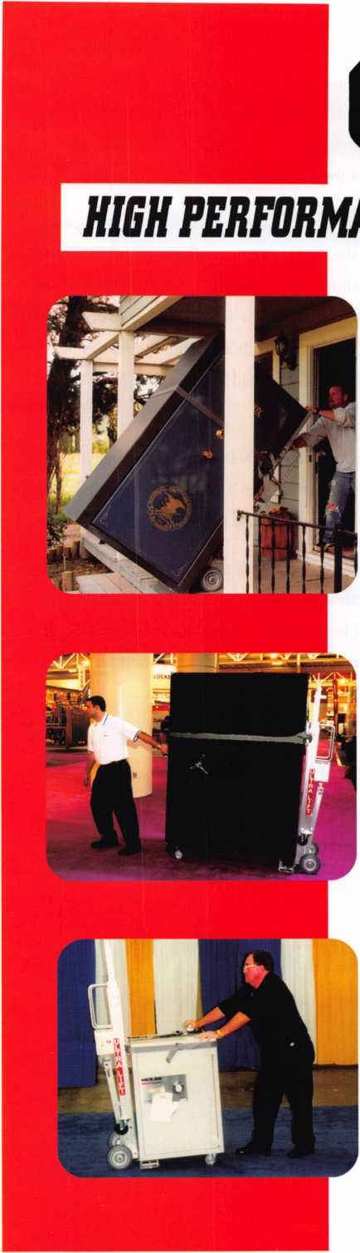

***OPERATOR SAFETY***

Injuries can be virtually eliminated. Ultra Lift does the lift­ing so that operator effort required to complete a move is minimized. Heavy loads are broken back with ease. The operator stays in control by using a combination of motor power, balance and leverage in every phase of a move.

***REDUCE LABOR COSTS***

Fewer people are required for any move with Ultra Lift. Manpower can be scheduled more productively. Labor savings often pay for the Ultra Lift in one month.

***ELIMINATE DAMAGE***

Loads are broken back, set down and moved under power with maximum leverage and operator control. Gentle handling eliminates bumps, bounces and damage to the load and premises.

***INCREASE PROFITS***

Increased operator safety, reduced labor cost and elimina­tion of damage to the load and premises all contribute to significant increases in profits.

FOR LITERATURE, VIDEO OR ON-SITE DEMONSTRATION, WRITE OR CALL:

ULTRA LIFT CORPORATION

475 STOCKTON AVENUE, UNIT E SAN JOSE, CA 95126 800-346-3057 408-287-9400 FAX 408-297-1199 E-mail: [info@ultralift.com](mailto:info@ultralift.com) [www.ultralift.com](http://www.ultralift.com)

U.S. PATENT 4.570.953

ULTRA LIFT supplies the power — so you don't have to. One person can safely and easily handle loads that usually require 2 or 3 people, even up or down stairs. Two people can handle most safes to 1500 pounds. If safety is your concern, ULTRA LIFT is the best move you'll ever make!

I called the customer advised I would like to attempt to make a key and use her car as a guinea pig of sorts.

I advised the customer I needed to do some further re­search and I would call her when I had some concrete in­formation to work with.

I logged into Clearstar and couldn’t find anything rele­vant there. I tried to contact some of the big name people in the industry and got no call backs. So I am back at square one.

I called the customer advised I would like to attempt to make a key and use her car as a guinea pig of sorts. As

one would expect there was a pause! After that she started to laugh and said she was fine with it as long as I could guarantee her old key would still work when I was done. I advised charges if it worked. We made an ap­pointment for a few days later.

She arrived in a few days and said she would be back in about an hour she was going to go shopping. I pulled the vehicle in our shop and proceeded to hook up the T-Code. My first project was to get the BCM number to convert to the pin code. I found the module behind the fuse panel. Recovered the number and had it converted. Now the fun begins!

I decided to use the Ilco N104T key. I set the machine up with the level 4 system as that’s what both T-Code books show. The key programmed up perfectly. HOORAY!!

My primary reason for writing this editorial is to empha­size that you can’t have enough reference material in your arsenal of information. If you can even buy a book from another machine just to have some additional infor­mation. **<=&**

**32**

Keynotes • July/August 2007

i

s

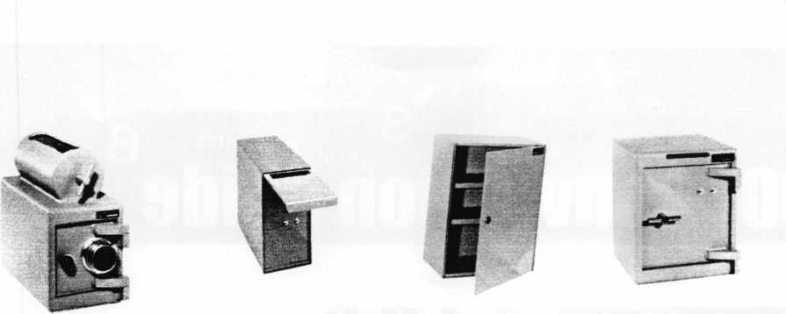

A & B Safe Corporation

Manufacturers of Quality Depository Safes & Chests

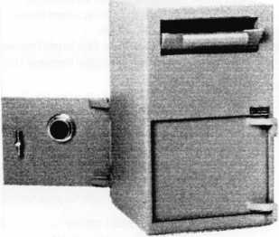

800-253-1267 Fax 856

[info@a-bsafecorp.com](mailto:info@a-bsafecorp.com)

[www.a-bsafecorp.com](http://www.a-bsafecorp.com)

114 South Delsea Dr. Suite 3 Glassboro, NJ 08028

-863-1208

4

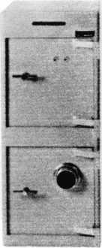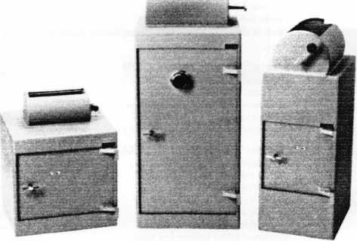

Over Seventy-Five Models In Stock

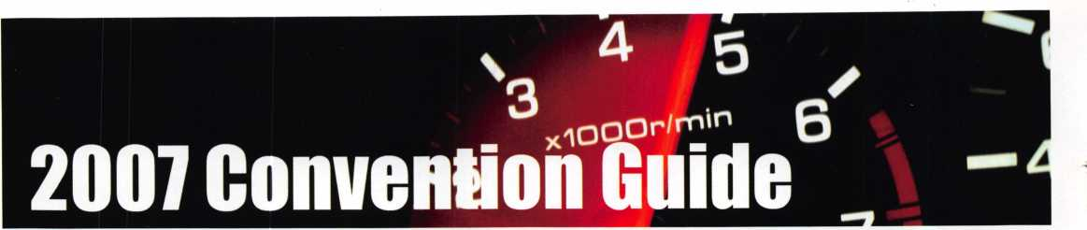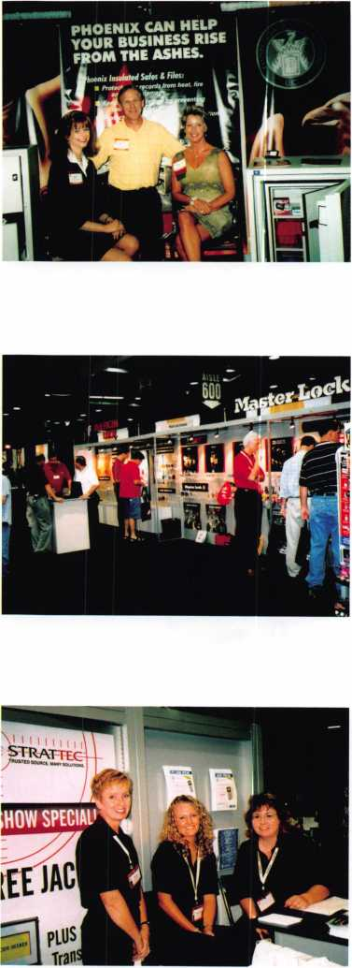

Exhibitors

(** Associate Members)

1 -800-LOCKSMITH #401

73 Greentree Drive #16, Dover, DE 19904 • 866-517-5566; 800-516-0637 fax [www.one800locksmith.com](http://www.one800locksmith.com); [one800lock@aol.com](mailto:one800lock@aol.com) Contact(s): Jake, Pat, Joe, Gerard, Joanne

Nationwide Locksmith Company looking for Locksmiths and Locksmith Shops to provide Services throughout the United States

1st in Hardware #600

2901 Whittington Ave, Suites F&G;

Baltimore, MD 21230 410-646-9900; 866-646-0045 fax

[www.lstinhardware.com](http://www.lstinhardware.com); e-mail: [info@lstinhardware.com](mailto:info@lstinhardware.com) **(ontact(s): Ed Ko- renge, John Edwards**

Distributor-Alarms; Builders Hardware; BusinessAechnical & Educational- Electric/Electronic Security; Lock Devices; Tools & Supplies; Storefront Door Hardware

A-l Security/Lockcraft #922

3001 West Moore St. • Richmond, VA 23230 804-359-9003; 804-359-9415 fax [www.demandal.com](http://www.demandal.com); e-mail: [service@demandal.com](mailto:service@demandal.com) Contact(s): Frank McCarthy Manufacturer— Tools & Supplies

**\*\*A&B Safe Manufacturing Corporation #701**

**114 S. Delsea Dr. Suite 3 • Glassboro, NJ 08028 856-863-1186; 856-863-1208 fax [www.a-bsafecorp.com](http://www.a-bsafecorp.com); e-mail: [info@a-bsafecorp.com](mailto:info@a-bsafecorp.com) Contact(s): Edward C. Dornisch, Sweetie A. Dornisch** Manufacturer-Bank Security Equipment; Safes/Vaults

ADI, Inc #722

263 Old Country Rd • Melville, NY 11726 631-692-1568; 631-692-3693 fax [www.adilink.com](http://www.adilink.com);

e-mail: [james_letkovsky@adi-dist.com](mailto:james_letkovsky@adi-dist.com) Contact(s): James Letkovsky

Distributor-Alarms; CCTV/Photo imaging; Electric/Electronic Security; Lock Devices

Aable Locksmiths #338

47 Marlboro Drive, Milford, CT 06460 203-882-0600; 203-882-0600 fax [www.aablelocksmiths.com](http://www.aablelocksmiths.com); e-mail: [frankaable@aol.com](mailto:frankaable@aol.com) Contact(s): Frank & Elizabeth

Manufacturer, Wholesaler-Automotive; Builders Hardware; Tools & Supplies

Abloy Door Security # 304

An ASSA Abloy Group Company 9630 Trans Canada • Montreal, Quebec,

Canada H4S1V9

800-465-5761; 800-730-3570 fax [www.abloy.ca](http://www.abloy.ca); e-mail: [info@abloy.ca](mailto:info@abloy.ca) Contact(s): Martin Day

Manufacturer-Builders Hardware; Lock Devices

As of June 15,2007

**\*\*ABUS Lock Company #828**

**23910 N. 19th Ave. Ste. 56, Phoenix, AZ 85085 800-352-2287; 623-516-9934 fax [www.abus.com](http://www.abus.com); e-mail: [glaitala@abuslock.com](mailto:glaitala@abuslock.com) Contact(s): Brandon Esquer, Zac Twight, Grant Laitala, Dan Laitala** Manufacturer—Lock Devices

**\*\*Accredited Lock Supply #438**

**1161 Paterson Plank Road Secaucus, NJ 07094 201-865-5015; 201-865-5031 fax [www.acclock.com](http://www.acclock.com); email: [mail@acclock.com](mailto:mail@acclock.com) Contact(s): Charles Weaver, Georgette Fitzpatrick,**

**Ron Weaver, Joel Blum**

*Distributor-Alarms; Bank Security Equipment; Automotive; Builders Hard­ware; BusinessAechnical Educational; CCTV/Photo Imaging; Electric/Elec­tronic Security;*

*Lock Devices; Tools & Supplies; Safes/Vaults*

**\*\*Adams Rite Manufacturing #304**

**An ASSA Abloy Group Company 260 Sonta Fe Street • Pomona, CA 91767 909-632-2300; 909-632-2373 fax [www.adamsrite.com](http://www.adamsrite.com)**

*Manufacturer—Electric/Electronic Security; Lock Devices*

**\*\*Adrian Steel Company #121**

**906 James Street • Adrian, Ml 49221 517-265-6194; 517-265-5834 fax Contact(s): Todd Goldmeyer** Manufacturer— Tools & Supplies

**“Advanced Diagnostics**

**USA, Inc #644**

**180-C South Spruce Ave., So.**

**San Francisco, CA 94080 650-876-2020; 650-876-2022 fax [www.tradeusa.com](http://www.tradeusa.com); email: [sales@adusa.us](mailto:sales@adusa.us)**

**Contact(s): John Steiner, Brook Francisco, John Steiner, Greg Chambers, Mike Hyde**

*Manufacturer-Automotive Equipment*

**\*\*Alarm Controls Corp #1028**

**19 Brandywine Drive, P.0. Box 280,**

**Deer Park, NY 11729 800-645-5538; 631-586-6500 fax [www.alarmcontrols.com](http://www.alarmcontrols.com); [info@alarmcontrols.com](mailto:info@alarmcontrols.com) Contact(s): Howard Berger, John Benedetto** Manufacturer-Alarms; Electric/Electronic Security

Alarm Lock Systems, Inc #234

345 Bayview Ave. • Amityville, NY 11701 631-789-4871; 631-789-3383 fax

[www.alarmlock.com](http://www.alarmlock.com); e-mail: [salesinfo@alarmlock.com](mailto:salesinfo@alarmlock.com) Contact(s): David Saltzman

Manufacturer—Alarms; Lock Devices

**“All 5 Lock #708**

**70 Enterprise Drive Bristol, CT 06010 860-583-1691; 860-583-4516 fax Contact: Joseph Nemec** Manufacturer- Lock Devices

*Styles &{ Colors for t verif Lifestyle*

* Recognized & Accepted by the TSA
* Security Window cannot be altered with a paper clip
* Security Window can only be reset by a person knowing the combination
* Zinc Die Cast Body (Not Brittle Plastic)
* Steel Shackle is virtually unbreakable

Security Window

O

**Red Window:**

Luggage has been searched.

O

**Green Window:**Lock Not Opened.

Protected by U.S. Patents 6,877,345 and 7,007,521. The Design of the Lock is a Registered Trademark® of The Eastern Company.



Itm



**Security Products** A Division of The Eastern Company **A Proud Union Company. (S.E.I.U.)** 301 West Hintz Road | Wheeling, IL 60090 | Telephone: 800.733.8588 | Fax: 847.537.1881 **[www.cclsecurity.com](http://www.cclsecurity.com)**



**TRAUEL SENTRY**

**APPROVED**

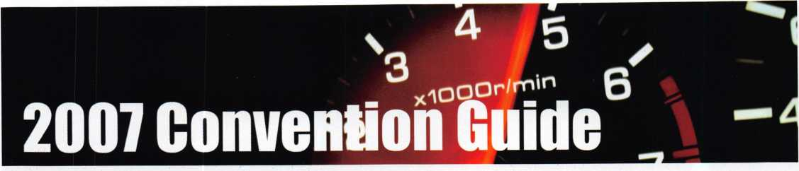

Exhibitors

**\*\*Allstate Insurance Company .#712**

**51 W. Higgins Road, R1A, South Barrington, IL 60010 847-557-2181; 847-551-2732 fax [www.allstate.com](http://www.allstate.com); e-mail: [anitabishop@allstate.com](mailto:anitabishop@allstate.com) Contact: Anita Bishop** Insurance

Altronix #802

140 58th St., Brooklyn, NY 11220 718-567-8181; 718-567-9056 fax [www.altronix.com](http://www.altronix.com); e-mail: [fowen@altronix.com](mailto:fowen@altronix.com) Contact(s): Frank Owen, Bob Yonce Manufacturer-Alarms; CCTV/Photo Imaging; Electric/Electronic Security

**\*\*AmericanAutoLock.Com #144**

**1039 North Christian Street, Lancaster, PA 17602 800-860-5625; 717-581-8353 fax [www.americanautolock.com](http://www.americanautolock.com); e-mail: [bill@lock.com](mailto:bill@lock.com) Contact(s): Bill Neff**

*Manufacturer, Distributor, Wholesaler-Automotive; Lock Devices; Tools & Supplies; Transponder Chip Technology- Computer Software*

American Door Chime #738

P.0. Box 50889, Nashville, TN 37205 800-342-9014; 615-662-9672 fax Contact(s): Ronald Cassamer

American Eagle Lock Co #238

144 Newport Rd • Leola, PA 17540 717-656-0174; 717-656-0818 fax [www.americaneaglelockco.com](http://www.americaneaglelockco.com)

Contact: Michael O'Connor-717-940-3819 cell

Manufacturer—Builders Hardware

American Lock Company #128

137 W. Forest Hill Ave; Oak Creek, Wl 53154 708-534-2000 or 800-323-4568; 708-534-0531 fax [www.americanlock.com](http://www.americanlock.com); e-mail: [contactus@americaniock.net](mailto:contactus@americaniock.net) Contact(s): Dave Kraninger Manufacturer-Lock Devices

**\*\*American Security Products #1005**

**11925 Pacific Ave. • Fontana, CA 92337 951-685-9680; 951-685-9685 fax [www.amsecusa.com](http://www.amsecusa.com); e-mail: [smalally@amsecusa.com](mailto:smalally@amsecusa.com) Contact(s): Bob Sallee, Tim Reeves, Pat Baker** Manufacturer—Bank Security Equipment; Electric/Elec­tronic Security; Lock Devices; Tools & Supplies; Safes/Vaults

Arrow Lock Mfg. Co. Inc #304

An ASSA Abloy Group Company

100 Arrow Lock Drive. • New Haven, CT 06511

800-839-3157; 800-421-6615 fax

[www.arrowlock.com](http://www.arrowlock.com); [info@arrowlock.com](mailto:info@arrowlock.com)

Manufacturer—Alarms; Builders Hardware; Lock Devices

ASSA, Inc #304

An ASSA Abloy Group Company 110 Sargent Drive, New Haven, CT 06511 800-235-7482; 800-892-3256 fax [www.assalock.com](http://www.assalock.com) Manufacturer-Lock Devices

ASSA Abloy Americas #304

110 Sargent Drive, New Haven, CT 06511 203-624-5255; 203-499-6840 fax [www.assaabloy.com](http://www.assaabloy.com)

Manufacturer-Builders Hardware; Electric/Electronic Secu­rity; Lock Devices

ASSA Abloy is the global leader in door opening solutions dedicated to satisfying end-user needs for security, safety and convenience.

Associated Locksmiths of America, Inc. (AL0A)

3500 Easy Street. • Dallas, Texas 75247 1-800-532-2562; 214-819-9736 fax [www.aloa.org](http://www.aloa.org); [aloa@aloa.org](mailto:aloa@aloa.org) International Locksmiths Trade Association Robert Mock, President

ALOA Legislative—Up-to-the-minute news and informa­tion on legislation affecting your business Key Personnel: Tim McMullen, Government Affairs,

ALOA Scholarship Foundation—Provides funding for promising locksmiths

Key Personnel: Gordon Racine, Larry Barnes

Auto Security Products #714

P 0 Box 10 • Redmond, WA 98073 425-556-1900; 425-558-1205 fax [www.carlocks.com](http://www.carlocks.com); e-mail: [info@carlocks.com](mailto:info@carlocks.com) Contact(s): Steve Shain, Brad Kenning Manufacturer—Automotive; Tools & Supplies

Auto Tech Security Systems #914

3732 Grissom Lane Kissimmee, FL 34741 407-870-8816; 413-832-2770 fax Contact:Brent Johnson

Bad Dog Tools #241

P.0. Box 851 Bristol, Rl 02809 401-253-1330; 401-253-1377 fax

[www.baddogtools.com](http://www.baddogtools.com); [ann@baddogtools.com](mailto:ann@baddogtools.com)  
Contact: Keith Stevens  
Manufacturer-Tools & Supplies

**\*\*Bianchi USA, Inc #744**

**31336 Industrial Parkway, Suite 3.,**

**North Olmsted, OH 44070  
800-891-2118; 216-803-0202 fax  
[www.bianchil770usa.com](http://www.bianchil770usa.com);  
e-mail: [info@bianchil770usa.com](mailto:info@bianchil770usa.com)  
Contad(s): Joy Skowron**

*Manufacturer-Tools & Supplies; Key Machines, Cloning  
tools, Transponder keys*

BiLock/Login Lock #707

53 Railroad Ave, Southington, CT 06489  
860-378-0302; 860-378-0340 fax  
[www.bilock.com](http://www.bilock.com); e-mail: [tom@loginlock.com](mailto:tom@loginlock.com)  
Contact(s): Tom Divito  
Manufacturer—Lock Devices

Black & Decker HHI Group #810

19701 Da Vinci, Lake Forest, CA 92610 949-672-4508; 949-672-4825 fax Contact: Anna Van Patten

Blackhawk Products #710

25913 County Road T.5 • Dolores, CO 81323 970-882-7191; 970-882-7228 fax [www.blackhawk7.com](http://www.blackhawk7.com); e-mail: [staff@blackhawk7.com](mailto:staff@blackhawk7.com) Contact: Roger Weitzenkamp Manufacturer—Computer software

BMG Door Hardware, Inc #1038

187 W. Orangethorpe Ave St. E, Placentia, CA 92870 714-572-0098; 714-572-0978 fax • [samc@bmgo.com](mailto:samc@bmgo.com) Contact: Sam Chun

Bosch Security Systems #1044

130 Perinton Parkway, Fairport, NY 14450 717-735-6535 • Contact: Nanci Jo Anderson

CAL Royal Products, Inc #937

6605 Flotilla St. City of Commerce, CA 90040 323-888-6601; 323-888-8017 fax Contact: David Yasher

CAL Security Enterprises, Inc #1011

16380 NW 84th Avenue, Miami Lakes, FL 33016 305-827-9384; 305-827-9387 fax e-mail: [drubiol227@aol.com](mailto:drubiol227@aol.com) Contad(s) Michael Hernandez, Doris Rubio Manufacturer-Lock Devices; High Security Lock for Sliding Glass Doors & Windows

Camden Door Controls #601

5151 Everest Drive Unit #6 Mississauga, Ontario L4W-2Z3 Canada 1-877-226-3369; 905-366-3378 fax [www.camdencontrols.com](http://www.camdencontrols.com); e-mail: [info@camdencontrols.com](mailto:info@camdencontrols.com) Contad(s): Heidi Goldberg

Manufacturer—Electric/ Electronic Security; Lock Devices; Handicap Activation Devices

**\*\*CCL Security Products #817**

**301 W. Hintz Road • Wheeling, IL 60090 800-733-8588; 847-537-1881 fax [www.cclsecurity.com](http://www.cclsecurity.com); e-mail: [wwalsh@cclsecurity.com](mailto:wwalsh@cclsecurity.com) Contad(s): Bill Walsh**

*Manufacturer—Builders Hardware; Lock Devices; Combi­nation Padlocks and Cabinet Locks*

**\*\*Clark Security Products #229**

**4775 Viewridge Avenue, San Diego, CA 92123**

1. **974-6740; 858-974-6740 fax [www.clarksecurity.com](http://www.clarksecurity.com); e-mail: [ron.cooling@clarksecurity.com](mailto:ron.cooling@clarksecurity.com) Contad: Ron Cooling**

*Distributor—Automotive; Builders Hardware; CCTV/Photo Imaging; Electric/Electronic Security; Lock Devices; Tools & Supplies; Safes/Vaults*

Clear Star Security Network #939

1140 University Ave. Berkeley, CA 94702 510-841-4807; 510-841-7915 fax [www.clearstar.com](http://www.clearstar.com); e-mail: [security@clearstar.com](mailto:security@clearstar.com) Contad(s): Jay Long

Restricted-Access Website for Locksmiths & Safe Techs

CODELOCKS, LLC #805

2930 B College Ave., Costa Mesa, CA 92626 714-979-2900; 714-979-2902 fax Contad: R. Foster

Commercial Van Interiors .#816

8840 St. Charles Rock Road St. Louis, M0 63114 800-759-7477; 314-427-1525 fax [www.commercialvan.com](http://www.commercialvan.com) Contad: Mark Stegen Distributor— Vehicle Upfitter

**\*\*C0MPX Security Products #228**

**P.O. Box 200, Mauldin, SC 29662 864-297-6655; 864-297-9987 fax [www.compx.com](http://www.compx.com); e-mail: [lgalvao@compx.com](mailto:lgalvao@compx.com) Contad(s): Lou Galvao; Mike Kavulic** Manufacturer—Bank Security Equipment; Electric/Elec­tronic Security; Lock Devices; Tools & Supplies

Corbin Russwin #304

An ASSA Abloy Group Company 225 Episcopal Road, Berlin, CT 06037 800-543-3658; 800-447-6714 fax [www.corbin-russwin.com](http://www.corbin-russwin.com) • Contad: Lee Garver Manufacturer—Builders Hardware; Electric/Electronic Se­curity; Lock Devices

Corporate Safe Specialists #804

14825 S. McKinley Ave.* Posen, IL 60469 800-342-3033; 708-371-3326 fax [www.corporatesafe.com](http://www.corporatesafe.com) • Contad(s): Mandy Ruiz Safes/Vaults-Locks and Keypads for Safes

CP Films, Inc .#948

P.O. Box 5068, Martinsville, VA 24115 800-255-8627; 276-627-3032 fax [www.llumar.com](http://www.llumar.com); e-mail: [cpfilms@cpfilms.com](mailto:cpfilms@cpfilms.com) Contad(s): Randy Garcia, Keister Richardson Manufacturer-Window Film

C.R. Laurence Co., Inc #521

2503 E. Vernon Ave., Los Angeles, CA 90058 800-421-6144; 800-262-3299 fax [www.crlaurence.com](http://www.crlaurence.com); e-mail: [crl@crlaurence.com](mailto:crl@crlaurence.com) Contad(s): Paul Daniels, Bili Gyore Manufacturer, Distributor-Builders Hardware; Lock De­vices; Transaction and Commercial Hardware

**\*\*D&D Technologies #131**

**7731 Woodwind Dr. Huntington Beach, CA 92647 800-716-0888; 714-677-1299 fax [www.ddtechglobal.com](http://www.ddtechglobal.com); e-mail: [info@ddtechusa.com](mailto:info@ddtechusa.com) Contad(s): Brian Sweet, Jim Paterson, Rod Kraft, Steve Pleasants, Rich Woodbeck, Gary Lisko** Manufacturer-Lock Devices, Gate Hardware

Dakota Alert, Inc #848

109 W. Main St., P.O. Box 130, Elk Point, SD 57025 605-356-2772; 605-356-2584 fax [www.dakotaaleri.com](http://www.dakotaaleri.com); • e-mail: [sales@dakotaalert.com](mailto:sales@dakotaalert.com) Contact: Jason Quam Manufacturer-Alarms

See you

VISIT H.L. FLAKE

@ 2CC7 AL€A Trade Shew

booth #534

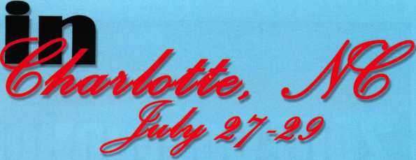

WIN! WIN! WIN!

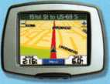

GARMIN StreetPilot Mobile GPS system



Every $200 order placed at ALOA  
= 1 raffle ticketl

(Drawings twice daily!)

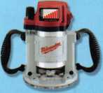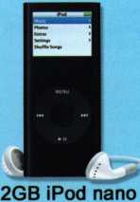

Milwaukee 3-1/2 hp  
Variable Speed Router

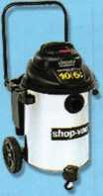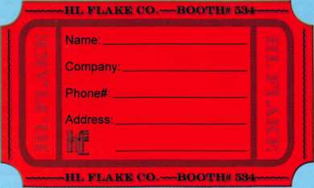

Shop Vac 6.5HP 10  
Gal. Vacuum

Another chance to win...

The first 50 locksmiths to visit our booth daily will  
enter a drawing to win an HPC duplicating machine!

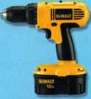

DeWALT 1/2" 18V  
Compact Drill/Driver Kit

MAP

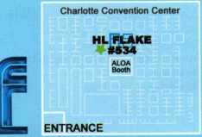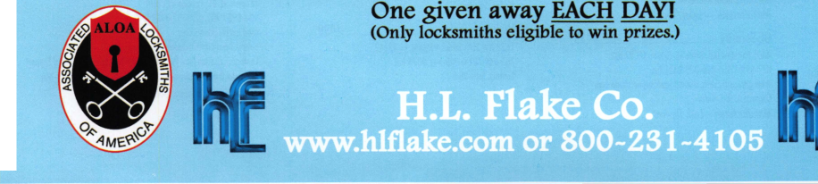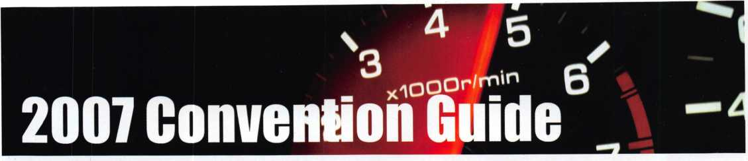

Exhibitors

Dallas Convention & ESP Lock Products/Hudson

Visitors Bureau .#800

325 North St. Paul Street Suite 700,

Dallas, Texas 75201 • 214-571-1000 or

toll free: 1-800-232-5527;

Tourist Info. Center: 214-571-1300  
[www.dallascvb.com](http://www.dallascvb.com)

Dallas Hyatt #800

300 Reunion Boulevard, Dallas, Texas, USA 75207  
214-651-1234; 214-742-8126 fax  
[www.dallasregency.hyatt.com](http://www.dallasregency.hyatt.com)

**\*\*DETEX Corp #822**

**302 Detex Drive • New Braunfels, TX 78130**

**800-729-3839; 836-620-6711 fax**

**[www.detex.com](http://www.detex.com); e-mail: [tak@detex.com](mailto:tak@detex.com)**

**Contact(s): Trice Kastein, Gary Hackney**

*Manufacturer—Alarms; Builders Hardware; Electric/Elec­*

*tronic Security*

Dida Locks #837

15050 North 54th Place Scottsdale, AZ 85254

602-421-8548; 602-795-8669

e-mail: [Kchenl@cox.net](mailto:Kchenl@cox.net) • Contact: Kevin Chen

**\*\*DoorKing, Inc #402**

**120 S. Glasgow Avenue • Inglewood, CA 90301 800-826-7493; 310-641-1586 fax**

**[www.doorking.com](http://www.doorking.com); e-mail: [info@doorking.com](mailto:info@doorking.com)  
Contact(s): Dave Minner**

*Manufacturer—Electric/ Electronic Security; Lock Devices*

**\*\*D0RMA Architectural Hardware .#928**

**Dorma Drive • Reamstown, PA 17567**

**717-336-3881; 717-336-2106 fax**

**[www.dorma-usa.com](http://www.dorma-usa.com);**

**e-mail: [lseliber@dorma-usa.com](mailto:lseliber@dorma-usa.com)**

**Contact(s): Lloyd Seliber, Jerome Andrews**

*Manufacturer—Builders Hardware; Electric/*

*Electronic Security; Lock Devices.*

**\*\*Dugmore & Duncan, Inc #614**

**30 Pond Park Rd. • Hingham, MA 02043  
888-384-6673; 888-329-3846 fax  
[www.dugmore.com](http://www.dugmore.com); e-mail: [ed@dugmore.com](mailto:ed@dugmore.com)  
Contact(s): Ed Minishak**

*Distributor—Builders Hardware; Lock Devices*

Duravision-USA #943

16 Malems Street, Tauranga, New Zealand e-mail: [Gordon@bennettmirror.com](mailto:Gordon@bennettmirror.com) Contact: Gordon Caulfield

**\*\*Dynalock Cor #1034**

**P.0. Box 2728, Bristol, CT 06011 877-DYNALOCK; 860-585-0338 fax**

**[www.dynalock.com](http://www.dynalock.com); e-mail: [info@dynalock.com](mailto:info@dynalock.com)  
Contact(s): John L. Schum**

*Manufacturer-Electric/Electronic Security; Custom Built Con-  
soles*

Eclipse Industries #1016

1923 Commercial Street, Escondido, CA 92029  
760-746-1016; 760-746-5636 fax  
[www.eclipsesafe.com](http://www.eclipsesafe.com); e-mail: [eclipseind@earthlink.net](mailto:eclipseind@earthlink.net) Contact(s):  
Martin Stinson

Manufacturer—Safes/Vaults

Lock LLC .#919

81 Apsley Street Hudson, MA 01749

800-434-8960 ext 326; 978-562-9859 fax

[www.hudsonlock.com](http://www.hudsonlock.com);

e-mail: [amy.fuller@hudsonlock.com](mailto:amy.fuller@hudsonlock.com)

Contact(s): Sari Thibault [ext 325), Jeff Conforti (extl 24), Amy

Fuller (ext 326)

Manufacturer- Lock Devices; Tools & Supplies

European Locksmith

Federation (ELF) #1009

P.0. Box 630, Noerrebrogade 84,

Copenhagen N, DK2200 Denmark Contact: Hans Mejlshede

Farpro Security Solutions #541

4480 Charleroi, Montreal Nord,

Quebec, Canada H1H 1T5

514-327-7868; 514-327-8106 fax Contact: Vince DeRose

**\*\*FireKing Security Group #516**

**101 Security Parkway • New Albany, IN 47150 800-528-9900; 800-227-7513 fax [www.fireking.com](http://www.fireking.com); e-mail: [marketing@fireking.com](mailto:marketing@fireking.com) Contact(s): Cassie Wooldridge**

*Manufacturer—CCTV/Photo Imaging; Safes/Vaults*

**\*\*Framon Manufacturing Co., Inc #544**

**909 Washington Ave. • Alpena, Ml 49707 989-354-5623; 989-354-4238 fax [www.framon.com](http://www.framon.com); e-mail: [sales@framon.com](mailto:sales@framon.com) Contact(s): Phil Agius** Manufacturer— Tools & Supplies

Fried Bros Inc #125

467 N. 7th St, Philadelphia, PA 19123 215-627-3205; 215-592-1255 fax w[ww.fbisecurity@fbisecurity.com](mailto:ww.fbisecurity@fbisecurity.com); e-mail: [fbisecurity@fbisecurity.com](mailto:fbisecurity@fbisecurity.com) Distributor-Bank Security Equipment; Automotive; Builders Hardware; Business/Technical & Educational; CCTV/Photo Imaging; Electric/Electronic Security; Lock Devices; Tools & Supplies; Safes/Vaults

Fuki Co., Ltd #709

1-28-23, Hon-lsshiki, Edogawa-ku,

Tokyo 133-0044 Japan 81-3-3654-4169; 81-3-3655-4169 fax [www.fuki4169.com](http://www.fuki4169.com); e-mail: [twolock@ha-bekkoame.ne.jp](mailto:twolock@ha-bekkoame.ne.jp) Contact: Manaru Goto Manufacturer— Tools & Supplies

Gardall Safe Corp #836

P.O. Box 240, Syracuse, NY 13206 800-722-7233 or 315 432-9115; 315-434-9422 fax [www.gardall.com](http://www.gardall.com); e-mail: [mkoesterer@gardall.com](mailto:mkoesterer@gardall.com) Contact(s): Mark Koesterer Manufacturer—Safes/Vaults

GE Security #235

4001 Fairview Ind. Drive SE, Salem, OR 97302 877-699-6787; 888-329-0331 fax [www.gesecurity.com](http://www.gesecurity.com); e-mail: [suprasupport@ge.com](mailto:suprasupport@ge.com) Contact(s): Rick Boes Manufacturer—Lock Devices

GEICO Emergency Road

Services #244

One Geico Center Macon, GA 31296 800-841-9160; 478-621-1822 fax Contact:Jeff Jordan

GMS Industries, Inc #523

2799 152nd Avenue N.E.. Redmond, WA 98052  
888-774-5625; 604-448-1249 fax  
[www.gmslock.com](http://www.gmslock.com); e-mail: [information@gmslock.com](mailto:information@gmslock.com)  
Contact(s): Lynnly Lee, Ken Erickson  
Manufacturer—Lock Devices

Greater Philadelphia Locksmith  
Association (GPLA) #1014

8014 Craig St., Philadelphia, PA 19136-Headquarters  
President: Bob Schuetrumpf, CRL, GIL  
717-392-6333; 717-581-8353 fax  
[www.gpla.org](http://www.gpla.org); [bill@lock.com](mailto:bill@lock.com)  
Contact: William Neff, CML

**\*\*G-U Hardware, Inc #1022**

**12650 Patrick Henry Drive, Newport News, VA 23602  
310-302-8971; 310-822-0034 fax  
Contact. Kris Newman**

HES, Inc #304

An ASSA Abloy Group Co. • 22630 N. 17th Avenue  
Phoenix, AZ 85027-1303 • 623-582-4626;

623-582-4641 fax • [www.hesinnovations.com](http://www.hesinnovations.com);

e-mail: [sales@hesinnovations.com](mailto:sales@hesinnovations.com)

Manufacturer—Electric/Electronic Security; Lock Devices

HPC, Inc #428

3999 N. 25th Ave • Schiller Park, IL 60176  
847-671-6280; 847-671-6343 fax  
Contact(s): Francie Hoffman  
[hpc@hpcworld.com](mailto:hpc@hpcworld.com); [fhoffman@hpcworld.com](mailto:fhoffman@hpcworld.com)  
Manufacturer—Automotive; BusinessAechnical & Educa-  
tional; Tools & Supplies; Safes/Vaults; Key Cabinets  
& Security Storage

**\*\*Hammerhead Industries, Inc #349**

**1501 Goodyear Ave, Ventura, CA 93003  
805-658-9922; 805-658-8833 fax  
[www.gearkeeper.com](http://www.gearkeeper.com); e-mail: [info@gearkeeper.com](mailto:info@gearkeeper.com)**

Contact: Mark Bursek *Manufacturer—Key Retractor*

Han Fey Lock Technologies #846

Ruimelsingel 1 5035 BM Tilburg, The Netherlands E-mail: han.fey@l 2move.nl • Contact: Han Fey

Hayman Safe Co #540

1291 N. SR 426, Oviedo, FL 32765  
800-444-5434; 407-365-8958 fax  
[www.haymansafe.com](http://www.haymansafe.com);  
e-mail: [info@haymansafe.com](mailto:info@haymansafe.com)  
Contact(s): Gary Hayman, Nita Davis,

Dick DiVittorio, Aaron Hayman

Safes/Vaults

High Tech Tools #439

1628 NW 28th Street* Miami, FL 33142 305-649-7014; 305-541-0074 fax Contact: Tony Vigil

**\*\*H.L. Flake Company #534,638**

**5005 Gulf Fwy, Houston, TX 77023 713-926-3200 or 800-231-4105; 888-329-0601 fax [www.hlflake.com](http://www.hlflake.com); e-mail: [customerservice@hlflake.com](mailto:customerservice@hlflake.com) Contacts): Leslie Moerer, Dan Floeck, Jeff Floeck,**

Sherri Snyder, Arnold Ramirez *Distributor—Automotive; Builders Hardware; BusinessAechnical & Educational; Electric/Electronic Secu­rity; Lock Devices; Tools & Supplies*

Howard Keys #138

1610 Industrial Center Circle Charlotte, NC 28213-6397 800-524-9199; 704-509-6248 fax [www.howardkeys.com](http://www.howardkeys.com); e-mail: [info@howardkeys.com](mailto:info@howardkeys.com) Contact: Andrew Goldberg

Manufacturer of Licensed House Keys and Transponder Keys

**\*\*IDN, Inc #416**

**2401 Mustang Dr. Ste. 100 • Grapevine, TX 76051 817-421-5470; 817-421-5468 fax Contact(s): Mike Groover**

*Distributor—Alarms; Bank security equipment; Automo­tive; Builders Hardware; BusinessAechnical & Educational; CCTV/Photo imaging; Electric/Electronic Security;*

*Lock Devices; Tools & Supplies; Safes/Vaults*

**\*\*lngersoll Rand #108**

**11819 N. Pennsylvania St. Carmel, IN 46032 317-810-3700; 317-810-3989 fax [www.irsecuritytechnologies.com](http://www.irsecuritytechnologies.com); e-mail: [pat_olmstead@irco.com](mailto:pat_olmstead@irco.com) Contact: Pat Olmstead**

*Builders Hardware; Electric/Electronic Security; Lock De­vices*

**\*\*ILC0 Key Systems ....#204**

**400 Jeffreys Rd., Rocky Mount, NC 27804 252-446-3321; 252-446-4702 fax [www.kaba-ilco.com](http://www.kaba-ilco.com); e-mail: [info@irm.kaba.com](mailto:info@irm.kaba.com) Contact(s): Chuck Murray, John Greening** Automotive; Lock Devices; Tools & Supplies

Inkas Safe Mfg .#900

64 Signet Drive, Toronto, ON M9L 2Y4 Canada 877-913-7233; 416-744-3535 fax [www.inkas.ca](http://www.inkas.ca); e-mail: [jmartin@inkas.ca](mailto:jmartin@inkas.ca) Contact: Jim Martin Manufacturer—Safes/Vaults

Institutional Locksmiths Assoc #1008

Thomas Negron, President 505 Dklyn Ave. Trenton, NJ 08610 609-599-9535; 609-599-9036 fax [www.ilanational.org](http://www.ilanational.org); e-mail: keysl [50@juno.com](mailto:50@juno.com)

Intralock Tools, Ltd (ITL) #908

2639 B Progressive Way,

Abbotsford, BC, Canada U2T 6H8 604-852-8906; 604-852-8938 fax [www.infralocktools.com](http://www.infralocktools.com); e-mail: [info@intralocktools.com](mailto:info@intralocktools.com)

Contact(s): Gordon Parr, President; Andy Berlinguette, Technical Support Manufacturer—Automotive; Tools & Supplies: Key Ma­chines, Safe Opening Tools

2007 **Pacific Security**

**CONFERENCE**

**Presented by The Pacific  
Locksmith Association**

**October** 9**-**13**,** 2007

Airport Holiday Inn and Conference  
Center Portland, Oregon

* 4 Days of Dynamic Classes

• ACE Classes

* Saturday Trade Show
* Excellent Education—prp, CEU’s * SEMINARS

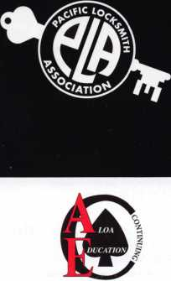

• Associated Locksmiths of America, ir/Schlage,  
dhi, Timemasters, napco, assa/abloy, DSC,

MEDECO AND THE BEST INDEPENDENT INSTRUC-  
TORS IN THE COUNTRY

PRP Exam Trade Show

For more Information Contact: PacificSecurityConference.com Conference Info: Bill botek 503.644.9881 Vendors: Richard Corvi 360.737.4390

PLAN NOW

TO ATTEND THE 6TH ANNUAL PACIFIC SECURITY CONFERENCE

Members of Security Industry Associations Will Receive Class Discounts

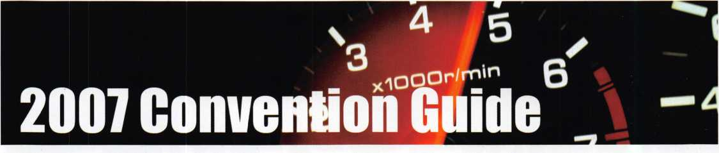

Exhibitors

**\*\*Jet Hardware Mfg. Corp #113**

800 Hinsdale St. •Brooklyn, NY 11207 718-257-9600; 718-257-0973 fax [www.jetkeys.com](http://www.jetkeys.com); e-moil: [keys@jetkeys.com](mailto:keys@jetkeys.com) *Manufacturer— Tools & Supplies: Electronic Transponder Duplicating Machine (Smart Clone), Key Displays, Key Cut­ting Machines, "Groovy" Keys*

JLM Wholesale .#801

3095 Mullens Court, Oxford, Ml 48371 800-522-2940; 800-782-1160 fax e-moil: [sales@jlmwholesales.com](mailto:sales@jlmwholesales.com) Contact: Dennis Ingamells

JMA USA #842

2409 Avenue J, Suite A, Arlington, TX 76006 817-385-0515; 817-385-4850 fax Contact: Gabriel Guevara

KSP .#933

33 Hermon St., Worcester, MA 01610 800-577-5397; 508-753-2183 fax [www.iccore.com](http://www.iccore.com); e-mail: [kzawalich@iccore.com](mailto:kzawalich@iccore.com) Contact(s): Karen Zawalich, Doug Maston Manufacturer—Lock Devices; Tools & Supplies

KABA Access Controls .#204

2941 Indiana Ave. • Winston Salem, NC 27105 336-725-1331; 336-725-8814 fax [www.kabaaccess.com](http://www.kabaaccess.com); e-mail: [cself@kaa.kaba.com](mailto:cself@kaa.kaba.com) Contact(s): Michael Kincaid, Rich Lang Manufacturer—Electric/Electronic Security; Lock Devices

KABA Safe + Container Locks (Kaba-Mas/LaGard) .#204

749 Short Street, Lexington, KY 40508

1. 253-4744; 859-255-2655 fax [www.kaba-mas.com](http://www.kaba-mas.com); e-mail: [customerservice@kml.kaba.com](mailto:customerservice@kml.kaba.com) Contact(s): Ashley Prall, Steve Pollack Manufacturer—Bank Security Equipment; Electronic Secu­rity

Keedex Inc .#1045

510 Cameron St, Placentia, CA 92870-6425

714-993-4300; 714-993-4303 fax

[www.keedex.com](http://www.keedex.com); e-mail: [bestlock@aol.com](mailto:bestlock@aol.com)

Contact(s): George Hill, Julie McCluney

Manufactuer—Automotive; Builders Hardware;

Electric/Electronic Security; Lock Devices; Tools & Supplies;

Safes/Vaults

**\*\*Kenstan Lock Company #946**

**101 Commercial St. Suite 100, Plainview, NY 11803 516-576-9090; 516-576-0100 fax [www.kenstan.com](http://www.kenstan.com); e-mail: [mborkowski@kenstan.com](mailto:mborkowski@kenstan.com) Contact(s): Margaret Borkowski, William Bullwinkel** Manufacturer—Lock Devices

**\*\*Keri Systems, Inc .#340**

**2305 Bering Dr, San Jose, CA 95131 408-435-8400; 408-577-1792 fax [www.kerisys.com](http://www.kerisys.com); e-mail: [sales@kerisys.com](mailto:sales@kerisys.com) Contact(s): Mike Bevan, Vince De luliis** Manufacturer—Electric/Electronic Security

**\*\*KEY-BAK .#1004**

**4245 Pacific Privado; Ontario, CA 91761  
909-923-7800; 909-923-0024 fax  
[www.keybak.com](http://www.keybak.com); e-mail: [mikew@keybak.com](mailto:mikew@keybak.com)**Manufacturer-Tools & Supplies

Keyless Ride #147

800 Paloma Dr. Ste 110, Round Rock, TX 78664  
512-310-5757; 208-475-6230 fax  
[www.keylessride.com](http://www.keylessride.com); e-mail: [sales@keylessride.com](mailto:sales@keylessride.com)  
Contact(s): Noel Lopez, John Milburn  
Distributor—Alarms; Automotive; Tools & Supplies

Klassy Keys, Inc #519

63 Carrs Tavern Road • Clarksburg, NJ 08510  
888-844-5397; 800-610-6670 fax  
Contact(s): Bob DeJonge

**\*\*LAB Security #434**

**700 Emmett, Bristol, CT 06010  
800-589-6037; 860-583-7838 fax  
[www.labpins.com](http://www.labpins.com); e-mail: [sales@labpins.com](mailto:sales@labpins.com)  
Contact(s): Mike Sigmund, Alan Mauro**Manufacturer— Tools & Supplies; Tumbler Pins &

*Re-pinning Kits*

Laser Security #640

421E. Nasa Rd, Webster, TX 77598 281-338-9100

Lectro Truck .#246

310 South 10th Street, Oostburg, Wl 53070

800-619-0625; 920-564-2322 fax

[www.lectrotruck.com](http://www.lectrotruck.com);

e-mail: [information@lectrotruck.com](mailto:information@lectrotruck.com)

Contact(s): Jason Tagel, Bob Cedar

Manufacturer—Tools & Supplies; Material Handling

Equipment (Safe Moving)

LLS Sales #1048

205 South Pemberton Rd, Pemberton, NJ 08068 609-894-2429; 850-437-0030 fax [www.llssales.com](http://www.llssales.com); e-mail: [llssales@comcast.net](mailto:llssales@comcast.net) Contact(s): Mike Larar, Charles Stead, Chris Roney Distributor—Automotive Computer Programmers

**\*\*Lockmasters, Inc #320**

**5085 Danville Rd. • Nicholasville, KY 40356 859-885-6041; 859-885-7093 fax [www.lockmasters.com](http://www.lockmasters.com) Contact: Cheryl Holland**

*Distributor—Automotive; Builders Hardware; Electric/Electronic Security; Lock Devices; Tools & Supplies; Safes/Vaults*

LSI-Lockmasters

Security Institute #347

1014 South Main St. • Nicholasville, KY 40356 859-887-9633; 859-887-0810 fax [www.lsieducation.com](http://www.lsieducation.com); e-mail: [deannadeborde@lsieducation.com](mailto:deannadeborde@lsieducation.com) Contact(s): Deanna DeBorde, Shane Varney,

Chuck Batcke, Sharon DeBrocco, Dave Killip Professional Training-For more than 50 yrs LSI has pur­sued the goal of being the security industry's leading edu­

cational facility. LSI offers its students a comprehensive curriculum of courses in technical locksmithing, combina­tion locks, access control, security management and Tech­nical Operations Programs. Most of LSI's courses are accredited by the Southern Association of Colleges and Schools (SACS). Specialized classrooms equipped with the tools and materials needed to succeed on the job are a benefit at LSI.

LockPicks.com by Brockhage .#947

P.0. Box 1900,1750 Rogers Ave. San Jose, CA 95109 800-480-0875; 408-437-3129 fax [www.lockpicks.com](http://www.lockpicks.com); e-mail: [info@lockpicks.com](mailto:info@lockpicks.com) Contact(s): Barrett Brockhage, Pres & CEO; Damon Davis, Opera­tions Manager

Manufacturer, Wholesaler, Distributor-Automotive; Tools & Supplies-Key Blanks

LockSaver/Mil-Comm Products .#811

2 Carlton Ave, E. Rutherford, NJ 07073 800-743-4518 8 [www.milcomm.com](http://www.milcomm.com); e-mail: [sales@mil-comm.com](mailto:sales@mil-comm.com) Contacl(s): Gordon Furlong,

Charley Furlong, Mike Reive

Manufacturer— Tools & Supplies; Lock Lubricants

LocksmithingCommunity.com #1006

23 Dogwood Court, Maple Shade, NJ 08052 856-577-1494 • Contact: John Truempy

Locksmithing, Uni., LLC #711

828 S. Broom St. Wilmington, DE 19805-4245  
302-575-0993; 302-571-1677 fax  
[www.sargentpunch.com](http://www.sargentpunch.com); e-mail:[ted@sargentpunch.com](mailto:ted@sargentpunch.com)  
Contact(s): Ted Gula  
Manufacturer—Key Machines

**\*\*Locksmith Ledger Inti #328**

**3030 Salt Creek Lane Ste 200  
Arlington Heights, IL 60015  
847-454-2702; 847-454-2759 fax  
Contact: Nancy Brokamp**

*Locksmith industry publication-has provides up-to-the-  
minute valuable information for nearly 6 decades.*

Lounging Lizard Publications #1105

536 North 13th Street, Allentown, PA 18102 610-392-4362; 610-758-6444 fax Contact: Don 0'Shall

**\*\*Lucky Line Products, Inc #337**

**7890 Dunbrook Rd. • San Diego, CA 92126 800-654-6409; 800-334-9709 fax**

**[www.luckyline.com](http://www.luckyline.com); e-mail: [info@luckyline.com](mailto:info@luckyline.com)  
Contact(s): Bill Fleming, JanHoward**Manufacturer—Automotive

**\*\*MAG Mfg #610**

**15381 Assembly Ln. • Huntington Beach, CA 92649  
714-891-5100; 714-892-6845 fax  
Contact(s): Julie Penaskovic**Manufacturer— Builders Hardware

MBA USA, Inc #400

200 Orchard Drive, Nicholasville, KY 40356 888-622-5495; 859-887-9491 fax [www.mbausa.com](http://www.mbausa.com); e-mail: [sales@mbausa.com](mailto:sales@mbausa.com) Contad(s): Mark Bates, Andy Dennison,

Distributor—BusinessAechnical & Educational; Lock De­vices; Tools & Supplies; Training

MDS Incorporated #535

317 Bracken Lane • Brandon, FL 33511 813-653-1180; 813-684-5953 fax Contacts: Bob Battle, Paul Butler Borescopes, Magnascopes, Lights

**\*\*MPT Industries .#815**

**6-8 Hamilton Business Park; 85 Franklin Rd,**

**Dover, NJ 07801 • 973-989-9220;**

**973-989-9234 fax • [www.mptindustries.com](http://www.mptindustries.com); e-mail: [sales@mptindustries.com](mailto:sales@mptindustries.com) Contact(s): John Barschdorf, Michael Trueba Jr.** Manufacturer-Lubricants for LocksAools &

*Security Equipment*

MTS International #443

2415 S. Dairy Ashford Ste 10-C Houston, TX 77077 281-920-4747; 281-920-4748 fax Contact: Marcel DeSouza

Main's Lock Supply #233

13630 2nd Street, Yucaipa, CA 92399 909-795-2320; 909-795-3123 fax

[www.iccores.com](http://www.iccores.com); e-mail: [randy@iccores.com](mailto:randy@iccores.com)  
Contact(s): Randy Main, Judy Main  
Distributor-Lock Devices

MARKS USA .#929

5300 New Horizons Blvd. • Amityville, NY 11701  
631-225-5400; 631-225-6136 fax  
[www.marksusa.com](http://www.marksusa.com); e-mail: [wjs@marksusa.com](mailto:wjs@marksusa.com)  
Contact(s): Bill Sporre

Manufacturer—Electric/Electronic Security; Lock Devices

Master Lock Company #128

137 W. Forest Hill Avenue • Oak Creek, Wl 53154  
414-571-5625 or 800-308-9244,800-308-9245 fax  
[www.masterlock.com](http://www.masterlock.com); e-mail: [masterlock@mlock.com](mailto:masterlock@mlock.com)  
Contact(s): Dave Kraninger  
Manufacturer—Lock Devices

**\*\*Maxcess Card Systems, Ltd #917**

**846 Mahler Rd, Burlingame, CA 94010  
800-713-4823; 650-692-9410 fax  
[www.maxcess-card.com](http://www.maxcess-card.com);  
e-mail: [maxcess@maxcess-card.com](mailto:maxcess@maxcess-card.com)  
Contact(s): Bruce Sedley, John Kerr,**

**Don Reid, Ken Cecil**

*Manufacturer—Electric/Electronic Security; Lock Devices*

**\*\*Medeco High Security Locks #304**

**An ASSA Abloy Group Co.**

**3625 Allegheny Drive • Salem, VA 24153  
540-380-1808; 540-380-1793 fax  
[www.medeco.com](http://www.medeco.com); e-mail: [jmclendon@medeco.com](mailto:jmclendon@medeco.com)  
Contact: Jennifer McLendon**

*Manufacturer— Electric/Electronic Security (Electro-me-  
chanical Locks); Lock Devices; Tools & Supplies*

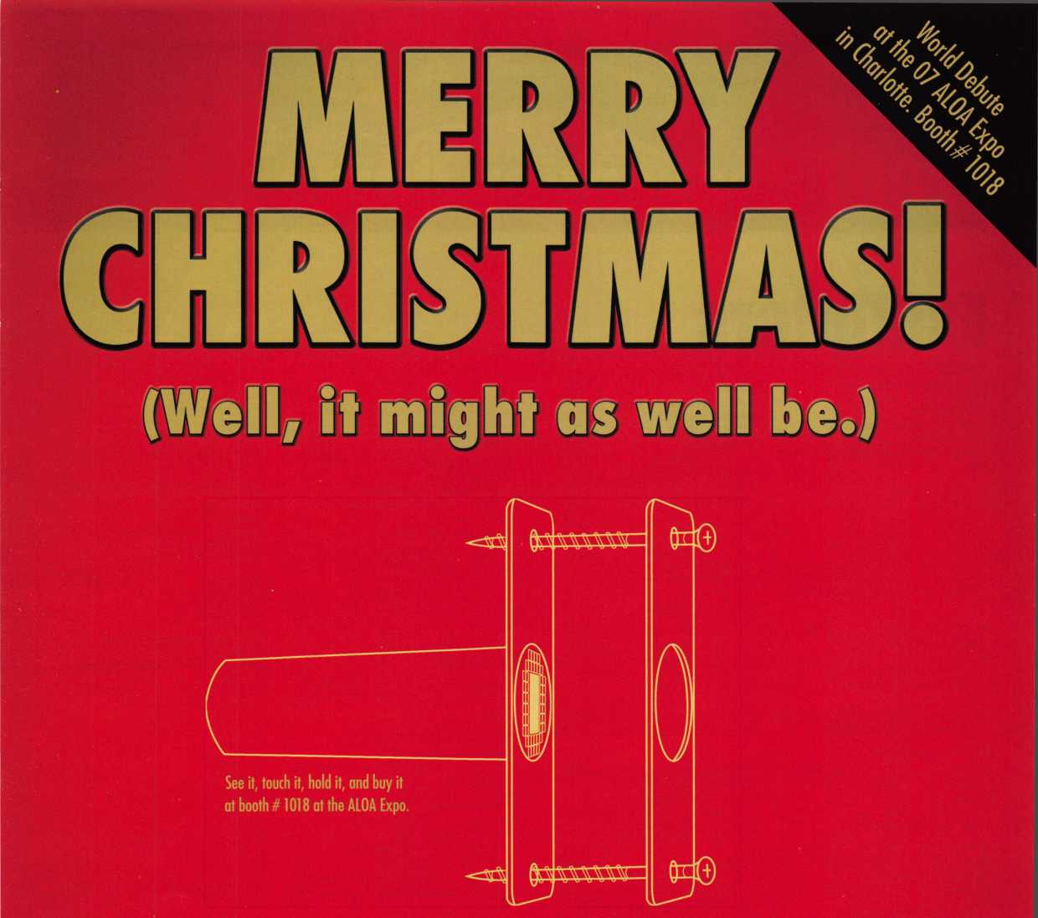

**The much anticipated Sure-Strike™ is here. Unlike any striker plate you've ever seen for exterior doors. Its patent pending design  
not only self-adjusts to misaligned deadbolts due to shifting doors, it also resists kick-ins, sawing, and prying by would-be burglars...  
making it truly the most innovative striker plate ever built. And better yet, it's only available to the public through you - the locksmith,  
Now you've got something to sell that those big home improvement stores only wish they had. To find out how your business, and  
your customers, can benefit from the new, innovative Sure-Strike give us a call or visit us on the web and put it on your wish list.**

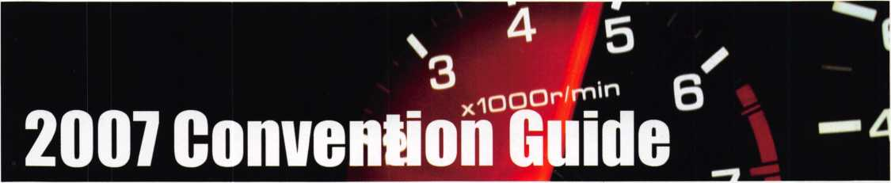

Exhibitors

Midwest Wholesale Hardware #923 Novation Wireless

1000 North Century Ave. • Kansas City, MO 64120

1. 821-8527; 800-621-6581 fax [www.midwestwholesale.com](http://www.midwestwholesale.com);

e-mail: [hdwsales@midwestwholesale.com](mailto:hdwsales@midwestwholesale.com) Contact: Jeff Greashaber

Wholesale—Builders Hardware; Electric/Electronic Secu­rity

**\*\*MUL-T-L0CK USA, Inc .#304**

**An ASSA Abloy Group Co.**

**300-1 Route 17 South, Suite 7 • Lodi, NJ 07644 903-778-3320; 973-778-4007 fax [www.mul-t-lockusa.com](http://www.mul-t-lockusa.com); e-mail: [info@mul-t-lockusa.com](mailto:info@mul-t-lockusa.com) Contact(s): Sheri Butts, Ortal Aish, Tannis Weinstein** Manufacturer—Builders Hardware; Electric/Electronic Security; Lock Devices; Tools & Supplies; High Security Locks

National Auto Lock Service #1046

180-B South Spruce Ave., South San Francisco, CA 94080 650-875-0125; 650-875-0123 fax [www.laserkey.com](http://www.laserkey.com); e-mail: [laserkey@aol.com](mailto:laserkey@aol.com) Contact(s): Michael Hyde

Manufacturer, Distributor-Automotive; BusinessAechnical & Educational; Lock Devices; Tools & Supplies

National Automotive Service

Task Force #935

101 Blue Seal Drive, S.E, Suite 101,

Leesburg, VA 20175

703-669-6600; Fax: 703-669-6124 fax [www.nastf.org](http://www.nastf.org); email: [info@nastf.org](mailto:info@nastf.org)

National Business Foundation #444

808 East Utah Valley Drive, American Ford, UT 84003

1. 216-8631; 801-216-8628 fax Contact: Charles Staib

North Bennet Street School #539

39 North Bennet St School, Boston, MA 02113 617-227-0155; 617-227-9292 fax [www.nbss.org](http://www.nbss.org); e-mail: [admissions@nbss.org](mailto:admissions@nbss.org) Contact: Robert Delaney

North Carolina Locksmith's Association #1107

120 Timber Hollow Drive, Unden, NC 28356 910-980-0891 • [www.ncla.us](http://www.ncla.us) • President: Reid Skinner

Norton Door Controls #304

An ASSA Abloy Group Co.

3000 Highway 74 East, Monroe, NC 28112 800-438-1951; 800-338-0965 fax [www.nortondoorcontrols.com](http://www.nortondoorcontrols.com) Manufacturer—Builders Hardware

Nostalgia Booth .#941

P.0. Box 838, Battleboro, NC 27809

1. 446-2060 • Contact: Beth Kirkpatrick

Security Systems #1102

4510 East Thousand Oaks Blvd, Suite 201

Westlake Village, CA 91362

805-494-3070; 805-494-3170 fax

[www.novwireless.com](http://www.novwireless.com);

e-mail: [jwahl@novwireless.com](mailto:jwahl@novwireless.com)

Contact(s): Jay Wahl-cell-310-877-2825

Manufacturer—Electric/Electronic Security; Lock Devices;

Wireless Access Control Products

Olympus Lock, Inc #139

18424 Highway 99, Lynnwood, WA 98037 206-362-3290; 206-362-3569 fax [www.olympus-lock.com](http://www.olympus-lock.com); e-mail: [info@olympus-lock.com](mailto:info@olympus-lock.com) Contact(s): Mike Donohue, Jerry Martin Manufacturer—Lock Devices

**\*~0maha Wholesale Hardware #1032**

**1201 Pacific St, Omaha, NE 68108**

**800-238-4566 • [www.omahawh.com](http://www.omahawh.com);**

**e-mail: [sales@omahawh.com](mailto:sales@omahawh.com)**

**Contact(s): Tom Gaffney, Carl Norgard**

*Wholesaler—Automotive; Builders Hardware; Business/*

*Technical & Educational; CCIV/Photo Imaging;*

*Electric/Electronic Security; Lock Devices; Tools & Supplies;*

*Safes/Vaults*

OSI Security Devices #944

1580 Jayken Way Chula Vista, CA 91911 619-628-1000; 619-628-1001 fax [www.omnilock.com](http://www.omnilock.com); e-mail: [sales@omnilock.com](mailto:sales@omnilock.com) Contact(s): Rick Rasmussen, Will Brock Manufacturer—Electric/Electronic Security

PDQ Industries #239

2754 Creek Hill Rd. • Leola, PA 17540 717-656-4281; 717-656-6892 fax [www.pdqlocks.com](http://www.pdqlocks.com); e-mail:[moconnor@pdqlocks.com](mailto:moconnor@pdqlocks.com) Contact: Michael O'Connor, cell-717-940-3819 Manufacturer—Builders Hardware; Lock Devices

**’""Pacific Lock Company #515**

**21618 Manila St. Chatsworth, CA91311**

**888-562-5565 or 818-678-6500; 818-678-6500 fax**

**[www.paclock.com](http://www.paclock.com); e-mail: [sales@pacloc.com](mailto:sales@pacloc.com)**

**Contact(s): Greg Waugh-President, Josh Fleagane-Vice President,**

**Bob McDonough-Sales, Marilyn McDonough-Sales, Dick Elrick-Sales**

*Manufacturer—Locks Devices-Padlocks*

Perma-Vault Safe Co #910

72 Ash Circle Warminster, PA 18974 215-293-9951 or toll free-800-662-3360;

215-293-9952 fax • [www.perma-vault.com](http://www.perma-vault.com); e-mail: [sales@perma-vault.com](mailto:sales@perma-vault.com) Contact: Norman Bartwink Manufacturer—Safes/Vaults

Peterson Manufacturing #734

P.O.Box 744. East Rochester, NY 14445

585-264-1199 • [www.thinkpeterson.com](http://www.thinkpeterson.com)

Automotive; Tools & Supplies; Quality LockPicks, By-Pass

Devices, Bump Hammers, Drill Jigs and other fine Hand

Tools

**\*\*Phoenix Safe Int #537**

**382 N. Mt Zion Rd. •. Lebanon, IN 46052 765-483-0954; 765-483-0962 fax [www.phoenixsafeusa.com](http://www.phoenixsafeusa.com); e-mail: [pcooper@phoenixsafeusa.com](mailto:pcooper@phoenixsafeusa.com) Contact(s): Penny Golden** Distributor • Safes/Vaults

Plum Blossom Lock Group Co #706

Zheng Zhan Industry Zone,

Pu jiang/Zhejiang/ China • 1-250-598-8983 [www.chinameihua.com](http://www.chinameihua.com); e-mail: [Christine-li@shaw.ca](mailto:Christine-li@shaw.ca) Contact: Christine Li Manufacturer—Lock Devices

**^Positive Identity Solutions #702**

**118 Overhill Drive, Suite 101, Mooresville, NC 28117 704-235-5035; 704-235-5037 fax [www.pids-usa.com](http://www.pids-usa.com); e-mail: [jkeck@pids-usa.com](mailto:jkeck@pids-usa.com) Contact(s): Mark Ahuna, Roger Parks** Distributor—CCTV/Photo Imaging; Electric/Electronic Security; Lock Devices

PowerMate/LP

International, Inc #1047

151 Savannah Oaks Drive; P.0. Box 696, Brantford, ON N3T 5P9 Canada

519-759-3292; 519-759-3298 fax [www.powermate.info](http://www.powermate.info); mak@powermate.info Contact(s): Ivan VanderDeen, Joe Donato Manufacturer— Tools & Supplies; Complete Moving Solu­tions for the Safe Industry

Professional Business Products #129

620 W. Commerce Rd •. Commerce, Ml 48382

800-355-6322; 248-360-3982 fax

[www.pbp2000.com](http://www.pbp2000.com); e-mail: [sales@pbp2000.com](mailto:sales@pbp2000.com)

Contact(s): Kristy Emerick, Denise Knurick

Distributor—Automotive-key chains/rings; Personalized-

metal safe plates, labels, invoices, key envelopes, repair

tags, magnets, key tags & signs

PRO-LOK #716

655 North Hariton Street •. Orange, CA 92868 714-633-0681; 714-633-0470 fax [www.pro-lok.com](http://www.pro-lok.com); e-mail: [adamd@pro-lok.com](mailto:adamd@pro-lok.com) Contact: Adam Duberstein

Manufacturer—Automotive; Tools & Supplies; Safes/Vaults

Promet Safe Incorporated #143

259 Sullivan Ave Unit D, South Windsor, CT 06074

1. 436-6246; 860-436-6876 fax [www.promet-safe.com](http://www.promet-safe.com); e-mail: [sales@promet-safe.com](mailto:sales@promet-safe.com) Contact(s): Dmitry Chulisov Manufacturer—Safes/Vaults

**\*\*R0FU International Corp #705**

**7107 28th Street East •. Tacoma, WA 98424 800-255-R0FU; 253-922-1728 fax [www.rofu.com](http://www.rofu.com); e-mail: [julie@rofu.com](mailto:julie@rofu.com) Contact(s): Julie Collins-VP, Ken Erickson-VP** Manufacturer—Electric/Electronic Security

**\*\*Rutherford Controls Int'l Corp #715**

**210 Shearson Crescent, Cambridge,**

**Ontario Canada NIT 1J6**

**800-265-6630; 800-482-9795 fax**

**[www.rutherfordcontrols.com](http://www.rutherfordcontrols.com);**

**e-mail: [scott.simpson@rutherfordcontrols.com](mailto:scott.simpson@rutherfordcontrols.com)**

**Contact(s): Tommy Mlak, Elaine Ness, Cecil Thornton**

*Distributor—Electric/Electronic Security; Lock Devices*

Safe & Vault Technicians Association (SAVTA)#736

3500 Easy St. • Dallas, TX 75247 214-819-9771; 214-819-9736 fax [www.savta.org](http://www.savta.org); e-mail: [dialcenter@aol.com](mailto:dialcenter@aol.com) Safe Technicians Trade Association Contact: Mike Oehlert

Safety By Design #835

707 Spirit 40 Park Dr. Suite 100,

Chesterfield, MO 63005 636-449-0707; 636-449-0708 fax [www.turnerlock.com](http://www.turnerlock.com); e-mail: [stevel@turnerlock.com](mailto:stevel@turnerlock.com) Contact(s): Steve Leinenbach, Bob Boehlow Manufacturer—Builders Hardware; Lock Devices

**\*\*Sargent & Greenleaf, Inc #420**

**One Security Drive • Nicholasville, KY 40356 859-885-9411; 859-885-3063 fax [www.sglocks.com](http://www.sglocks.com), e-mail: [sales@sglocks.com](mailto:sales@sglocks.com) Contact(s): Phil Pitt Manufacturer—Lock Devices**

**\*\*SARGENT Manufacturing Co #304**

**An ASSA Abloy Group Co. • 100 Sargent Drive N.**

**New Haven, CT 06511 •800-727-5477;**

203-776-5992 fax • [www.sargentlock.com](http://www.sargentlock.com); e-mail: [webmaster@sargentlock.com](mailto:webmaster@sargentlock.com) *Manufacturer—Builders Hardware; Electric/Electronic Security; Lock Devices*

**\*\*Schwab Corp #109**

**110 Professional Cl., Lafayette, IN 47905 765-447-9470; 765-447-8278 fax [www.schwabcorp.com](http://www.schwabcorp.com); e-mail: [schwab@schwabcorp.com](mailto:schwab@schwabcorp.com) Contact(s): Ron Elzy**

*Manufacturer—Safes/Vaults-Fireproof Files, cabinets, safes & vault doors*

Securitech Group, Inc #242

54-45 44th Street • Maspeth, NY 11378 718-392-9000; 718-392-8944 fax Contact: Mark Berger Electric/Electronic Security

**\*\*Securitron Magnalock Corp #304**

**An ASSA Abloy Group Company 550 Vista Blvd.*Sparks, NV89434 775-355-5625; 775-355-5633 fax [www.securitron.com](http://www.securitron.com); e-mail: [info@securitron.com](mailto:info@securitron.com)** Manufacturer—Electric/Electronic Security; Lock Devices

Security Associates International #1010

2101 S. Arlington Heights Rd Suite 150 Arlington Heights, IL 60005 847-956-8650; 847-956-0414 fax Contact: Pam Dobrogowski

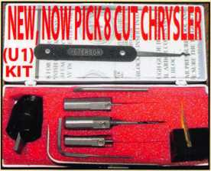

Works on all focus-type locks! Universal Ford Flush-Mounted/Chrysler 8-Cut Ignition Removal Kit #U1 (patented)

Use this tool on all Ford flush mount ignitions, with or without side bar, large and small diameter face, all types of focus locks. With adapter, you can do virtually all Chrysler, Dodge, and Jeep 8-cut ignitions with no damage to lock. Similar kits sell for over $100.00 and only do Chrysler. Fit key and replace. In less than 5 minutes, you will have them out. Kit includes: 1 force tool (to remove face); 3 drill & arbors; 3 drill guides for all access holes; side B AR pressure tool; turn wrench; tumbler hold­ing tool (to assemble and disassemble). No other tool needed with this kit. SHOW SPECIAL: get free adapter for Chrysler, Dodge and Jeep with each kit.

$155.00 +$6.00 S&H

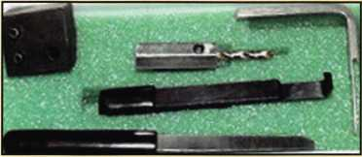

1998 Up G.M. In-Dash Ignition Removal Kit (patent 5454245)

Remove plastic ring and chrome cap in seconds. Make access hole to pick side bar. Turns cylinder to ACC position to re­move lock in less than 5 minutes with no damage to lock. Your first job will pay for this kit. $70.00 + $6.00 S&H

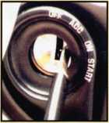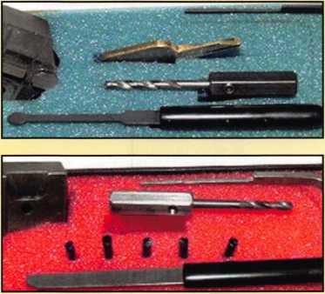

1996 Up Ford 8 Tumbler Ignition Removal Kit and Side Bar Breaker Tool

(patent 5701773)

Use force tool to turn ignition to "on" position in less than 60 seconds. To start car or for fast ignition lock removal or use kit to push side bar in, turn cylinder to "on" position for fast removal without any damage. Fit key, replace same lock.

$90.00 + $6.00 S&H

1994 Up G.M. 9 Tumbler Ignition Removal Kit (patent 5454245)

The locks have longer side bars than the older type and must be in the "on" position to remove. This kit will do that with no damage to the lock. Fit key and install same lock. Does all types, vats, mrd, top hat, module, etc. Your first job will more than pay for this kit. New with update to do module locks, blazers, suburbans, pick-ups, etc.

$80.00 +$6.00 S&H

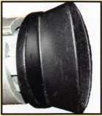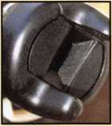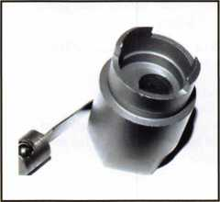

Ford "Quick-On" (patent 5454245)

Now turn all 10-cut ignition cylinders to the "on" position for fast removal-in less than 60 seconds. Sable, Taurus, all styles even those with airbags. No damage to housing.

$65.00+ $6.00 S&H

No-Nonsense Squeeze Lock Plug Remover

(patent 5165158)

Now you can remove all squeeze lock plugs in 15 seconds or less from all GM, Ford, Chrysler, AMC, and Jeep. No more fumbling, gadgets, cut fingers, broken tabs, or the need for 3 hands! It's so easy you can do it in the dark while it's still in the glove box.

$50.00 + $6.00 S&H

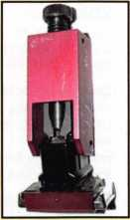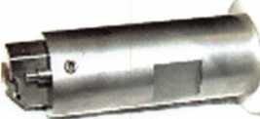

The G.M. Trunk & Door Persuader

The unique tool will open virtually all GM trunks and doors through the current year when tool fits into the cylinder core cavity in less than 50 seconds. No drilling, pulling, picking, special tools or electricity needed. When customer's key does not open trunk because: Problem 1: spring retainer popped up into outer shell; Problem 2: One side of side bar sprung off. Side bar does not retract; Problem 3: key or cylinder worn. Side bar does not retract; Problem 4: Key jammed in lock at "turned" position, etc. With The Persuader you will open these locks in less than 50 seconds with no damage to lock. Just repair and replace. There is nothing to wear out. Yes, if needed, it will open with no key. Note: Because of The Per­suader's capabilities, it will be sold to locksmith only. $45.00 + $6.00 S&H

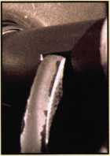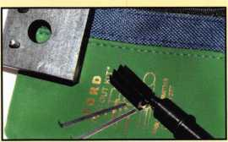

Ford "Disc-Out" Kit (patent 4682308)

This kit will remove those stubborn Ford pin ignitions from 1976 to present in less than 5 minutes. These locks incorporate 2 locking devices and a hard steel disc across the shear line. They must be turned to "on" position to release both locking devices so as not to damage the hous­ing. $60.00 + $6.00 S&H

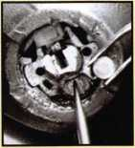

Frank Markisello guarantees all his products to do as stated.

[www.aablelocksmiths.com](http://www.aablelocksmiths.com) • 47 Marlboro Dr. • Milford, CT 06460

(203)882-0600 • fax (203)882-0600

Stop By Booth #338  
And see all new products!

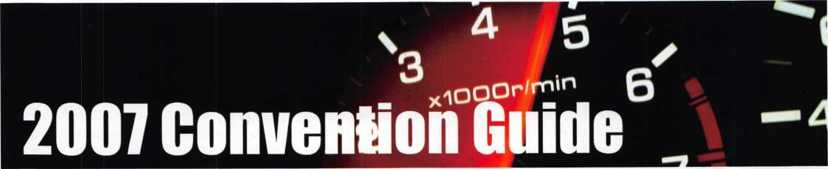

Exhibitors

**\*\*Security Distributors Inc . #125**

8901 Chancellor Row • Dallas, TX 75247-2924 214-879-1500 • Contact(s): Steve Zissos *Distributor—Bank Security Equipment; Automotive; Builders Hardware; BusinessAechnical & Educational;*

*ECU/Photo Imaging; Electric/Electronic Security;*

*Lock Devices; Tools & Supplies; Safes/Vaults*

Security, Inc #713

10125 South 2nd St, Franklin, Wl 53132 414-858-9413; 414-858-9443 fax e-mail: [dgoss@securityinc.com](mailto:dgoss@securityinc.com) Contact: Dan Goss

**\*\*Select Engineered Systems #1000**

**7991 W. 26th Ave. Hialeah, FL 33016 800-342-5737; 305-823-5215 fax [www.select-ses.com](http://www.select-ses.com); e-mail: [sales@selectses.com](mailto:sales@selectses.com) Contact(s): Bob Sensenig, Robert Peirlak** Electric/Electronic Security; Telephone Access Control

Select Hinges/Select Products Limited #740

9770 Shaver Road • Portage, Ml 49024 800-423-1174; 269-323-3815 fax [www.select-hinges.com](http://www.select-hinges.com); e-mai!:[bobc@select-hinges.com](mailto:bobc@select-hinges.com) Contact(s): Bob Cronk Manufacturer—Builders Hardware

SERLAC #945

1904 Barton Park Rd #415, Auburndale, FL 33823 813-689-5979; 813-853-2217 fax Brandon, FL 33511 • Contact: James Barnhardt

Simons Voss Technologies #346

10125 S. 52nd St, Franklin, Wl 53132 414-421-2481; 414-421-2496 fax [www.simons-voss.us](http://www.simons-voss.us)

Contact(s): Amy Driver, Warren Simonsen

Manufacturer—Electric/Electronic Security; Lock Devices

South Carolina Locksmith Association (SCLA)#931

P0 Box 264, Camden, SC 29020-1836 803-753-8056 (voice mail - leave a message)

1. 753-5344 fax • [www.sclocksmith.org](http://www.sclocksmith.org)

**\*\*Southern Lock .#938**

**10910 Endeavor Way, Largo, FL 33777**

**727-541-5536; 727-544-8278 fax**

**[www.southernlock.com](http://www.southernlock.com);**

**e-mail: [dmatthies@southernlock.com](mailto:dmatthies@southernlock.com)**

**Contact(s): Ed Padeau, David Matthies**

*Distributor—Automotive; Builders Hardware;*

*Electric/Electronic Security; Lock Devices; Tools & Supplies;*

*Safes/Vaults*

Southwest Specialty Products # 612

2710 W. Cheery Lynn Rd., Phoenix, AZ 85017 602-307-0901; 602-307-0909 fax [www.cansafe.net](http://www.cansafe.net); e-mail: [sspecialty@qwest.net](mailto:sspecialty@qwest.net) Contact(s): Sandy Patchefsky Manufacturer— Can Safes

Steck Mfg. Co #1012

1115 S. Broadway, Dayton, OH 45408 937-222-0062; 937-222-6666 fax [www.steckmfg.com](http://www.steckmfg.com); e-mail: [jbrill@steckmfg.com](mailto:jbrill@steckmfg.com) Contact: John Brill Manufacturer—Automotive

STRATTEC Security #728

3333 W. Good Hope Road • Milwaukee, Wl 53209 414-247-3421; 414-247-3465 fax aftermarket.strattec.com; e-mail: [jbaker@strattec.com](mailto:jbaker@strattec.com) Contact(s): Jeff Baker Automotive

Strong Arm Drills & Rigs #500

2228 Kenry Way • So. San Francisco, CA 94080 800-710-8168; 650-794-0541 fax [www.strongarmdrills.com](http://www.strongarmdrills.com); e-mail: [jvdrills@aol.com](mailto:jvdrills@aol.com) Contact: Jeff Volosing

Manufacturer, Wholesaler, Distributor-Tools & Supplies; Safecracker drill bits and Drill Rigs

Sungil America, Inc #442

3405 Sweetwater Rd, Lawrenceville, GA 30071 678-768-7888; 678-924-9404 fax [www.sungilsafe.com](http://www.sungilsafe.com); e-mail: [sales@snasafe.com](mailto:sales@snasafe.com) Contact(s): Jimmy Sung Wholesaler—Safes/Vaults

**\*\*Sure-Strike by WMW Innovation Company #1018**

**2711LBJ Freeway Suite 1036, Dallas, TX 75234 888-474-2341; 888-474-2341 fax [www.sure-strike.com](http://www.sure-strike.com); e-mail: [info@sure-strike.com](mailto:info@sure-strike.com) Contact(s): Bob O'Neail-903-681-4546,**

**Steve Garwacki-903-286-0851**

*Manufacturer—Lock Devices*

The Ben Jim #149

24711 Harper Ave. St. Clair Shores, Ml 48080 586-778-1911; 586-778-0530 fax [www.theben-jim.com](http://www.theben-jim.com); e-mail: [thebenjim@aol.com](mailto:thebenjim@aol.com) Contact(s): Ben Heath Manufacturer—Lock Bypass Tools

The Determinator #809

P.0. Box 895, Ocoee, FL 34761 800-561-0443; 407-884-6730 fax E-mail: [determinatortom@aol.com](mailto:determinatortom@aol.com) Contact(s): Tom Tusing Manufacturer—Automotive

**\*\*The Locksmith Store, Inc #840**

**1229 E. Algonquin Rd Unit E.,**

**Arlington Heights, IL 60005 847-364-5111; 847-364-5125 fax [www.locksmithstore.com](http://www.locksmithstore.com); e-mail: [info@locksmithstore.com](mailto:info@locksmithstore.com) Contact: Josh Swiderek**

*Distributor—Automotive; Builders Hardware; BusinessAechnical & Educational; Electric/Electronic Secu­rity; Lock Devices; Tools & Supplies*

The National Locksmith #134

1533 Burgundy Parkway • Streamwood, IL 60107 630-837-2044; 630-837-1210 fax Contact: Marc Goldberg

**\*\*The Ultimate Lock Dist. Co #448**

**6206 Chimney Rock Rd, Kileen, TX 76542**

1. **681-2277; 254-953-4933 fax e-mail: [sales@ultimatelocksales.com](mailto:sales@ultimatelocksales.com) Contact: J.T. Bower**

**\*\*Timemaster, Inc #343**

**157 Venture Court Suite 9 Lexington, KY 40511 888-798-8464; 800-798-8463 fax [www.time-master.com](http://www.time-master.com) • Contact: Tim Abner** Distributor

**\*\*Top Notch Distributors, Inc #145**

**80 Fourth Street, Honesdale, PA 18431 570-253-5625; 570-253-7178 fax [www.topnotch.bz](http://www.topnotch.bz); e-mail: [sales@topnotch.bz](mailto:sales@topnotch.bz) Contact(s): Mickey Abbott, Bill Fenwick** Distributor—Builders Hardware; Electric/Electronic Secu­rity; Lock Devices

**\*\*Townsteel, Inc #839**

**707 N. Barranca Ave. Bldg #6, Covina, CA 91723 626-858-5080; 626-858-3393 fax [www.townsteel.com](http://www.townsteel.com); e-mail: [sales@townsteel.com](mailto:sales@townsteel.com) Contact(s): Elina Oui**

*Manufacturer—Lock Devices; Safes/Vaults*

**\*\*Turn 10 Wholesale #543**

**P.0. Box 746, Marietta, OH 45750 800-848-9790; 800-391-4553 fax [www.turnten.com](http://www.turnten.com); e-mail: [sales@turnten.com](mailto:sales@turnten.com) Contact(s): Andy Miller** Wholesaler—Safes/Vaults

**\*\*U.S. Lock #604**

**77 Rodeo Drive • Brentwood, NY 11717 31-243-3000; 631-243-0275 Fax [www.uslock.com](http://www.uslock.com); e-mail: [keuler@uslock.com](mailto:keuler@uslock.com) Contact(s): Kathy Euler**

*Automotive; Builders Hardware; BusinessAechnical & Edu­cational; CCTV/Photo imaging; Electric/Electronic Security; Lock Devices; Tools & Supplies; Safes/Vaults; Biometrics*

Ultra Lift Corporation .#904

475 Stockton Avenue Unit E • San Jose, CA 95126 800-346-3057; 408-297-1199 fax Contact: George W. Dabb

**\*\*Videx, Inc #832**

**1105 NE Circle Blvd. • Corvallis, OR 97330  
541-758-0521; 541-752-5285 fax  
[www.videx.com](http://www.videx.com); e-mail: [sales@videx.com](mailto:sales@videx.com)  
Contact(s): Tish Phillips-Sales Channel Manager**Manufacturer—Bank Security Equipment; Electric/Elec-  
tronic Security; Lock Devices

**\*\*Wikk Industries, Inc #704**

**6169 B Industrial Court, Greendale, Wl 53129 877-421-9490; 877-421-3158 fax [www.wikk.com](http://www.wikk.com); e-mail: [sales@wikk.com](mailto:sales@wikk.com) Contact(s): Glenda Horn, Lori Bedard** Manufacturer-Automatic Door Activation Devices and Accessories

*Wikk Industries, Inc. has designed and manufactured the AccessAbility line of automatic door activating controls and mounting accessories since 1984. These products are known throughout the industry for their classic good looks, reliability and durability. Wikk also enjoys a repu­tation for customization in its products and for innovations such as the INGRES?*

Wilson Bohannon Co .#813

621 Buckeye St., Marion, OH 43302 800-382-3639; 740-388-1653 fax [www.padlocks.com](http://www.padlocks.com); e-mail: [wbco@padlocks.com](mailto:wbco@padlocks.com) Contact(s): Steve Kirk Manufacturer—Lock Devices

Yale Commercial Locks

and Hardware #304

An ASSA Abloy Group Company 100 Yale Avenue, Lenoir City, TN 37771 800-438-1951; 800-338-0965 fax [www.yalelocks.com](http://www.yalelocks.com)

Manufacturer—Builders Hardware; Electric/Electronic Security; Lock Devices

ZIPF Lock Co #335

830 Harmon Ave • Columbus, OH 43223

800-848-1577; 800-228-6320 fax

e-mail: [zipflockco@aol.com](mailto:zipflockco@aol.com)

Contad(s): Rick Zipf, Don Chandler

Distributor—Builders Hardware; BusinessAechnical &

Educational; Electric/Electronic Security; Lock Devices;

Tools & Supplies.

**EASTER LOCK & KEY k 325-3535 /**

USDVA

ILLINOIS

DUPLICATION

PROHIBITED

**Professional Products for Professional Locksmiths**

**Smart Clone**

**For All Cloneable Keys... Including Ford, Infiniti & Toyota**

**Smart Clone Key Blanks**

**Largest Selection of Groovy Keys... Anywhere**

**Automotive**

**Transponder**

**Keys**

**JET HARDWARE MANUFACTURING CORP**

800 Hinsdale Street, Brooklyn NY 11207

**View Our Complete Line of Professional Locksmith Hardware at**

**www. etkeys.com**

**Displays and Key Assortments**

**Precision Key Machines and Cutters**

**250 Bin Packs**

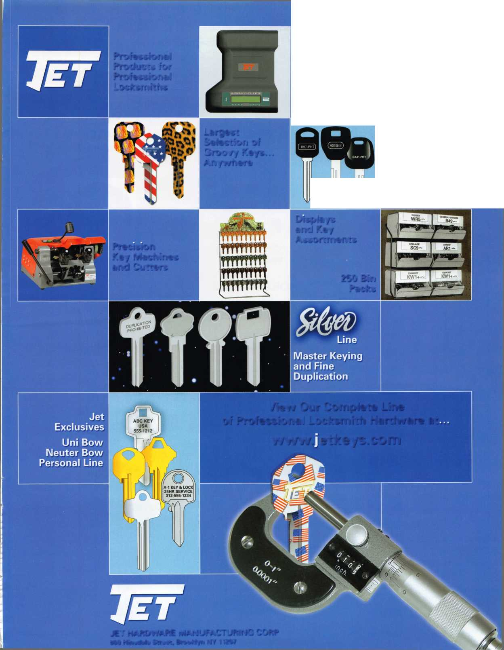

1

Meet the Boar

V

osted

6/8/ 7

Election Results

PRESIDENT

007

ASSOCIATE

DIRECTOR

Ken Kupferman, CML

SECRETARY

Dan Floeck, Jr.

NORTH  
WEST  
REGION  
DIRECTOR

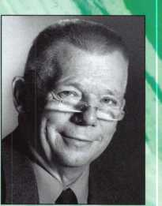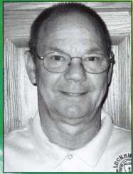

INTERNATIONAL

DIRECTOR

Hans Mejlshede, CML

John Soderland, CML, G

NORTH CENTRAL  
REGION  
DIRECTORS

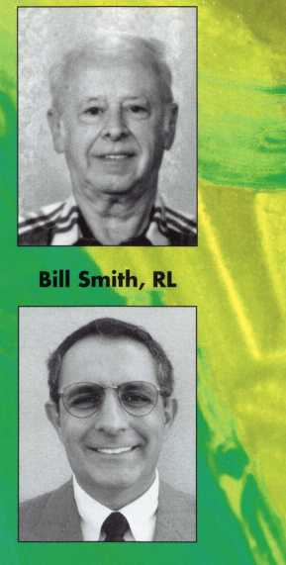

Guy Spinello, RL

Keith Whiting, CML, CFL

NORTH  
EAST  
REGION  
DIRECTORS

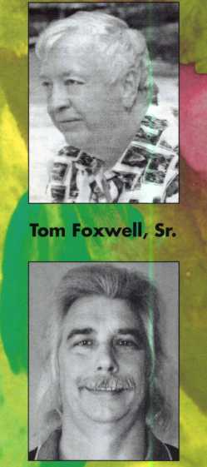

Robert (Bobby) DeWeese, CML

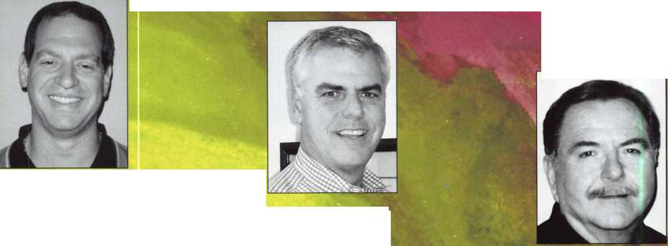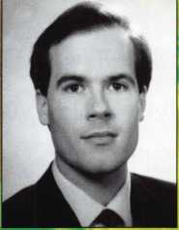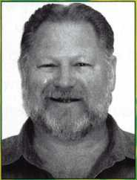

SOUTHWEST REGION  
DIRECTORS

**llfll**

Greg Parks, CRL

Gordon Racine, CML

Tom Gillingham, CML, CPS

SOUTH CENTRAL REGION DIRECTOR

Lipscomb, CML, CPS

SOUTH

EAST

REGION

DIRECTORS

TRUSTEES

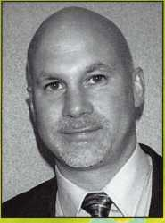

William Young, CML. CPS

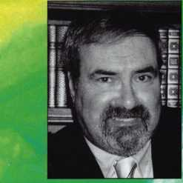

Robert Mock

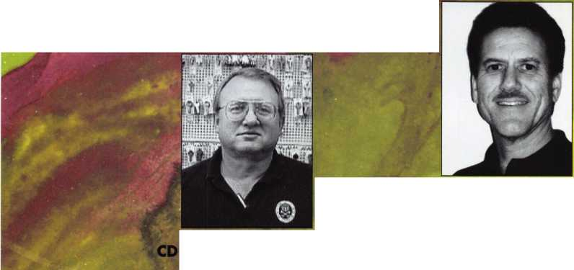

Lug Door Woes

By Greg Perry, CML, CPS

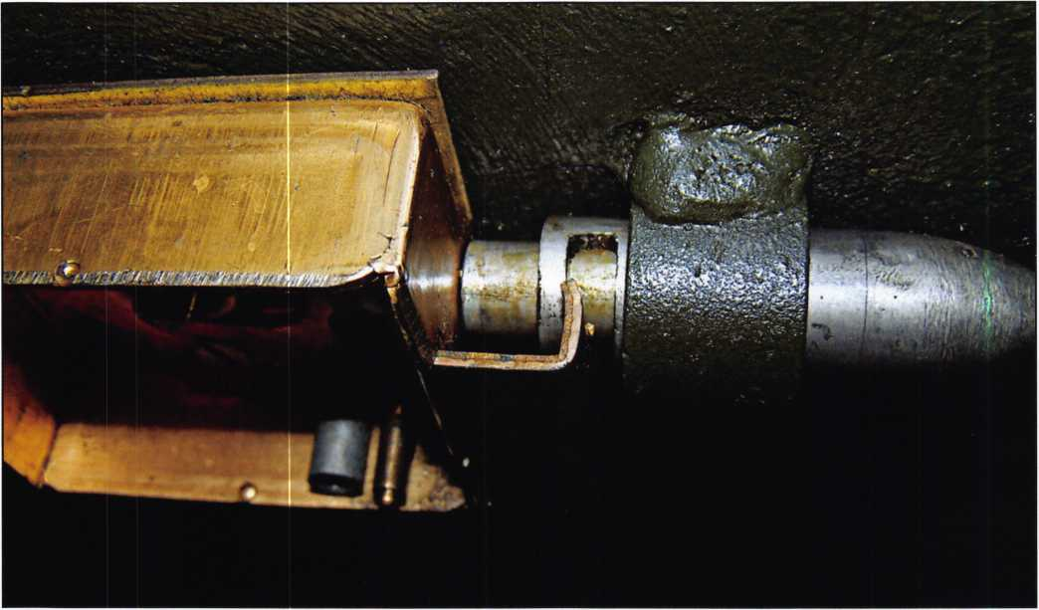

photo. 1

It just stopped working? A common customer complaint but many different causes, our job is to figure out why and open the safe, preferably without further damage.

The customer indicated another locksmith had changed the combination about 2 months prior. When they called him to open the safe he said it would take too many drill bits that cost $50.00 each and not worth his time. He claimed “The last one required eight bits and took him 8 hours”. This time I believe the problem should have been found and avoided during the last combination change with a proper service. My guess is the last guy never even removed the back cover plate. Instead he stuck a

change key in the lock and wrote a bill. Look at photo 1 and see if you can see a problem. From the outside sometimes it’s difficult to tell the vintage of the safe and which lock is inside. A few clues exist, the large T han­dle along with the dial and ring point to an older style lug door. So what lock is inside? A few choices exist, the R104 with a conventional fence design, and KCB107, or it’s possible that someone changed the lock out to something totally different. The lug door in ques-

Keynotes • July/August 2007

BIGrCrJlaJrfc

JUNE 15-22, 2008 • DALLAS, TEXAS

W

Strap on your cowboy boots! In 2008, we are cele­brating the 52nd annual ALOA Convention and Expo in Dal­las, Texas. ALOA 2008 of­fers plenty of exciting classes and seminars that will educate and expose you to some of the best security-related tech­nology the industry has to offer.

PLUS...MORE FUN!!

* Kick-Off Party
* ALOA Golf Tournament
* Tour
* Banquet
* Networking

**For more information about Dallas, Texas please visit: [www.dallascvb.com/visitors](http://www.dallascvb.com/visitors)**

**MEET VENDORS**

K

**CONTESTS**

Having built an international reputation among locksmiths as a powerful resource to ex­plore industry alliances, ALOA 2008 is the ideal place to learn, network or showcase your business on the show floor.

f

**For more information,  
visit us on the web at  
[www.aloa.org](http://www.aloa.org), or call  
us toll free at  
800.532.2562 ext.218  
★**

^ Strap Oil Your Cowboy Boots! Send complete information along with registration forms and a class description list.

Please send information regarding ALOA membership.

Name

Company

Address

Pho

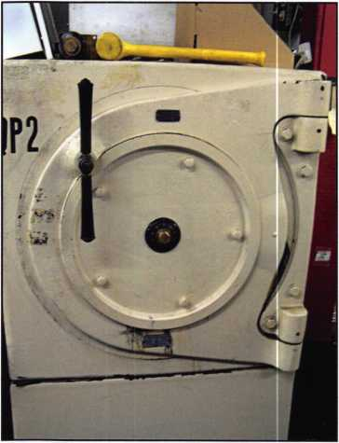

photo. 2

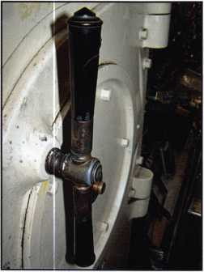

photo. 3

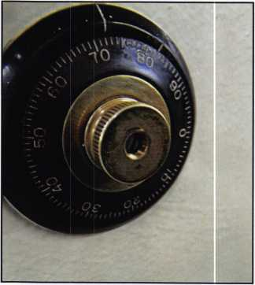

photo. 4

tion was made by Mosler Safe May 14, 1944, it has a KCB107 lock installed, discovered after the door was open. The customer indicated the dial was a little hard to turn the last time and now there is no feel to the wheel pack. He also said the label on the inside read 1944 for a manufacture date. Also missing was the feel of the fence against the drive cam. Dialing the combination and using a dead- blow hammer had no effect. So what is the problem

So what is the problem and where would you put the hole?

and where would you put the hole? My choice after looking at The Ed Willis drawings and Dave McOmie’s books was to drill for the flipper fence design at the fence, 3/8” down and 1 ” to the left of dial center. Normally this is not a great location to drill. This lock has a front mounted drive cam and the bolt assembly blocks most of the wheel pack view. Why choose this location? A very narrow gap allows a look at the wheel pack and if needed the fence can be manipulated or drilled off. The wheels can perhaps (I think or hoped) be manipu-

Keynotes • July/August 2007

Electronic

Timelock

Movements

Your benefits

1. Longer Battery life (up to 3-4 years depending on working conditions)
2. Smoother programming operation, thanks to the new hardware design
3. Improved reliability based on latest components and fully golden board contacts
4. No data loss for nearly 60 seconds during battery change

and still the largest range of mechnical movements in the industry...

Swiss made movements UL approved Timelocks

*iepee*

*Over*

microtechniques sa

Route de Neuchatel 15a CH-2072 Saint-Blaise/Switzerland

® +41 32 756 10 30 A +41 32 756 10 49

e-mail: info(Q)stbmicro.com website:[www.stbmicro.com](http://www.stbmicro.com)

Worlwide distribution

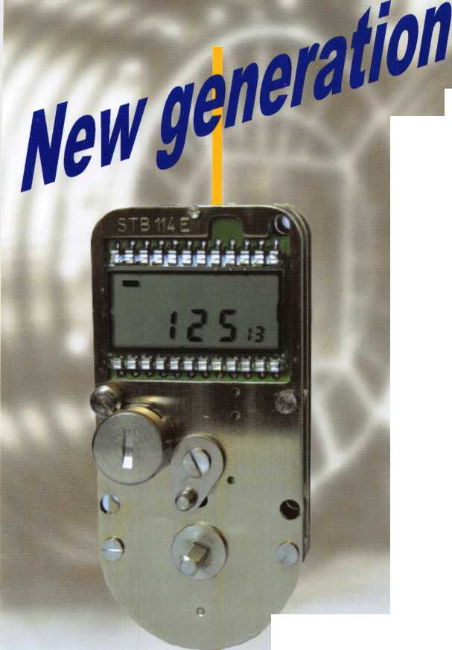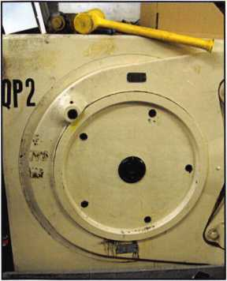

photo. 5

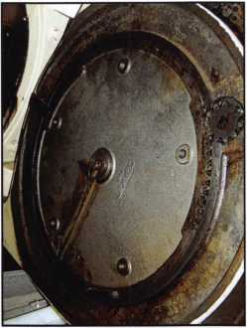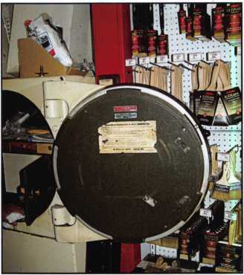

photo. 6

photo. 7

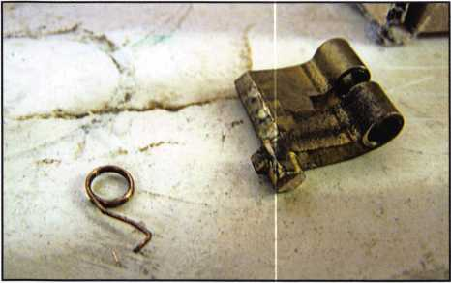

photo. 8

lated to drop in. The lock exhibited two possible prob­lems to me first I was unable to count any wheels. After removing the dial I tried an old trick of pushing in on spindle to try and regain the connection between the drive cam and wheel pack. A loose back cover on the lock with a front drive cam will sometimes regain the connection if a loose cover exists. It didn’t help the feel for the wheel pack. This is not always indicative of a real problem. My guess was just a very loose wheel pack, properly serviced it should have more feel. Sec­ond the lack of a feel from the fence. As it turns out the lever spring was broken causing the lack of feel. But why wouldn’t the vibrations from the deadblow hammer cause it to drop in? Did I give up too quickly?

As it turns out the lever spring was broken causing the lack of feel,

Drilling this door starts with removing the dial. The knob of the dial has a cap that when removed reveals a screw used to connect the outer portion of the dial and spindle to the inside portion of the spindle. Next the bolts seen in photo 5 holding the crane hinge need to be removed and the hinge swung away as seen in photo 6. Use caution as you swing the hinge away as the faceplate or attaching plate is free and may fall out of the hinge. The other thing to remember is to reattach the hinge prior to turning the safe door or your toes and/or the cus­tomer may complain about the floor. This door since it has a gear drive to turn the door is not likely to fall, but sometimes we just aren’t thinking clearly. Now you have room to drill right in to the door and the repair does

Keynotes • July/August 2007

Craft

your own career

in Locksmithing

Learn to be a locksmith at our conveniently  
scheduled hands-on morning program. Classes  
are given from 7:30 am - 12:30 pm. Over nine  
months you will learn to service, install and  
bypass a wide variety of locking devices including

residential, commercial and automotive locks. Master keying, electronic  
access, and safe manipulation round out a curriculum which is updated  
annually to incorporate the latest industry advancements. September and  
February admissions.

Other full-time courses offered are • Bookbinding • Cabinet & Furniture  
Making • Carpentry • Preservation Carpentry • Jewelry Making & Repair  
• Piano Technology • Violin Making & Repair

Financial aid is available for qualified students. Accredited member ACCSCT. Non-accredited workshops 1 week to 3 months also offered.

NORTH-BENNET-STREET-SCHGDL

AN EDUCATION IN CRAFTSMANSHIP 39 North Bennet St. • Boston, MA 02113 • (617) 227-0155

WAVw.nbss.org

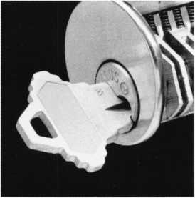

not show once the crane hinge is replaced. This door is case hardened, meaning it’s difficult to start and also exit. The outer surface penetrated without the use of a drill rig. The inner surface required setting up a lever rig. It probably would have drilled by hand with good shoulder pressure but I was concerned about exiting into the lock case and causing more damage. Once inside the lock case was drilled with a flat milled drill bit to not damage the bolt or fence. The hole was a little off but close enough to see the wheels line up and understand the problem.

Take a look back at photo 1 some time in the past the lock bolt was removed from the lock body and the relock bolt built into the lock bolt was not reset properly. Photo 9 shows the proper way the relock bolt needs to be set. The pressure of the relock bolt against the lock case cre­ated additional force pulling the bolt and flipper fence away from the wheel pack. This is why the vibrations would not drop the fence into the wheel pack. A very flat tension washer caused the lack of any feel from the wheel pack. This was easily fixed by bending the washer. But how do we fix the broken fence spring in

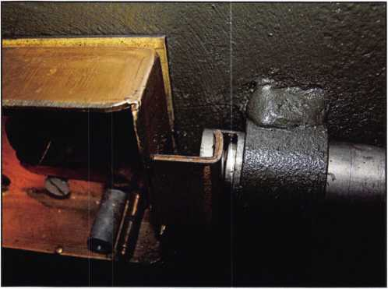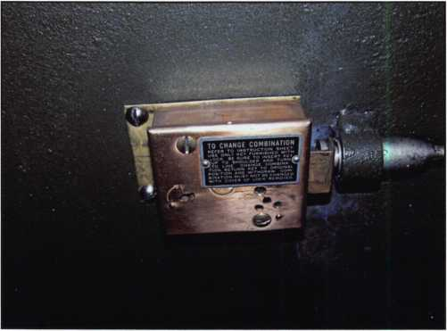

photo. 9

photo. 10

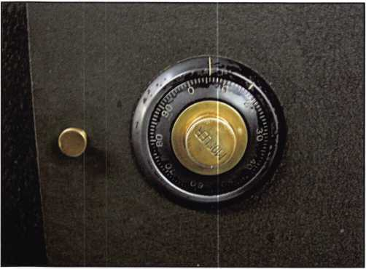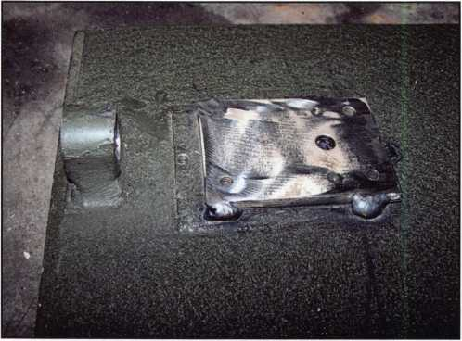

photo. 11

photo. 12

Keynotes • July/August 2007

:

ESL10XL

M

z •-

**L'** kTi

**BETTER THAN EVI**

**The new electronic lock**

American Security Products Company • 11925 Pacific Avenue • Fontana, CA 92337

Die-cast and brass or chrome plated to better match our safes. Slanted and attractive keypad.

[www.amsecusa.com](http://www.amsecusa.com) (800) 421-6142

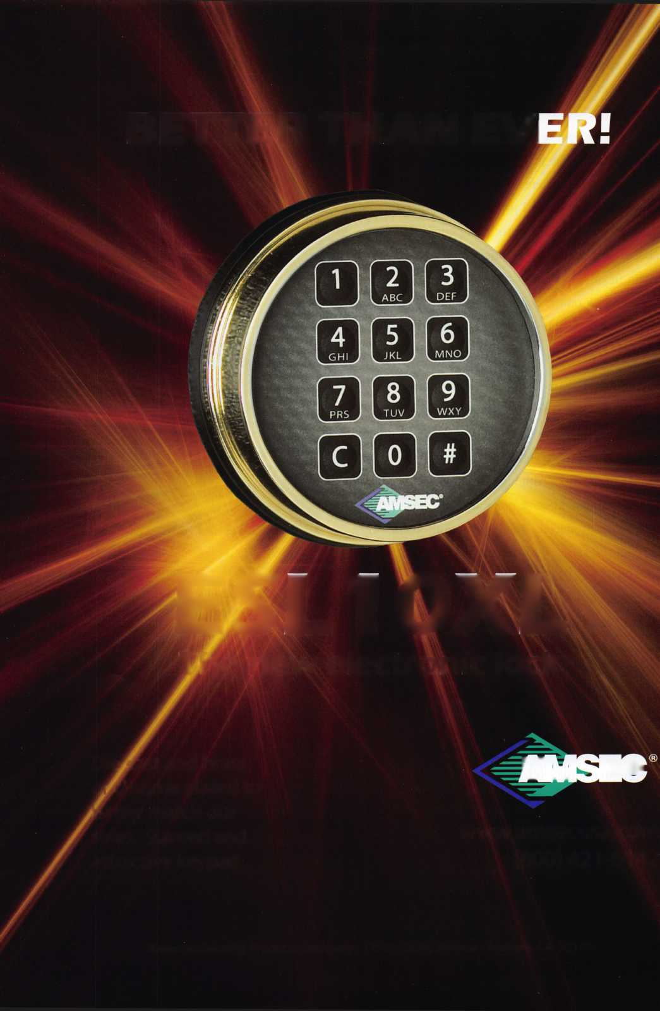

the lock? A couple of choices exist, take a look at pho­tos 10 an 11, the same lock exists on the inner door.

The easiest answer is to move the lock from the inner door to the outer door. Considering the time, this was the route I chose. This door is also a candidate for an electronic lock upgrade. The inner door was removed and taken back to my shop where an S&G 6730 lock was retrofitted to it, see photos 12 to 15. The important thing to remember when doing a retrofit like this is the connection between the lock bolt and the door bolt needs to remain flexible or floating. This is the reason the lock is moved back on the door and the gap between the lock bolt and the door bolt is bridged similar to the original design.

A few notes on this discovered while researching for this article. Maurice Jones, probably the most knowl­edgeable expert on Mosler products wrote an article in the June 1994 issue of Safe & Vault Technology titled Rise and Demise of the 302. Although the article fo­cused on the 302 it provided some great info on when particular locks were produced. The B-6 was built from 1927 to 1957, the 120 series was used predominately from 1958 to 1964 when the 302 series was developed. The 302 series locks were installed until 1991 when they switched to S&G locks. Mark Bates in his book Modem Safe locks indicates the KCB104 was produced from 1931 to 1957, I’m assuming the others in this fam­ily including the lock in this safe were produced during the that time frame.

The safe yielded to drilling with a couple of StrongArm drill bits in about 30 minutes, it took longer to set up the lever rig then it did to drill. I guess the other guy doesn’t know about modem safe drill bits.

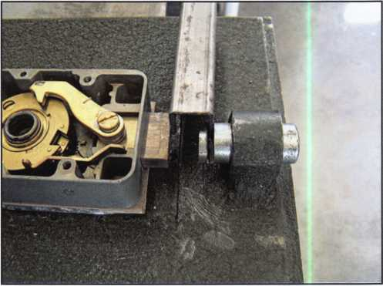

photo. 13

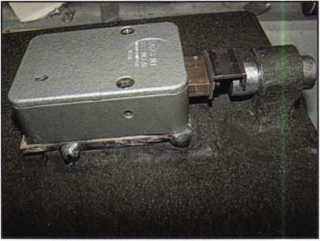

photo. 14

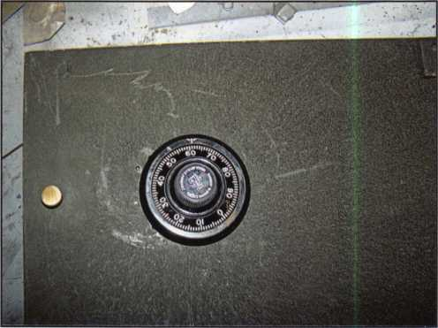

photo. 15



Keynotes • July/August 2007

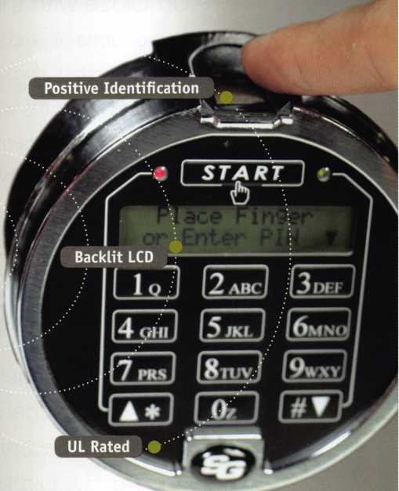

Authenticated Access

NEXT LEVEL OF SECURITY AND

ACCESS CONTROL

° Authenticated access - Only those  
with registered fingerprints can  
access safe

o Active Capacitive Technology -  
Reliable and only a live finger  
will open lock

o Backlit LCD - Signals when lock  
is open, easy to enroll and delete  
fingerprints

o Top-mounted fingerprint reader -  
Easy access

° Multiple user codes - Up to eight  
pass codes per lock

° Easy retrofit - Fits in the same  
space as most existing locks

o 24/7/365 live technical support -  
support when needed

Biometric Locks for  
Increased Security

With biometric locks you no longer need to worry about losing,  
forgetting or sharing the combination or PIN to your safe.  
Increase security with positive identification for safe access  
by combining a users fingerprint with a pin number. Your finger  
is your code and only those whose fingerprint has been  
registered can open the lock. Cash losses and internal theft  
are an unfortunate reality and since 1988 CSS has been helping  
to make retail and restaurant establishments more secure.

VISIT US AT ALOA  
BOOTH 804

TO MOVE AHEAD

To purchase a safe with a biometric Lock, or upgrade your existing Lock, please contact a CSS representative today at (800) 342-3033 x200.

To learn more about Corporate Safe Specialists' full range of biometric safes, products, services and cash management solutions, please visit [www.corporatesafe.com](http://www.corporatesafe.com).



© 2007 Corporate Safe Specialists, 14800 S. McKinley Ave, Posen, IL 60469

*Security » Innovation » Service*

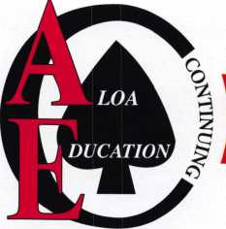

**ALOA 2007** SCHOLARSHIP **WINNERS!**

Up Close with the 2007 ALOA Scholarship Recipients.



We've done it again. For yet another year, the ALOA Scholarship  
Foundation has dug deep to provide free locksmithing instruction to those  
aspiring locksmiths who otherwise would have been unable to attend the  
biggest show of them all - ALOA 2006. The good people you are about  
to meet are the benefactors of ALOA Scholarship gifts representing thou-  
sands upon thousands of dollars.

Kristen Oldenburg

is new to  
lock-  
smithing  
having

begun her career as a  
locksmith less than a  
year ago. She wants to  
gain more knowledge of  
all aspects of lock-  
smithing and feels the  
educational opportunity  
that ALOA offers will be a  
great help in her success  
as a locksmith.

Chris Clasen

is eager to learn all that  
he can at the ALOA  
convention and feels it  
would be very beneficial  
to him and his new ca-  
reer in locksmithing. He

has partici-  
pated in sev-  
eral local  
training

courses, has been men-  
tored by two veteran  
locksmiths and has also  
joined the Minnesota  
chapter of ALOA.

Keith A. Gilmer

is a firm believer in ad-  
vancing his locksmith ed-  
ucation through the 2007  
ALOA Convention and

Expo. He  
also feels  
this would  
be a great

opportunity for him to re-  
ceive formal education to  
further his career as a  
locksmith.

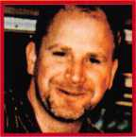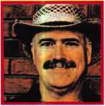

Keynotes • July/August 2007

Get started here.

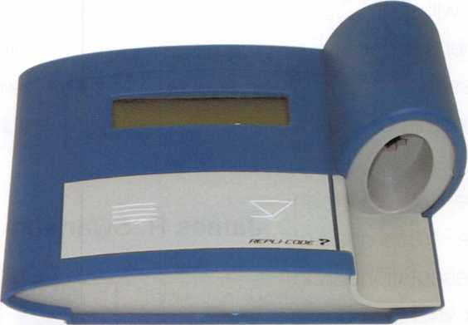

Repli-Code7TX

See your authorized  
Blanchi distributor  
for details!

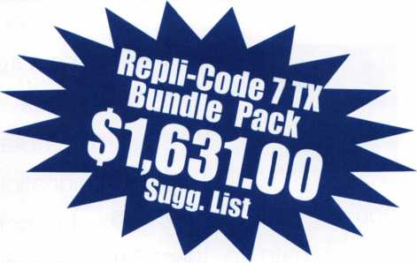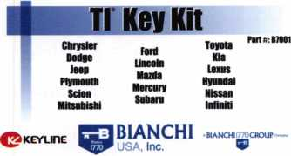

wwwMaactt1779usa£sa [Mo@ttaecM1770usa.com](mailto:Mo@ttaecM1770usa.com) 809 891 2118 716 803 0202 fai

|  |  |  |  |  |  |  |  |  |
| --- | --- | --- | --- | --- | --- | --- | --- | --- |
| «  I  sms no | L  u | 1720 | u  \l/  IT1MB | l  lit | J  Y430 | L  IN | J  i  nos | U |
| u  irtuta | V'  ITtVUO | | V | L  \ | J  / | L | J  ) | 3, - 3—  lumeo |

Tl Key Kit  
(B7001)

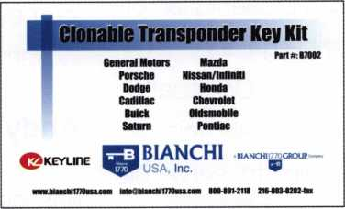

|  |  |  |  |  |  |
| --- | --- | --- | --- | --- | --- |
| a  T  HUNTS | 1 1  Q | T  1191 PT5 | 1 ®  i | ?  BS1S3-TT5 | trmm |
| a | 0 | s | 6  1 " 1 | 8 |  |

Clonable Transponder Key Kit

(B7002)

Program 75%* of transponder vehicles on the road  
with the Repli-Code 7 TX Bundle Pack

**a BIANCHI1770GROUR** Company

**9**

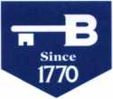

**BIANCHF**

USA, Inc.

800.891.21t8

[www.bianchi1770usa.com](http://www.bianchi1770usa.com)

*Estimated amount



**ALOA 2007** SCHOLARSHIP **WINNERS!**

Jeffrey M. Gater

has 30 years  
experience  
in the lock-  
smith trade

and is ready to take his  
career path to the next  
level, teaching. He would  
like to learn the necessary  
skills in class preparation  
and topic presentation of-  
fered through the ALOA  
Instructor Certification  
Class. He feels this will  
enable him to serve his  
fellow tradesmen and  
women through educa-  
tion.

Tom Martinson

has been an aspiring locksmith since his years in highschool. He is very eager to learn the trade. He feels attending the

ALOA con-  
vention will  
be a tremen-  
dous asset

in obtaining his CRL des-  
ignation. He also believes  
the convention will be an  
invaluable reservoir of  
ideas, presentations, and  
seminars increasing his  
marketability to become a  
journeyman for a local  
locksmith.

Andy Billheimer

has been interested and  
involved in the lock-

smithing field  
for 5 years.  
He also feels  
his knowl-

edge is very limited and is  
very enthusiastic to learn  
as much as he can. He  
so far has attended one  
ALOA convention taking

classes the entire week.  
He also believes with  
more knowledge his skills  
will become more efficient  
and his career will ad-  
vance further.

James R. Swanson

has been  
an ALOA  
member  
since 2006.

He believes training and experience are the only true ways he can provide the best quality work and solutions for his employer and customers. As an in­stitutional locksmith for a hospital he gains a great deal of satisfaction provid­ing security and life safety for the patients and his fellow employees.

Through training and classes he can improve

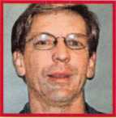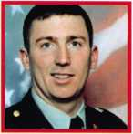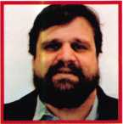

Keynotes • July/August 2007

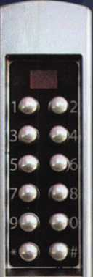

**The Narrow Stile Solution**

**You've Been Wanting**

E-PLEX

**3000**

Aesthetically Pleasing Design

Retrofits to Various Adams Rite® Hardware

Latch Holdback for True Storefront Applications

Electronic Access Control

300 Users/9000 Event Audit Trail

Programmable at the Door or Via Optional  
Software

Simple Installation

Non-Handed, Field Reversible

Passage and Lockout

Satin Chrome and Dark Bronze Finishes

3 Year Warranty

**..and it has E-Plex Simplicity and Reliability**

**E’PLEK 5000 SERIES**

For additional access control features, look to the complete line of E-Plex with multiple lock­ing devices, audit capability, card access, soft­ware based management, access schedules and various finishes.

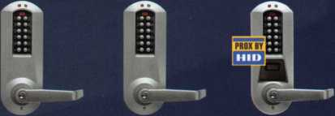

**5000 5200 5700**

**Kaba Access Control 1.800.849.8324 [www.kabaaccess.com](http://www.kabaaccess.com)**

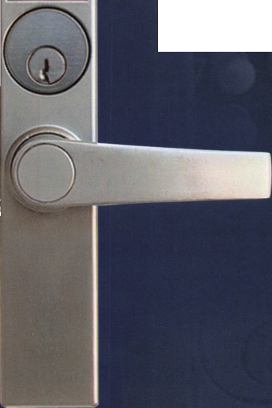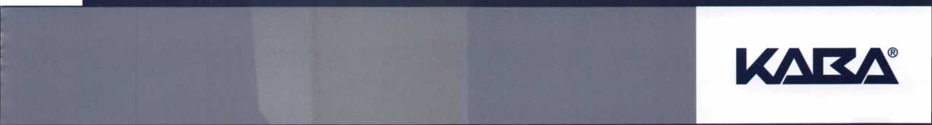

**ALOA 2007** SCHOLARSHIP **WINNERS!**

his skills and gain more  
knowledge to acheive his  
CRL classification.

Tom Krafcik

has been working as an  
apprentice locksmith for  
four years and his knowl-  
edge of the industry con-

tinues to  
grow. He  
tries to keep  
up-to-date

by reading locksmith  
magazines and lock-  
smithing books outside of  
work. Since starting out  
as an automotive tech, his  
tasks have grown to in-  
clude residential, com-  
mercial, safe work, and  
even access control. Over  
time he has developed  
very valuable work experi-  
ence and now feels it is  
time to gain the technical

knowledge that comes  
with being an ALOA certi-  
fied locksmith. This will  
propel him towards fulfill-  
ing his short-term and  
long-term goals of be-  
coming a master in the  
trade.

Robert Bayron

has been a locksmith for  
25 years and hopes to  
acheive his Master level  
soon through the help of  
ALOA. He looks foward to  
learning more about many  
of the technological ad-  
vance made in the lock-

smith  
industry. Re-  
cently he  
has been

given the opportunity to  
work on the sales end on  
the industry. He believes  
becoming an educated

salesman with both expe­rience and the drive will enable him to provide the best assistance for both the customers and my fel­low employees. He would like to continue his educa­tion by taking various courses in locksmith and security related subjects, which he hopes will en­able him to work suc­cessfully with the many changes and challenges in this constantly chang­ing environment.

Andrea Parsons

has spent the last four years working with her locksmith husband ob­serving the daily opera­tions of a successful lock shop. She is hoping that soon she and her hus­band will be able to have

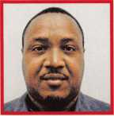

**2**

Keynotes • July/August 2007

Come visit us at the ALOA Trade Show in Charlotte, NC for full details and a demonstration, v ‘Booth #1102’

* No Wiring _ No Drilling _ No AC Power
* **Installation time Reduced t**o 30 Minutes per Door
* Increase Business & Profits Dramatically
* Developed by Long-time Industry Professionals
* Purchase Direct from Manufacturer

. And it’s

Personal Computer



IMOVATIOI I

**wireless** Access **control systems**

***Profit More... Wire* /.ess™**

**888-99 7-33 72 • [www.novwireless.com](http://www.novwireless.com)**

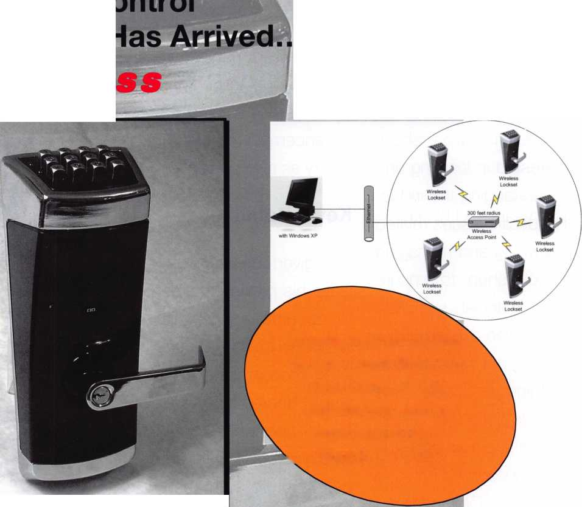

**ALOA 2007** SCHOLARSHIP **WINNERS!**

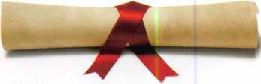

their own  
lock shop  
with enough  
hard work

and determination. She is  
interested in learning and  
understanding the indus-  
try specific issues related  
to owning and managing  
a lock shop to ensure  
their financial success.  
She is also excited about  
learning the trade of lock-  
smithing as well. She  
plans to obtain her CRL in  
August and then continue  
her education until she  
obtains her CML certifica-  
tion. She firmly believes

education, professional­ism, and courtesy are keys no only to personal success but also to the advancement of the in­dustry as a whole.

Kevin Potter

was given the chance to leave his previous career to become a locksmith within the past two years. Even though it meant a wage decrease he felt this opportunity could lead him to a brighter and better future with many opportunities for a suc­cessful career. He is very

much looking forward to  
learning and developing  
his skills for his career as  
a locksmith. Not only

does he be-  
lieve he will  
become  
more of an

asset to his company and  
trade, but he will feel  
more confident with pro-  
viding his children with a  
good future.

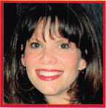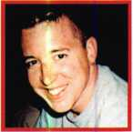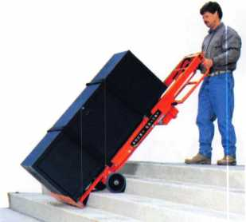

STAIR CLIMBING SYSTEM

Visit us online at:

[www.lectrotruck.com](http://www.lectrotruck.com)

...or call us today at:

800**-**619-0625

The Lectro-Truck will make it easier for you to break back a load, climb and descend steps, and even load onto your truck or trailer!

Save on damage costs.

Save on injury costs.

Save on labor costs.

The bottom line: You save money!!

The Lectro-Truck makes this all possible - all while having a 1500 # capacity!! Call us today to find out what you have been missing.

STATE OF THE ASSOCIATION

ALOA continues to offer you more for your money by working smarter for you

By Charles W. Gibson, Jr., CAE, Executive Director

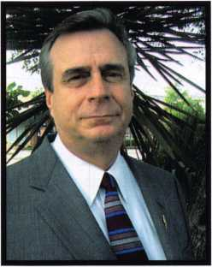

The Board of directors requires that I report to the Membership annually concerning the  
state of the association and its financial condition. The Board has established "Ends", or  
goals, for the association. The staff then determines and carries out the "Means" to achieve  
these Ends. The Board has established five Ends. These Ends in order of priority are Legisla-  
tion, Communication, Education, Recognition and Professionalism. I make periodic reports  
to the Board concerning progress toward these Ends. The reports are on our web site  
[www.aloa.org](http://www.aloa.org). The report I am making to the membership in this issue of Keynotes is a  
shorter version of these reports. For a better understanding of the manner in which the as-  
sociation is governed, members are invited to read the Board's Governance Policy. The pol-  
icy is available on line at [www.aloa.org](http://www.aloa.org). You may also request a copy by contacting the  
ALOA office at (800) 532-2562.

END 1: LEGISLATION

It's been a busy year so far, as the ALOA Legislative Depart­ment closely monitored over 35 bills (after reading through 700!). We also had some successes: amending a Montana bill so that locksmiths may install CCTV and access control devices without having to get an alarm license; making some changes in the Tennessee law to keep it from being re­voked; defeating legislation in Oklahoma that would have rescinded the recently enacted locksmith licensing law and a last-minute attempt by foes in that state to insert language to open a wide loophole into the law.

ALOA continues to monitor statehouses in Massachusetts, North Carolina, New Jersey and Ohio that are still in ses­sion with important bills pending.

We've also had tremendous success with wide press cover­age of the "phony locksmith" issue. In many news reports, ALOA's is cited as the "go to" source for more information. This nationwide effort has influenced states to introduce locksmith licensing legislation. So far, Florida, Georgia, Hawaii, Maryland and Wisconsin are working on legisla­tion for 2008.

In April, ALOA Legislative Manager, Tim McMullen, JD,

CAE made a follow-up presentation to the National Associ­ation of Attorney's General Consumer Protection Committee regarding the issue of "phony locksmiths". At the last year's presentation to them, the Attorney's General noted that they must receive complaints from consumers before pursuing. In response, ALOA created a complaint page accessible from the front page of the ALOA website. A Press Release was distributed to the media, and Tim has already been getting follow-up calls. You can take a look at the page (and refer people to it) at: <http://www.aloa.org/AGMap/AG.htm>

Tim also asked that the Attorney's General to post ALOA's

10-point checklist for consumers for detecting companies that may be engaging in this scheme. He also presented them a 53-page compilation of phone book page ads and internet listings as a sample of this widespread problem. ALOA offered to work with Consumer Protection Divisions to improve the enforcement and information exchange among the states with respect to investigations, litigation and con­sumer education.

END 2: COMMUNICATION

"Communication" was changed from priority four to two at last fall's Board Meeting. The Board intended, through this change, to increase the association's focus on communica­tion.

I have just finalized a contract with a provider of an associ­ation management software. Separately we will redesign and improve the website. These two projects together will create a number of the capabilities that the Board has asked for. On-line maintenance of membership data by the mem­ber, on-line convention registration, one password for the site and a secure member forum are among these capabili­ties. These changes will take time. We have provided sam­ples of data to the software company. They will have to write the program(s) necessary to transfer data from our ex­isting program to the new one. In addition, program(s) must be written to transfer the data from the current PRP data­base to the new program. All of these things must be tested, the functionality of the new on-line features must be tested. The staff has to be trained. Before the end of the year, the capabilities described above should be operational.

Keynotes • July/August 2007

**65**

END 3: EDUCATION

From July, 2006 thru July 14, 2007, the ALOA Continuing Education (ACE) program conducted 194 full day and 46 half-day ACE classes & seminars at 33 locations. This amounts to a total of 4,064 student class days conducted in the last year. It should be noted that 107 of these full day classes were conducted away from the ALOA convention throughout the US and Canada. Over the past several years, well more than half of ALOA's education has been away from the ALOA convention. This makes certification and re-certifi­cation easier for members. The ALOA Training Center is in its second year of operation. The Center is in Dallas at the ALOA Headquarters. The schedule continues to grow with three Six-day Basic Locksmithing Courses, a Three-day Auto­motive Locksmith course and many more classes planned for the remainder of 2007 and 2008. We have also conducted business ethics classes for Texas locksmith licensing require­ments in the Center.

Proficiency Registration Program (A Component of Educa­tion):

Since July 1,2006, we administered the PRP at 50 regular sittings with 480 participants since July 2006. In addition there were 45 ACE classes that provided after class PRP exams. There were 368 students that chose the option to take the after-class PRP's. The pass rate for these exams is 89%. There are 5 new CML's, 11 new CPL's and 78 new CRL's. As of July 1,2007 there are 722 CML's, 663 CPL's, 2811 CRL's and RL's (646 grand fathered RL's). There are 3751 regis­trants in the program who have taken but not passed some portion of the CRL requirement. There are a total of 7947 participants in the PRP database at this time. ALOA also ad­ministers the SAVTA STPRP. There are 11 CMST's, 209 CPS's and 205 who have taken and not passed the CPS or CMST exam.

END 4: RECOGNITION

I am a member of the Board of Directors of The National Auto­motive Service Task Force, Inc. (NASTF). My participation in the group brings ALOA to the attention of many associations, automobile manufacturers and other organizations in the auto­motive industry. The National Insurance Crime Bureau (NICB) also works with NASTF. Because of this the NICB is much more aware of ALOA and its member locksmiths. Bill Young (past president of ALOA) and Ken Kupferman (president elect) are both members of the Vehicle Security Committee of NASTF. Their participation with this committee also serves to fulfill this End. In addition, it is the purpose of NASTF to facilitate distri­bution of after market repair information from manufacturers. In our case, this is mechanical key codes and electronic infor­mation such as PINs.

The primary effort in increasing the use of the logo during the past year was the use of the slogan, "Locksmiths You Can Trust". This slogan has been printed with the ALOA logo. It was unveiled to the membership in Keynotes and in a sepa­rate mailing in February. We have had very good response to this initiative.

Advertisements will be published throughout the year in Maintenance Solutions and Security Solutions for the Enter­prise Leader as a way to increase ALOA recognition. Mainte­nance Solutions has 35,000 subscribers that are facility decision makers representing both institutional and commer­cial buildings. Our focus was membership recruitment. Our ads in Security Solutions for the Enterprise Leaders are to pro­mote ALOA's certification, education and training center. The audience is 31,000 subscribers comprised of Security/Loss Prevention, Executives and Financial Managers and Facili­ties/Operations Managers.

END 5: PROFESSIONALISM

Following the adoption of the requirement to obtain a profi­ciency designation to maintain membership, I expected a drop in the membership renewal rate. Our renewal rate for 2006 was lower than 2005. However, so far in 2007 re­newals are quite good. Requests for education and PRP sit­tings for 2007 are also up. It appears that many members, local associations and chapters are preparing to meet the standards rather than drop out because of them.

ALOA has participated with several industry groups on many issues. David Lowell, CML, CMST represents ALOA on the UL Standards Technical Panel for Physical Security Devices, (STP 687) which this last year updated the standards for UL 0680

* Emergency Vault Ventilators and Vault-Ventilating Ports, UL 140 - Standard for Relocking Devices for Safes and Vaults, UL291 - Automated Teller Systems, UL1034 - Burglary Re­sistant Electric Locking Mechanisms...They are continuing to work on a proposed High Security Electronic Locks Standard
* UL2058 and have formed a Task Group to review the re­quirements of UL1034 - Standard for Burglary-Resistant Elec­tric Locking Mechanisms. David also represents ALOA on the American Society for Testing Materials (ASTM International) Security Systems and Equipment Committee F-l 2 which is meeting in April 2007 (Subcommittee F 12.50 Locking De­vices) to address the issue of bump keys and to distinguish the levels of protection that may be provided for this and other surreptitious attacks in a comprehensive standard.

**66**

Keynotes • July/August 2007

FINANCIAL REPORT

The firm of Sutton Frost Cary was engaged to audit the 2006 ALOA financial records. The ALOA Audit Committee has reviewed this report. Parts of the Audit, the "Statement of Financial Position" (Balance Sheet) and the "Statement of Activities" (Profit and Loss) are printed with this article.

The Auditor found that ALOA's financial records fairly and accurately portray ALOA's financial po­sition.

The most positive aspect of ALOA's 2006 financial activity was a much reinforced cash position. ALOA gained $267,000 cash. The major part of this was the effort to convert "accounts payable" into cash. ALOA's operations also yielded a small profit. The purpose of ALOA is not to make money. The purpose is to provide specified services to members. It is however, necessary to be sta­ble financially to provide services.

ALOA continues to be financially capable of providing the services specified by the Board of Directors.

STATEMENT OF FINANCIAL POSITIONS

2006 2005

Assets

Current assets:

|  |  |  |
| --- | --- | --- |
| Cash | $ 800,492 | $ 533,319 |
| Certificate of deposit | 70,266 | 67,669 |
| Accounts receivable | 227,313 | 271,759 |
| Inventory | 62,265 | 63,993 |
| Prepaid expenses | 109,933 | 202,933 |
| Due from affiliates | 55,013 | 27,969 |
| Current portion of notes receivable from affiliates | 20,166 | 18,995 |
| Total current assets | 1,345,448 | 1,186,637 |
| Property and equipment: | | |
| Land | 97,500 | 97,500 |
| Building and improvements | 669,283 | 643,873 |
| Furniture and equipment | 293,073 | 269,955 |
| 1,059,856 | 1,011,328 |
| Less accumulated depreciation | (245,282) | (179,900) |
| Property and equipment, net | 814,574 | 831,428 |
| Notes receivable from affiliates, less current portion | 81,343 | 101,509 |

$ 2,241,365 $ 2,119,574

Liabilities and Net Assets

Current liabilities:

|  |  |  |
| --- | --- | --- |
| Accounts payable | $ 127,145 | $ 97,970 |
| Accrued expenses | 46,446 | 58,358 |
| Prepaid dues | 508,696 | 455,510 |
| Prepaid exhibit fees | 536,624 | 486,750 |
| Total current liabilities | 1,218,911 | 1,098,588 |
| Net assets - unrestricted | 1,022,454 | 1,020,986 |

$ 2,241,365 $ 2,119,574

STATEMENT OF ACTIVITIES

2006 2005

|  |  |  |
| --- | --- | --- |
| Revenues: | | |
| Membership dues and services $ | 907,225 | $ 927,263 |
| Convention | 1,094,758 | 821,410 |
| Management fee | 168,000 | 156,000 |
| Legislative income | 145,156 | 147,926 |
| Advertising | 124,134 | 124,458 |
| Promotional programs | 60,675 | 47,025 |
| Interest | 26,146 | 26,240 |
| Educational programs | 111,743 | 124,172 |
| Miscellaneous | 15,142 | 728 |
| Total revenues | 2,652,979 | 2,375,222 |
| Expenses: | | |
| Administrative | 1,420,032 | 1,464,273 |
| Convention | 627,013 | 435,862 |
| Keynote magazine | 161,450 | 177,763 |
| Building operations | 69,681 | 77,676 |
| Member services | 73,617 | 77,622 |
| Depreciation | 65,382 | 47,246 |
| Promotional programs | 23,077 | 47,287 |
| Educational programs | 157,899 | 158,352 |
| Legislative expense | 44,166 | 56,881 |
| Committee | 9,194 | 8,096 |
| Moving expense |  | 101,278 |
| Total expenses | 2,651,511 | 2,652,336 |
| Excess income (deficit) from revenue over expenses | 1,468 | (277,114) |
| Gain on sale of property | - | 977,165 |
| Increase in net assets | 1,468 | 700,051 |
| Net assets at beginning of year | 1,020,986 | 320,935 |

Net assets at end of year $ 1,022,454 _$__Lf|20^986_

Keynotes • July/August 2007

**67**

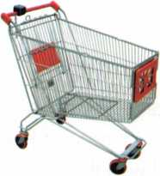

keynotes

Buyer's

Marketplace

ijjjl **SAFE CORPORATION**

Still the most popular

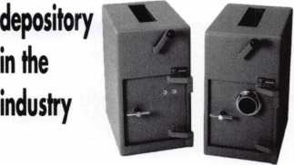

AB-3K AB-3C

800-253-1267

114 S. Delsea Drive, Suite 3 856-863-1186

Glassboro, NJ 08066 Fax 856-863-1208

IN-STOCK...MORE SAFES

***FREE Freight Program***

***(30 States)***

**AMSEC** RreKing

**Badal hayman**

MEIUNK y/CTOR

**TURD lO**

**WHOLESALE SERVICE**

800**-**848-9790

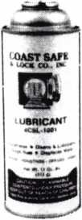

Using a general purpose  
lubricant? Be professional!  
Use a specially formulated  
lubricant for the Locksmith  
and Safe Technician trade.  
You and your customers will  
be well pleased. Guaranteed!

$48°° + shipping per case.

12 -1 loz. cans per case minimum order.  
Order via phone or fax. Credit cards accepted.  
Net 30 W.A.C. or send check with order.

Coast Safe & Lock Co., Inc.

P.O. Box 66257 • Mobile, AL 36606  
(251) 479-5264 • Fax (251) 471-6967

Keynotes • July/August 2007

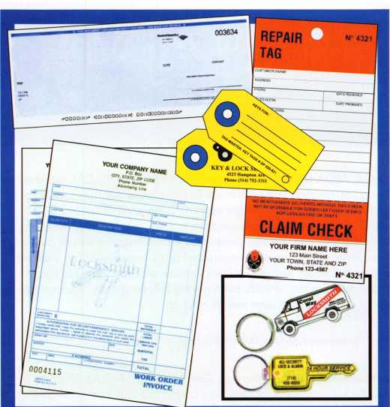

|  |  |  |
| --- | --- | --- |
| **Professional Busi** | | **iness Products** |
| **Invoices** | **Tags** | Call for a free |
| **Checks** | **Key Fobs** | brochure and samples |
| **Business** | **Magnets** | **1-800-355-6322** |
| **Cards** | **Labels** | [www.pbp2000.com](http://www.pbp2000.com) |

.

You need it When?

**How about now!? :-)**



Another Special  
Value-added Benefit to your

ALOA Membership! Click here

**i**L

[www.clearstar.com](http://www.clearstar.com) / ALOA

**CHECK & CREDIT CARD STATE-OF-THE-ART**

**TRANSMITTER FOR MOBILE PROFESSIONALS**

**SAVE TIME, ELIMINATE RISK. SAVE MONEY!**

^ **NO NSF’s!**

No More Bad Checks

& No More Driving to the Bank with Deposits!

Offer your Clients the Convenience of Paying by  
Visa, MasterCard, Discover or American Express -  
Attract New Customers, Improve Cash Flow

\ **ON-THE-SPOT FUNDS AUTHORIZATION!**

^ **DEPOSITS WIRE-TRANSFERRED TO** I I ANY CHECKING ACCOUNT!

*vis*

HI

Payment Processing Technologies LLC. is registered ISO/MSP of Chase Paymentech  
Solutions, LLC., Electronic Check Conversion & Guarantee Services by Global eTelecom

Keynotes • July/August 2007

**6**

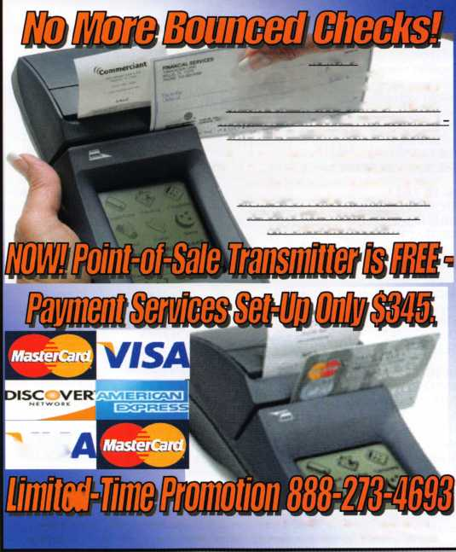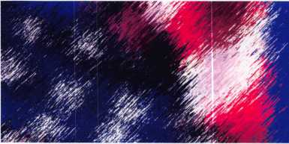

I e g i s I a t i date

v e



**KEYNOTES - JULY/AUGUST**

It's been a busy year so far, as the ALOA Legislative Department closely monitored over 35 bills (after reading through 7001). We also had some successes: amending a Montana bill so that locksmiths may install CCTV and access control devices without having to get an alarm li­cense; making some changes in the Tennessee law to keep it from being completely revoked; defeating legislation in Oklahoma that would have rescinded the recently enacted locksmith licensing law and a last-minute attempt by foes in that state to insert language to open a wide loophole into the law.

ALOA continues to monitor statehouses in Massachusetts, North Car­olina, New Jersey, Pennsylvania and Ohio who are still in session with important bills pending.

We've also had tremendous success with wide press coverage of the "phony locksmith" issue. In these news reports, ALOA's is constantly cited as the "go to" source for more information. This nationwide effort has influenced states that now desire to introduce locksmith licensing leg­islation. So far, Florida, Georgia, Hawaii, Maryland and Wisconsin have expressed interest to introduce legislation in 2008.

In April, ALOA Legislative Manager, Tim McMullen, JD, CAE made a fol­low-up presentation to the National Association of Attorney's General Consumer Protection Committee regarding the issue of "phony lock­smiths". At the last year's presentation to them, the Attorney's General noted that they must receive complaints from consumers before pursuing. In response, ALOA created a complaint page accessible from the front page of the ALOA website. A Press Release was distributed to the media, and Tim has already been getting follow-up calls. You can take a look at the page (and refer people to it) at:

http: //www. a loa. org/AGMa p/AG. h tm

Tim also asked that the Attorney's General to post ALOA's 1 0-point checklist for consumers for detecting companies that may be engaging in this scheme. He also presented them a 53-page compilation of phone book page ads and internet listings as a sample of this wide­spread problem. ALOA offered to work with Consumer Protection Divi­sions to improve the enforcement and information exchange among the states with respect to investigations, litigation and consumer education.

**ALOA Legislative Report (As of June 15, 2007)**

**AL HB 754/SB 754**

SPONSER: Barton

TITLE: Electronic Security Board of Li­censure ABSTRACT:

This bill would provide further for the definitions of an alarm system by adding "fire alarms" and would pro­vide clarification concerning the exemp­tion for electrical contractors STATUS:

DID NOT PASS.

SESSION ADJOURNED.

**CT HB 7268**

SPONSER: Public Safety and Security Committee

TITLE: An Act Requiring the Registration of Electronic Security Alarm Companies ABSTRACT:

To require that electronic security alarm companies register with the Department of Consumer Protection, and to require that all employees of such companies submit to criminal history records checks or comprehensive background checks. Language of electronic security includes access control and CCTV. STATUS:

DID NOT PASS.

SESSION ADJOURNED.

**HI HB 188**

SPONSER: Evans

TITLE: Locksmith Licensing

ABSTRACT:

Requires licensing for locksmiths. STATUS:

DID NOT PASS.

SESSION ADJOURNED.

**HI HB 423**

SPONSER: Herkes TITLE: Motor Vehicles ABSTRACT:

Requires motor vehicle manufacturers to allow registered owners through a reg­istered locksmith to access information necessary to produce replacement keys.

STATUS:

DID NOT PASS.

SESSION ADJOURNED.

**HI SB 1011**

SPONSER: Taniguchi TITLE: Motor Vehicles ABSTRACT:

Requires motor vehicle manufacturers to allow registered owners through a reg­istered locksmith to access information necessary to produce replacement keys. (SB 101 1 HD1)

STATUS:

DID NOT PASS.

SESSION ADJOURNED.

**IA HF 897**

SPONSER: Ways

TITLE: Electrician Licensing

ABSTRACT:

This bill adds alarm licensing to current electricians law. Alarm system is de­fined as a system or portion of a combi­nation system that consists of components and circuits arranged to monitor and annunciate the status of a fire alarm, security alarm, or medical alarm or supervisory signal/initiating devices and to initiate the appropriate response to those signals. This is a defi­nition of alarm system that ALOA ap­

proves.

STATUS:

BILL PASSED.

SESSION ADJOURNED.

**KY HB 481**

SPONSER: D. Graham TITLE: AN act relating to motor vehicles.

ABSTRACT:

Create a new section to prohibit any person from producing an ignition key or other device designed to operate a lock on a motor vehicle or start a motor vehicle for any person on the basis of a motor vehicle identification number (VIN) without obtaining and making a record of proof that the person request­ing the ignition key or other device is the owner or lessee of the motor vehicle or is a member of the same household as the owner or lessee of the vehicle. STATUS:

DID NOT PASS.

SESSION ADJOURNED.

**MA SB 1989**

SPONSER: Richard R. Tisei

TITLE: An Act Relative to Modernizing

the Requirements for Electrical Trade

Practice

ABSTRACT:

This bill provides for the licensing of electricians over "Security Systems" which the definition includes access control.

STATUS:

Hearing Scheduled 06/05/2007

**MD HB 903**

SPONSER: Davis, Impallaria,

N. King, Montgomery, Myers, and Taylor

TITLE: Vehicle Laws - Consumer Access to Replacement Key Information ABSTRACT:

Requiring a manufacturer of a motor ve­hicle sold or leased in the State on or after January 1, 2010, to implement a system for providing specified replace­ment key information to registered lock­smiths; requiring a motor vehicle manufacturer to make a specified key replacement system available to regis­tered motor vehicle owners or lessees 24 hours a day and 7 days a week; es­tablishing procedures for a registered locksmith and a motor vehicle manufac­turer to follow to provide a replacement key to a motor vehicle owner or lessee; etc.

STATUS:

DID NOT PASS.

SESSION ADJOURNED.

**MD SB 707**

SPONSER: Hooper, Forehand, and Munson

TITLE: Vehicle Laws - Consumer Access to Replacement Key Information ABSTRACT:

Requiring a manufacturer of a motor ve­hicle sold or leased in the State on or after January 1,2010, to implement a system for providing specified replace­ment key information to registered lock­smiths; requiring a motor vehicle manufacturer to make a specified key

Keynotes • July/August 2007

replacement system available to regis­tered motor vehicle owners or lessees at all times; making the Act contingent on the enactment of specified legislation; etc.

STATUS:

DID NOT PASS.

SESSION ADJOURNED.

**MT SB 153**

SPONSER: Cocchiarella TITLE: Revise professional and occupational licensing laws ABSTRACT:

Bill originally changed definition of "Se­curity alarm system" to mean, "an as­sembly of equipment and devices or a single device, designed or a portion of a system intended to detect or signal or to both detect and signal unauthorized intrusion, movement, or criminal acts at a location. Exempts locksmiths who may install CCTV and battery operated door devices.

STATUS:

BILL PASSED.

SESSION ADJOURNED.

**NC H 1746**

SPONSER: Allred

TITLE: Exempt Certain Locksmiths/Con- tinuing Ed Reqs.

ABSTRACT:

Exemption from continuing education for locksmiths who have 20 years of contin­uous experience or 60 years of age and 10 years of continuous experience. ALOA supports continuing education with no exemptions.

STATUS:

* 05/21/2007 - Re-referred to Committee On Judiciary

**NJ A 2520**

SPONSER: Johnson, Gordon M.

TITLE: Concerning electronic security systems and amending P.L.1962, c.162.

ABSTRACT:

This bill changes the definition of "elec­tronic security system" contained in the law so that it does not include access control systems, closed circuit television systems or intercom systems.

STATUS:

* 02/09/2007 - Introduced,

Referred to Assembly Regulated

Professions and Independent Authorities Committee

**NJ A 4041**

SPONSER: Chatzidakis, Larry TITLE: Concerning certain lock picking tools and supplementing Title 2C of the New Jersey Statutes.

ABSTRACT:

Establishes penalties for manufacture, purchase or possession of "bump keys." STATUS:

* 02/26/2007 - Introduced,

Referred to Assembly Law and

Public Safety Committee

**OH HB 41**

SPONSER: Uecker, McGregor, J., Ste- belton, Brown, Flowers, Fende, Wag­oner

TITLE: Security System Company Licens­ing Law ABSTRACT:

To require the licensure of persons oper­ating security systems companies (which includes locksmithing), to provide for the registration of individuals performing specified types of security systems work, and to establish the Security Systems Ad­visory Board in the Department of Com­merce. Definition of Security Systems Company includes locksmith services. STATUS:

* 02/20/2007 - Assigned to

Commerce and Labor Committee

**OK HB 1054**

SPONSER: Cooksey

TITLE: Professions and occupations and

the Alarm and Locksmith Industry Act;

deleting an exemption

ABSTRACT:

Exempts the sale, installation, service, or repair of alarm systems by individuals li­censed pursuant to the Electrical Licens­ing Act under the Alarm and Locksmith Industry Act.

STATUS:

DID NOT PASS.

SESSION ADJOURNED.

**OK HB 1845**

SPONSER: Collins

TITLE: Crimes and punishments; making certain acts unlawful; codification; emer­gency ABSTRACT:

An Act relating to crimes and punishments for possession of "bump keys"

STATUS:

DID NOT PASS.

SESSION ADJOURNED.

**OK SB 26**

SPONSER: Jolley

TITLE: Professions and occupations and

the Alarm and Locksmith Industry Act;

deleting an

exemption

ABSTRACT:

Exempts the sale, installation, service, or repair of alarm systems by individuals li­censed pursuant to the Electrical Licens­ing Act under the Alarm and Locksmith Industry Act.

STATUS:

DID NOT PASS.

SESSION ADJOURNED.

**OK SB 45**

SPONSER: Sears

TITLE: Professions and occupations; modifying provisions relating to the Con­struction Industries Board ABSTRACT:

Last minute amendment would have opened up an exemption from the li­censing law for

locksmiths who are "primarily engaged in selling....other building materials."

STATUS:

DID NOT PASS.

SESSION ADJOURNED.

**OK SB 632**

SPONSER: Barrington TITLE: Professions and occupations; changing the Alarm and Locksmith In­dustry Act to the Alarm Industry Act.

ABSTRACT:

Would rescind the locksmith licensing law.

STATUS:

DID NOT PASS.

SESSION ADJOURNED.

**PA HB 727**

SPONSER: Raymond TITLE: An Act providing for duplicate vehicle keys; and prescribing a penalty.

ABSTRACT:

An Act requiring positive ID and ownership before duplicating vehicle keys. If ownership cannot be verified, then prescribes mechanism by soliciting form to Depart­ment of Transportation. While ALOA supports Positive ID legislation, this is very cumbersome.

STATUS:

* 03/19/2007 - Referred to Transportation Committee

**SC H 3104**

SPONSER: Umphlett TITLE: Locksmith Law ABSTRACT:

Locksmith registration only.

STATUS:

DID NOT PASS.

SESSION ADJOURNED.

**SC S 338**

SPONSER: Reese TITLE: Tampering of Security devices ABSTRACT:

To create an offence of tampering with, altering, damaging, or destroying a se­curity device. While this bill defines a security system to include access control, it is only done so in the context of tampering with such devices.

STATUS:

DID NOT PASS.

SESSION ADJOURNED.

**TN HB 415**

SPONSER: Todd

TITLE: Locksmith Licenses

ABSTRACT:

Amends locksmith licensing provisions.

STATUS:

* 06/15/2007 - Transmitted to Governor for his action.

**TN HB 416**

SPONSER: Coleman TITLE: Locksmith Licenses ABSTRACT:

Requires the commissioner of commerce and insurance to maintain a registry of current locksmiths and any disciplinary actions against them on the department's Web site.

STATUS:

DID NOT PASS.

SESSION ADJOURNED.

**TN HB 1982**

SPONSER: DuBois

TITLE: Exemption from Licensure

ABSTRACT:

Exempts from licensure part-time locksmiths who earn less than $3,000 annually from providing locksmithing services.

STATUS:

DID NOT PASS.

SESSION ADJOURNED.

**TN SB 515**

SPONSER: Tracy TITLE: Locksmith Licenses ABSTRACT:

Requires the commissioner of commerce and insurance to maintain a registry of current locksmiths and any disciplinary actions against them on the depart­ment's Web site.

STATUS:

DID NOT PASS.

SESSION ADJOURNED.

**TN SB 516**

SPONSER: Tracy TITLE: Locksmith Licenses ABSTRACT:

Repeals locksmith licensing provisions.

STATUS:

DID NOT PASS.

SESSION ADJOURNED.

**TN SB 2311**

SPONSER: Bunch

TITLE: Exemption from Licensure

ABSTRACT:

Exempts from licensure part-time locksmiths who earn less than $3,000 annually from providing

locksmithing services.

STATUS:

DID NOT PASS.

SESSION ADJOURNED.

**TX HB 2295**

SPONSER: Driver, Eissler TITLE: Relating to a requirement that cer­tain motor vehicle manufacturers pro­vide key codes and other vehicle access information to registered locksmiths.

STATUS:

DID NOT PASS.

SESSION ADJOURNED.

**TX SB 1371**

SPONSER: Corona

TITLE: Relating to access to motor

vehicle key information.

STATUS:

DID NOT PASS.

SESSION ADJOURNED.

**WA HB 1001**

SPONSER: Lovick

TITLE: Combating auto theft.

ABSTRACT:

Makes it a crime to possess a "motor ve­hicle theft tool" with the INTENT to com­mit a crime. Motor vehicle theft tool is defined as, "Slim jim, false master key, master purpose key, altered or shaved key, trial or jiggler key, slide hammer, lock puller, picklock, bit, nipper, any other implement shown by facts and circumstances that is in­tended to be used in the commission of a motor vehicle related theft, or knowing that the same is intended to be so used.

STATUS:

BILL PASSED.

SESSION ADJOURNED.

**WA HB 2243**

SPONSER: Quail

TITLE: Addressing the replacement of motor vehicle keys.

ABSTRACT:

Requires that a motor vehicle manufac­turer of a new motor vehicle sold or leased in this state after December 31, 2008, shall provide the registered owner of the motor vehicle, through a registered locksmith, information neces­sary to permit the production of a re­placement key or other functionally similar device by the registered lock­smith that allows the registered owner of the motor vehicle to enter, start, and op­erate the motor vehicle. This information must be made available.

STATUS:

DID NOT PASS.

SESSION ADJOURNED.

**WA SB 5038**

SPONSER: Eide

TITLE: Combating auto theft.

ABSTRACT:

Commission of a burglary or motor vehi­cle theft, this act adds the following lan­guage, "It shall be prima facie evidence of circumstances evincing an intent to use for commission of a burglary or motor vehicle related theft for a person to be in possession of multiple vehicle keys or altered vehicle keys unless such person is a bona fide locksmith."

STATUS:

DID NOT PASS.

SESSION ADJOURNED.

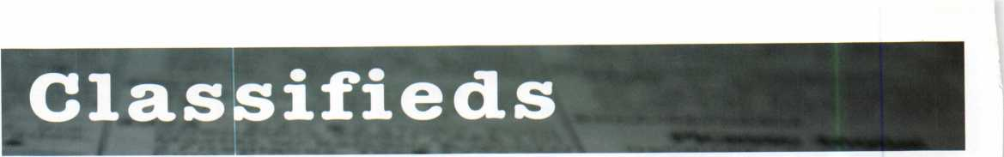

EMPLOYMENT

EXPERIENCED LOCK­SMITHS

Join our staff at John Koons Locksmiths in Southwest Florida. Posi­tions in one of our shops or outside service are available. We offer health insurance and va­cation. Housing is also available for qualified ap­plicants. Call George Klein at 1-800-282-8458 or fax a resume to 239- 931-6203. John Koons Locksmiths, 3526 Fowler Street, Fort Myers, Florida 33901.

SERVICE TECHNICIAN WANTED IN CHICAGO

Full time position, in­stalling and servicing Ac­cess Control and Electronic Door Hard­ware, with experience only. Union job with ex­cellent benefits. Please fax resume to 312-850- 6701, attention: Pat or email [pglavin@glavin- lock.com](mailto:pglavin@glavin-lock.com). No phone calls please.

LOCKSMITH NEEDED A Raleigh, NC company with over 35 years of service is looking for an experienced team player in all aspects of lock- smithing: commercial, res­

idential and automotive. Must have a valid NC locksmith license. We have medical, dental and life insurance with paid vacation and holidays. Salary based on experi­ence. For more informa­tion, please call 919-231-8017, ext. 425

EMPLOYMENT OPPORTU­NITY

IN LAS VEGAS!

A true career opportunity in Las Vegas for enthusi­astic and dependable people! A&B Security Group is seeking entry level or experienced lock­smiths and electronic se­curity professionals to join our dynamic and growing security services organi­zation. On the job train­ing and advancement opportunities into many areas such as alarms, CCTV, access control sys­tems, safes and more. We offer: Minimum first year salary $30,000. 401 k with matching, Hospital­ization package, Vaca­tion package, Paid holidays, Company vehi­cle and even a relocation allowance! Come work for A&B Security Group in Las Vegas and you'll stay in Las Vegas! Apply on our website,

[www.227lock.com](http://www.227lock.com) or call 702-227-LOCK and ask for Gary or Phil today!

LOCKSMITH WANTED

Locksmith wanted for Southwest Houston, Texas for BMC West. Must have 2 years experience. Drug test, background check and good driving record required. GREAT BENEFITS! Respond to: [houstonrecruiting@bm- cwest.coM](mailto:houstonrecruiting@bm-cwest.coM) or fax 281- 569-2610

LOCKSMITH: SEEKING: Highly successful lock­smith business expanding to Lake and McHenry Counties, Illinois, is searching for a licensed locksmith. Responsibili­ties: Market locksmith services to new commer­cial, residential and auto­motive accounts. Ability to troubleshoot/perform commercial, residential and automotive locksmith duties. Uses machinery, tools, and computer soft­ware in the performance of duties. Duties include: master keying, record keeping, installation and repair, rekey, program­ming, and decoding of mechanical and elec­tronic locks, cut by code, issue and return keys, have an awareness of all

applicable codes; pro­mote a safe working envi­ronment and practices. Performs other duties as needed. Qualifications:

HS Diploma, GED, or equivalent +2 yrs related commercial, residential and/or automotive lock­smith experience. Cur­rently have, or ablility to secure, valid Illinois Lock­smith license, ability to be bonded and possess a valid IL Drivers License. Ability to lift up to 50 lbs. Guaranteed Salary plus Commission opportunity. Van and equipment pro­vided. To apply email: LakeCountylL@popalock.c om or

call 847-917-5625.

MANAGER OF LOCK­SMITH

SERVICES: SEEKING: Manager of Locksmith Services: Successful lock­smith business expanding to Lake and McHenry Counties, Illinois is searching for a Manager of Locksmith Services.

Our well funded, market driven approach and ad­vertising will provide our Manager with top earn­ings potential. Responsi­bilities: Help define and build a market leading locksmith service in Lake and McHenry County,IL.

Keynotes • July/August 2007

Market locksmith services to new commercial, resi­dential and automotive accounts. Identify and de­velop new locksmiths. Ability to

troubleshoot/ perform commercial, residential and automotive locksmith duties, such as masterkey­ing design and records keeping, lock installation, encode locks, key dupli­cation and cut by code, repair and open locks and change combinations using special hand or bench tools and equip­ment, troubleshoot, repair and replace automotive ignition and door locks, etc. Ability to work inde­pendently in the perform­ance of assigned tasks, as well as manage other staff in the performance of their duties. Qualifica­tions: HS Diploma, GED or equivalent +5 years re­lated commercial, resi­dential and/or automotive locksmith ex­perience. Currently have or ability to secure valid Illinois Locksmith License, ability to be bonded and possess a valid IL Drivers License. Ability to lift up to 50 lbs. Guaranteed Salary plus Commission opportunity, guaranteed salary commiserate with experience. Van and equipment provided. To apply email: [LakeCoun- tylL@popalock.com](mailto:LakeCoun-tylL@popalock.com) or call 847-917-5625.

WANTED TO BUY/SELL

SECURITY SHOW AND EDUCATIONAL CONFER­ENCE

Jovan Security Distributors 11 th Annual Security Show and Educational Conference will be Sep­tember 28-30, 2007. 2350 Midland Avenue, Toronto, ON MIS 1P8. For more information please call Larry at 416- 288-6306

SPECIAL PRICING ON KWIKSET & SCHLAGE!

While supplies last on the following: Kwikset 242TxUS3 - $30.00 each. 690Tx5-$15.00 each. 665x5 - $12.00 each. 400x5 - $7.00 each. 341x3 Screen door lock - $7.00 each. Schlage B162x626 - $16.00 each. All FOB in Michigan. Call Cheryl: A- 1 Brown Locksmiths 269-983-0569

FOR SALE

Framon II Code machine, including spacing blocks, Framon code book and assorted cutters. Curtis #15 clipper with 20 depth cluster assemblies, 30 carriages and 28 depth gauges. 1 Keedex mini vats interrogator. 1 set Ford 10 cut tryout keys. 1 GM keying kit #702767. 1 GM 10 cut dash kit #PS3. 2 used

400 hook key cabinets. Approximately 3000 as­sorted automotive key blanks and 30 assorted vats blanks. Some various odds and ends, ignition switches, etc. Asking $2700. Call Al at 407- 761-7426. Alternate # 732-841-6562. Please leave message if no an­swer.

FOR SALE

NGS programmer - $1500.

Call 601-624-8185 or email,

safecracker [15@aol.com](mailto:15@aol.com) FOR SALE

1 Used ILCO 024 Semi- Automatic key machine - $250.00. 1 used HPC Trace A Key Model 6666 Automatic key machine - $250.00. All prices plus shipping. Call 313-881- 0280 or

email: [eastsidelock@sbc- global.net](mailto:eastsidelock@sbc-global.net)

LOCKSMITH BUSINESS FOR SALE

Locksmith Business for sale in beautiful Galve­ston Island, Texas. Ad­dress: 1624 21 Street, 77550. Owner retiring after 33 years due to health. Many commercial, residential, real estate, in­dustrial accounts. Very well established. Equip­ment and inventory in­cluded. Over 20,000 keys in stock. Includes

2001 Ford Club Econo­line van, 2 Bravo Key Machines, 2 Curtis Clip­per's #15 all accessories for all cars and all car opening tools and much more. Two blocks from beach. Business is boom­ing. More than we can handle. Business name onlyy selling for $325,000 obo with op­tion to buy property. All for $599,000 firm.

Please serious inquiries only. Call 409-765-9551 daytime or 409-789- 8487 only til 9pm Mon- day-Friday. VJ. Tramonterealty.com 409- 765-9837.

MOBILE LOCKSMITH BUSINESS FOR SALE

Mobile Locksmith Busi­ness for Sale in the thriv­ing Coachella Valley in Southern California. If you're an experienced locksmith with a current California locksmith per­mit, here's a chance to be in business for yourself.

Be your own boss and work towards your own dreams and goals instead of your employers'. For details, contact David, or leave a message at 760- 772-0153.

Classified Advertising Policy **b**

Classified advertising space is provided free of charge to ALOA members and for a fee of $2.00 per word, $40.00 minimum for non members. Classified ads may be used to advertise used merchandise and overstocked items for sale, "wanted to buy” items, business op­portunities, employment opportunities/positions wanted and the like. Members or non members wishing to advertise services or new merchandise for sale may purchase a "Commercial Classified Ad" for a fee of $4.00 per word with a minimum of $ 100.00. Each ad will run for two issues. For blind boxes there is a $10.00 charge for members and non members. All ads must be submitted in writing to the Advertising Sales Department via fax at 817-645-7599 or through an email to [adsales@aloa.org](mailto:adsales@aloa.org) by the fifteenth of the month two months prior to issue date. ALOA reserves the right to refuse any classified advertisement that it deems inappropriate according to the stated purpose of the classified advertising section.



associate

members

Distributor

**ADEL Fingerprint Technology; LLC**

Phone: 909-595-1222 Fax: 909-595-1667

**Accredited Lock Supply Co.**

Phone: 800-652-2835 Fax: 201-865-2435 [www.acclock.com](http://www.acclock.com)

**American Auto Lock.Com**

Phone: 717-392-6333 Fax: 717-581-8353 [www.americanautolock.co](http://www.americanautolock.co) m

**Boyle & Chase Inc.**

Phone: 800-325-2530 Fax: 800-205-3500 [www.boyleandchase.com](http://www.boyleandchase.com)

**Clark Security Products**

Phone: 858-974-6740 Fax: 858-974-6720 [www.clarksecurity.com](http://www.clarksecurity.com)

**Cook's Building Specialties**

Phone: 505-883-5701 Fax: 505-883-5704

**Dire's Lock & Key Company**

Phone: 303-294-0176 Fax: 303-294-0198

**Direct Security Supply; Inc.**

Phone: 800-252-5757 Fax: 800-452-8600

**Doyle Security Products**

Phone: 800-333-6953 Fax: 612-521-0166 [www.doylesecurity.com](http://www.doylesecurity.com)

**Dugmore and Duncan, Inc.**

Phone: 888-384-6673 Fax: 888-329-3846

**E. L. Reinhardt Co., Inc.**

Phone: 800-328-1311 Fax: 651-481-0166 [www.elreinhardt.com](http://www.elreinhardt.com)

**Foley-Belsaw**

**Company**

Phone: 800-821-3452 Fax: 816-483-5010 [www.foley-belsaw.com](http://www.foley-belsaw.com)

**Fried Brothers Inc.**

Phone: 800-523-2924 Fax: 215-592-1255 [www.fbisecurity.com](http://www.fbisecurity.com)

**H.L. Flake Co.**

Phone: 800-231-4105 Fax: 713-926-3399 [www.hlflake.com](http://www.hlflake.com)

**Hardware Agencies, Ltd.**

Phone: 416-462-1921 Fax: 416-462-1922

[www.hardwareagencies.com](http://www.hardwareagencies.com)

**IDN Incorporated**

Phone: 817-421-5470 Fax: 817-421-5468 [www.idn-inc.com](http://www.idn-inc.com)

**Instant Hardware Delivery, Inc**

Phone: 800-355-1 107 Fax: 800-663-8518

**Intermountain Lock & Security**

Phone: 800-453-5386 Fax: 801-485-7205 [www.imlss.com](http://www.imlss.com)

**Jovan Distributors, Inc**

Phone: 416-288-6306 Fax: 416-752-8371 [www.jovanlock.com](http://www.jovanlock.com)

**L V Sales Inc**

Phone: 323-661-4746 Fax: 323-661-1314 [www.lvsales.com](http://www.lvsales.com)

**Lockmasters, Inc.**

Phone: 859-885-6041 Fax: 859-885-7093 [www.lockmasters.com](http://www.lockmasters.com)

**Locks Company**

Phone: 800-288-0801 Fax: 305-949-3619

**Locksmith Ledger International**

Phone: 847-454-2700 Fax: 847-454-2759 [www.lledger.com](http://www.lledger.com)

**McDonald Dash Locksmith Supply Inc.**

Phone: 800-238-7541 Fax: 901-366-0005 [www.mcdonalddash.com](http://www.mcdonalddash.com)

**NLS Lock Supply Dba Nevada Lock Supply**

Phone: 702-737-0500 Fax: 702-737-7134

**Omaha Wholesale Hardware**

Phone: 800-238-4566 Fax: 402-444-1664 [www.omahawh.com](http://www.omahawh.com)

**Phoenix Safe International LLC**

Phone: 765-483-0954 Fax: 765-483-0962 [www.phoenixsafeusa.com](http://www.phoenixsafeusa.com)

**Positive Identity Solutions**

Phone: 704-663-1175 Fax: 704-660-1301 [www.pids-usa.com](http://www.pids-usa.com)

**Security Distributors Inc**

Phone: 800-333-6953 Fax: 612-524-0166

**Southern Lock and Supply Co.**

Phone: 727-541-5536 Fax: 727-544-8278 [www.southernlock.com](http://www.southernlock.com)

**Stone & Berg Wholesale**

Phone: 800-225-7405 Fax: 800-535-5625

**The Locksmith Store Inc.**

Phone: 847-364-51 1 1 Fax: 847-364-5125 [www.locksmithstore.com](http://www.locksmithstore.com)

**The Ultimate Distribution Company**

Phone: 254-681-2277 Fax: 254-953-4933 [www.ultimatelocksales.com](http://www.ultimatelocksales.com)

**Timemaster Inc.**

Phone: 859-259-1878 Fax: 859-255-0298 [www.time-master.com](http://www.time-master.com)

**Top Notch Distributors, Inc.**

Phone: 570-753-5625 Fax: 570-253-7178 [www.topnotch.bz](http://www.topnotch.bz)

**Turn 10 Wholesale**

Phone: 800-848-9790 Fax: 800-391-4553

**U.S. Lock Corp.**

Phone: 800-925-5000 Fax: 800-338-5625 [www.uslock.com](http://www.uslock.com)

Manufacturer

**A & B Safe Corporation**

Phone: 800-253-1267 Fax: 856-863-1208 [www.a-bsafecorp.com](http://www.a-bsafecorp.com)

**ABUS KG**

Phone: 492-335-634151 Fax: 233-563-4130 [www.abus.com](http://www.abus.com)

**ABUS Lock Company**

Phone: 800-352-2287 Fax: 602-516-9934 [www.abus.com](http://www.abus.com)

**Access Security Products Ltd.**

Phone: 905-337-7874 Fax: 905-337-7873 [www.access-safe.com](http://www.access-safe.com)

**Adams Rite Mfg Company**

Phone: 800-872-3267 Fax: 800-232-7329 [www.adamsrite.com](http://www.adamsrite.com)

**Adrian Steel Company**

Phone: 800-677-2726 Fax: 517-265-5834 [www.adriansteel.com](http://www.adriansteel.com)

**Advanced Diagnostics USA Inc**

Phone: 650-876-2020 Fax: 650-876-2022 [www.autokeys.com](http://www.autokeys.com)

**Alarm Controls Corporation**

Phone: 631-586-4220 Fax: 631-586-6500 [www.alarmcontrols.com](http://www.alarmcontrols.com)

**All Five Tool Company, Inc.**

Phone: 860-583-1691 Fax: 860-583-4516 [www.all5tool.com](http://www.all5tool.com)

**American Security Products**

Phone: 909-685- 9680x2013 Fax: 909-685-9685 [www.amsecusa.com](http://www.amsecusa.com)

**Bianchi USA, Inc.**

Phone: 800-891-2118 Fax: 216-803-0202 [www.bianchi](http://www.bianchi) 1770usa.com

**Buddy Products**

Phone: 312-733-6400 Fax: 312-733-8356 [www.buddyproducts.com](http://www.buddyproducts.com)

**CCL Security Products**

Phone: 800-733-8588 Fax: 847-537-1800 [www.cclsecurity.com](http://www.cclsecurity.com)

**CompX Security Products**

Phone: 864-297-6655 Fax: 864-297-9987 [www.compx.com](http://www.compx.com)

**D&D Technologies (USA), Inc.**

Phone: 714-677- 1300x292 Fax: 714-677-1299 [www.ddtechglobal.com](http://www.ddtechglobal.com)

**DETEX Corp.**

Phone: 800-729-3839 Fax: 830-620-671 1 [www.detex.com](http://www.detex.com)

Keynotes • July/August 2007

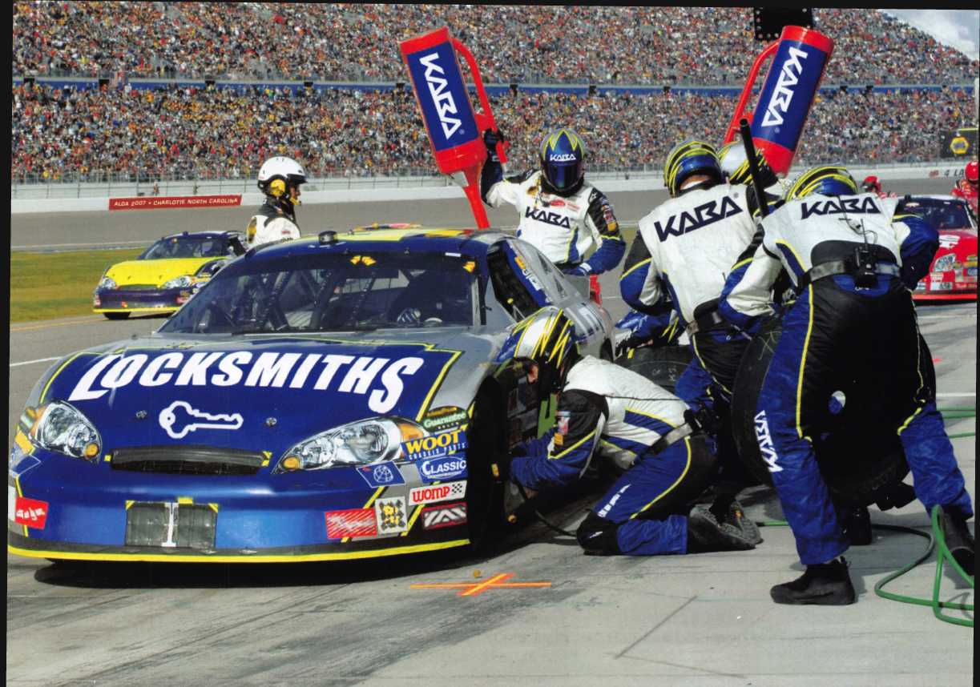

KEY SYSTEMS

SAFE LOCKS

ACCESS CONTROL

KAIZA

Visit Us at ALOA  
Booth #204

|  |  |
| --- | --- |
| assoc | i a t e |
| m e m b | ers |

**Don-Jo**

**Manufacturing, Inc.**

Phone: 978-422-3377 Fax: 978-422-3467 [www.don-jo.com](http://www.don-jo.com)

**Door Controls International**

Phone: 800-742-3634 Fax: 800 742-0410 [www.docrcontrols.com](http://www.docrcontrols.com)

**Doorkirg Inc.**

Phone: 800-826-7493 Fax: 310641-1586 [www.docrking.com](http://www.docrking.com)

**Dorma , Vrchitectual Hardwcire**

Phone: 717-336-3881 Fax: 717 336-2106 [www.dor](http://www.dor) ma-usa.com

**DynaLo :k Corp**

Phone: 8 bO-582-4761 Fax: 86C-585-0338 [www.dyralock.com](http://www.dyralock.com)

**FireKin<|**

**Security Group**

Phone: 8 30-457-2424 Fax: 80C-896-6606 [www.firecing.com](http://www.firecing.com)

**Framon**

**Manufc cturing Company Inc.**

Phone: 939-354-5623 Fax: 98$-354-4238 [www.fra](http://www.fra) non.com

**G-U Hardware Inc.**

Phone: 757-877-9020 Fax: 757 -877-9720 [www.g-u.com](http://www.g-u.com)

**HPC, Inc.**

Phone: 847-671-6280 Fax: 847-671-6343 www.hp* :world.com

**HY-KO Products Co.**

Phone: 330-467-7446 Fax: 33('-467-7442

**Hammerhead Industries, Inc.**

Phone: 805-658-9922 Fax: 805-658-8833 [www.gearkeeper.com](http://www.gearkeeper.com)

**Ingersoll Rand**

**Security**

**Technologies**

Phone: 317-810-3801 Fax: 317-805-5779 [www.schlagelock.com](http://www.schlagelock.com)

**Jackson Corporation**

Phone: 323-269-81 1 1 Fax: 800-888-6855 [www.jacksonexit.com](http://www.jacksonexit.com)

**Jet Hardware Mfg., Co.**

Phone: 718-257-9600 Fax: 718-257-0973 [www.jetkeys.com](http://www.jetkeys.com)

**KABA ILCO Corp.**

Phone: 252-446-3321 Fax: 252-446-4702 [www.kaba-ilco.com](http://www.kaba-ilco.com)

**KEY-BAK/West Coast Chain Mfg.**

Phone: 909-923-7800 Fax: 909-923-0024 [www.keybak.com](http://www.keybak.com)

**Kenstan Lock Company**

Phone: 516-576- 9090x315 Fax:516-576-0100 [www.kenstan.com](http://www.kenstan.com)

**Keri Systems Inc.**

Phone: 408-435-8400 Fax: 408-435-7163 [www.kerisys.com](http://www.kerisys.com)

**Kustom Key Inc.**

Phone: 800-537-5397 Fax: 800-235-4728 [www.kustomkey.com](http://www.kustomkey.com)

**LAB Security**

Phone: 800-243-8242 Fax: 860-583-7838 [www.labpins.com](http://www.labpins.com)

**Lucky Line Products, Inc.**

Phone: 858-549-6699 Fax: 858-549-0949 [www.luckyline.com](http://www.luckyline.com)

**M.A.G.**

**Manufacturing**

Phone: 714-891-5100 Fax: 714-892-6845

[www.magmanufacturing.com](http://www.magmanufacturing.com)

**MPT Industries, Inc.**

Phone: 973-989-9220 Fax: 973-989-9234 [www.mptindustries.com](http://www.mptindustries.com)

**MUL-T-LOCK USA, Inc.**

Phone: 800-562-351 1 Fax: 973-778-4007 [www.mul-t-lockusa.com](http://www.mul-t-lockusa.com)

**Maxcess Card Systems Inc**

Phone: 800-713-4823 Fax: 650-692-9410 [www.maxcess-card.com](http://www.maxcess-card.com)

**Medeco Security Locks**

Phone: 540-380-5000 Fax: 540-380-5010 [www.medeco.com](http://www.medeco.com)

**Mil-Comm Products Co Inc**

Phone: 201-935-8561 Fax: 201-935-6059

**Pacific Lock Company**

Phone: 888-562-5565 Fax: 818-678-6600 [www.paclock.com](http://www.paclock.com)

**Protex Safe Co., LLC**

Phone: 818-610-8030 Fax: 818-610-8004 [www.protexsafe.com](http://www.protexsafe.com)

**ROFU International Corp.**

Phone: 253-922-1828 Fax: 253-840-7272 [www.rofu.com](http://www.rofu.com)

**Rutherford Controls Int'l Co.**

Phone: 519-621-7651 Fax: 519-621-7939 [www.rutherfordcontrols.c](http://www.rutherfordcontrols.c) om

**Sargent &**

**Greenleaf, Inc.**

Phone: 859-885-941 1 Fax: 859-885-3063 [www.sargentandgreen- leaf.com](http://www.sargentandgreen-leaf.com)

**Sargent**

**Manufacturing Co.**

Phone: 800-727-5477 Fax: 888-863-5054 [www.sargentlock.com](http://www.sargentlock.com)

**Schwab Corp.**

Phone: 765-447-9470 Fax: 765-447-8278 [www.schwabcorp.com](http://www.schwabcorp.com)

**Securifort Inc**

Phone: 819-359-2226 Fax: 819-359-2218 [www.securifort.com](http://www.securifort.com)

**Securitron Magnalock Corp.**

Phone: 775-355-5625 Fax: 775-355-5636 [www.securitron.com](http://www.securitron.com)

**Security Door Controls**

Phone: 805-494-0622 Fax: 805-494-8861 [www.sdcsecurity.com](http://www.sdcsecurity.com)

**Security Solutions**

Phone: 405-376-1600 Fax: 405-376-6870 [www.securitysolutions- usa.com](http://www.securitysolutions-usa.com)

**Select Engineered Systems**

Phone: 305-823-5410 Fax: 305-823-5215 [www.selectses.com](http://www.selectses.com)

**Townsteel, Inc.**

Phone: 626-858-5080 Fax: 626-858-3393 www. town steel .com

**Trine Access Technology**

Phone: 718-829-2332 Fax: 718-829-6405 [www.trineonline.com](http://www.trineonline.com)

**Videx Inc.**

Phone: 541-758-0521 Fax: 541-752-5285 [www.videx.com](http://www.videx.com)

**WIKK Industries Inc.**

Phone: 414-421-9490 Fax: 414-421-3158 [www.wikk.com](http://www.wikk.com)

**WMW Innovation Company**

Phone: 888-474-2341 [www.sure-strike.com](http://www.sure-strike.com)

Service

Organization

**Allstate Insurance Company**

Phone: 847-551-2181 Fax: 847-551-2732 [www.allstate.com](http://www.allstate.com)

**HRH Insurance**

Phone: 817-462-3630 Fax: 817-462-3680 [www.hrh.com](http://www.hrh.com)

**Red Hawk**

Phone: 901-332-2911 Fax: 901-332-2878 [www.webstersinc.com](http://www.webstersinc.com)

**The Mechanic Group, Inc.**

Phone: 845-735-0700 Fax: 845-735-8383 [www.mechanicgroup.com](http://www.mechanicgroup.com)

**76**

Keynotes • July/August 2007